SLINGSBY t45 swallow
LASER-CUTTING KIT
Building instruction

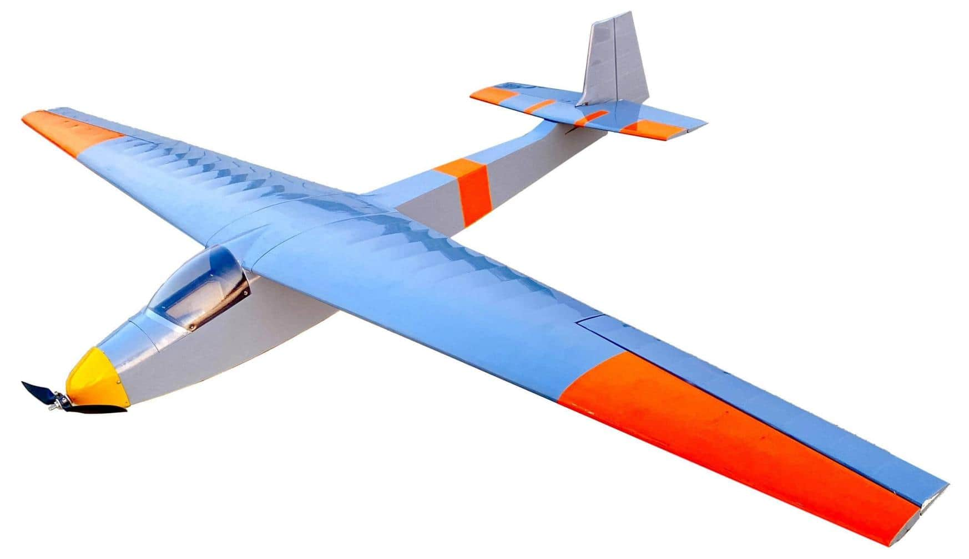

Catalog

introduction----------------------------------------------------------------------------------------P1

product list& KIT FEATURES -----------------------------------------------------------------P1

GERNERAL INFORMATION-------------------------------------------------------------------------P2

Building instruction---------------------------------------------------------------------------P3

- Fuselage Frame Assembly---------------------------------------------------------------P3
- TAIL&WING CONSTRUCTION-------------------------------------------------------------------------P9
- Structural views---------------------------------------------------------------------------------------------------P15

Specifications:
Wingspan : 1800mm Length : 1160mm
Flywing Weight : 1060g
Suggested power : Motor: 2212 1400kv ESC: 30A
Servos: 9g × 4 Batteries: 3S
Props: 9inches folding prop

introduction
The Slingsby Type 45 Swallow was designed as a club sailplane of reasonable performance and price. One of the most successful of Slingsby's gliders in sales terms, over 100 had been built when production was ended by a 1968 factory fire..The Swallow flew for the first time on 11 October 1957 and it remained in production for 11 years. About 115-120 Swallows were completed,though two were destroyed at the factory in a fire. Part of the uncertainty lies with kits issued by Slingsby for construction abroad. The short-span first prototype was later rebuilt as the Reussner Swift. The RAF used five Swallows, known as Swallow T.X. Mk.1, in its Air Training Corps. Approximately nine Swallows were used by branches of the Royal Air Force Gliding and Soaring Association at airfields across the world,and the equivalent Royal Navy association had four.25 were sold in Spain, nine in Pakistan and four in Burma. Most of the rest flew with clubs in the UK, though a few went to Commonwealth countries and the USA.
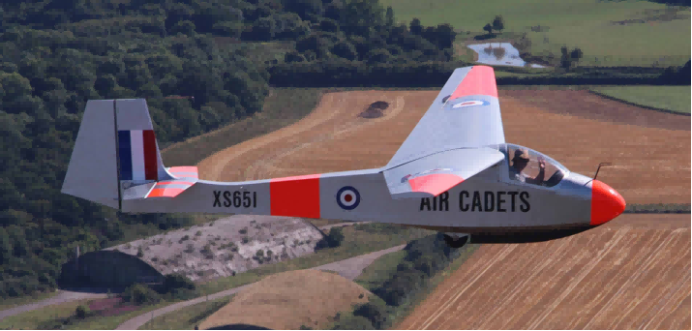
product list
Balsa sheets pack*1 1:1 installation drawing*1
Batten sets Operation instruction*1
Accessories bag*1 PVC windshield&canopy*1
Carbon tube*1
steel pull rod with PVC tube*1
KIT FEATURES
- Scheme-based on Slingsbby T45 Swallow.
- Extremely lightweight, state-of-the-art all-wood construction.
- Ultra-light take-off weight ensures high gliding performance.
- Full-scale simulation metallic structure.
- Extensive clear drawings and full-page colour instructions with hundreds of pictures .
- Only adhesives and coverings are required to complete the airframe.

GERNERAL INFORMATION
Be sure to read the safety instructions carefully before operating your model.
• Always follow the procedures and settings recommended in the instructions.
• If you are using remote-controlled model aircraft, helicopters, cars or ships for the first time, we recommend that you ask an experienced model pilot for help.
• Remote-controlled models are not toys in the usual sense and may only be used and operated by young people under 14 years of age under the supervision of adults.
• Their construction and operation requires technical understanding, careful craftsmanship and safety-conscious behaviour.
• Mistakes or negligence during construction, flying or driving can result in considerable damage to property or personal injury.
• Since the manufacturer and seller have no influence on the proper construction/assembly and operation of the models, these risks are expressly pointed out and any liability is excluded.
• Propellers on aircraft and all moving parts in general pose a constant risk of injury. Avoid touching such parts at all costs.
• Note that motors and controllers can reach high temperatures during operation. Avoid touching such parts at all costs.
• Never stay in the danger area of rotating parts with electric motors with connected drive battery.
• Overcharging or incorrect charging can cause the batteries to explode. Make sure the polarity is correct.
• Protect your equipment and Models from dust, dirt and moisture. Do not expose the equipment to excessive heat, cold or vibration.
• Always check your equipment for damage and replace defects with original spare parts.
• Do not use equipment that has been damaged or got wet due to a fall, even if it is dry again!
• Do not make any changes to the remote control which are not described in these instructions.
•Before the first flight, check the wing symmetry, tail unit and fuselage. All parts of the model should have the same spacing from the left and right wing or tail plane to the centre of the fuselage or the same angle.

Attention, danger of injury!
• Always keep a safe distance from your model aircraft.
• Never fly over spectators, other pilots or yourself.
• Always perform flight figures in a direction away from the pilot or spectators.
• Never endanger people or animals.
• Never fly near power lines or residential areas.
• Do not operate your model near locks or public shipping.
• Do not operate your model on public roads, motorways, paths and squares, etc., but only in approved locations.
• Do not operate the model in thunderstorms.
• Before each flight, check your remote control system for sufficient function and range.
• After flying, remove all batteries from the model.
Do not „aim“ the transmitter antenna at the model during operation. In this direction, the transmitter has the lowest radiation. The best position of the antenna is to the side of the model.
Use of devices with image and/or sound recording function:

Building instruction

1 Fuselage Frame Assembly
1-3 Assemble the left and right side boards of the fuselage. Join and glue A0, A0-1, and A0-2 together .
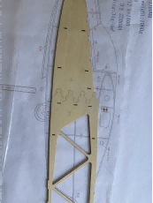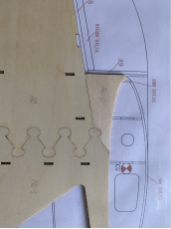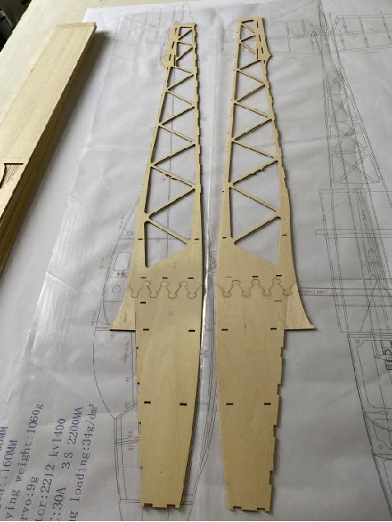

4 Glue A6, A10, A11, and A12 onto the fuselage side boards.
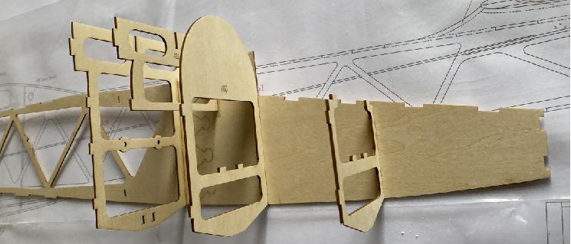
5-6 Glue the wheel mounts A14 and the bulkhead A13.
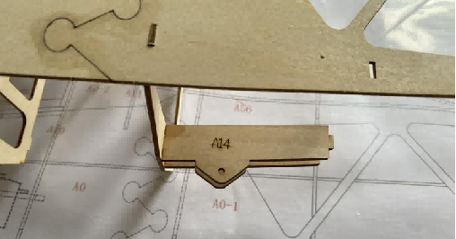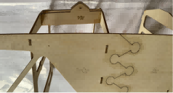
7 Glue the other side of the fuselage side board.
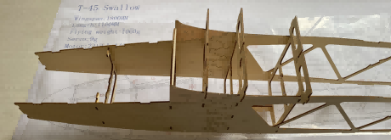
8-9 Assemble the middle wing ribs. Locate with the carbon tubes before gluing and fixing.
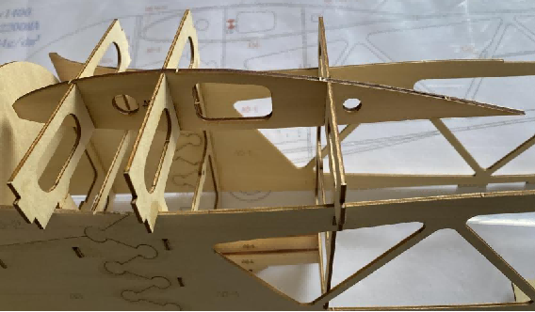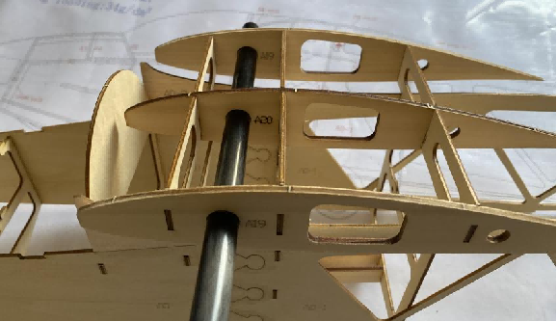
10-11 Glue the upper and lower cover plates, and make sure it’s vertical.
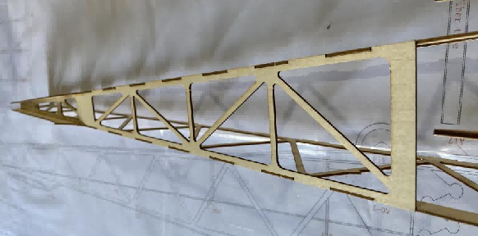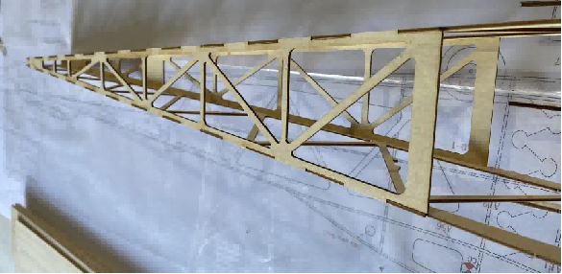
12-13 Glue the motor mount A1 to the fuselage. Install magnets on the cockpit floor A2 and glue it to the fuselage.
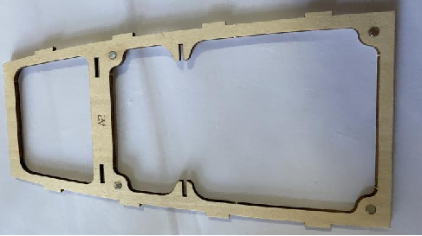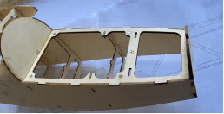

14 Glue 6x6mm balsa sticks to the inner side(corners) of the motor mount for reinforcement.
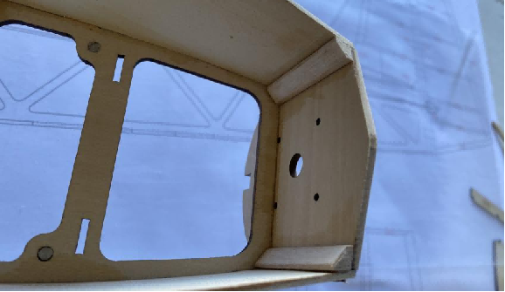
15 Glue the servo mount A7 to the fuselage.
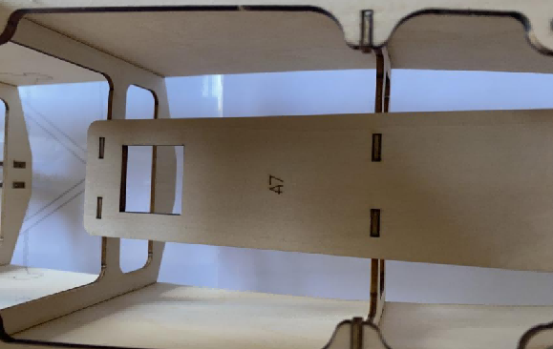
16-17 Cut 5mm balsa sheet and glue it to the leading edge of the middle wing ribs.
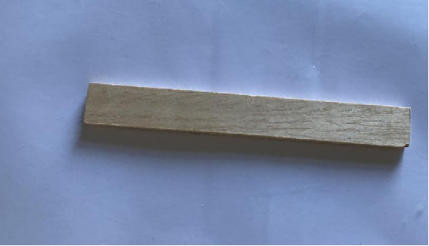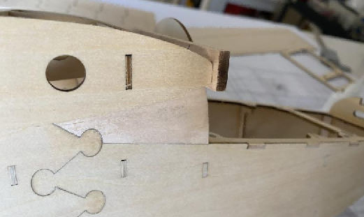

18-19 Glue A56 balsa wood to the underside of the wing platform.
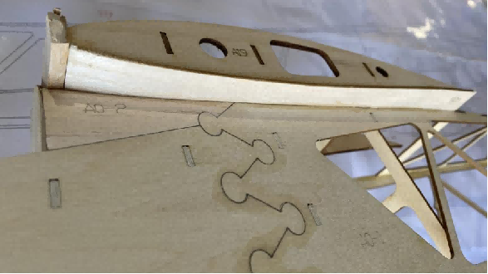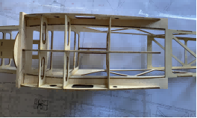
20 Glue 2mm balsa sheet as the covering for the wing platform.
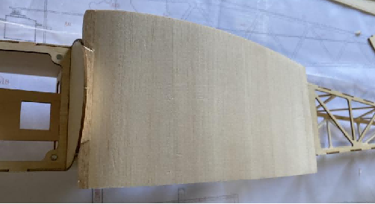
21 Sand the leading edge of the wing platform.
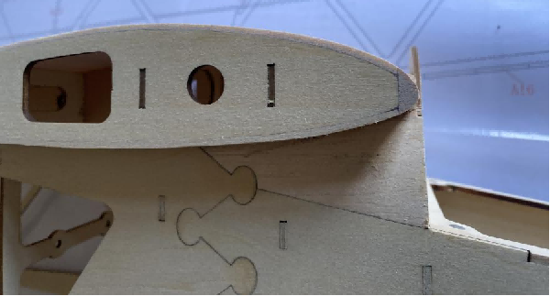
22 Glue A17 plywood to the bottom of the fuselage. Balsa sheet is used for reinforcement at the connection points at the rear.
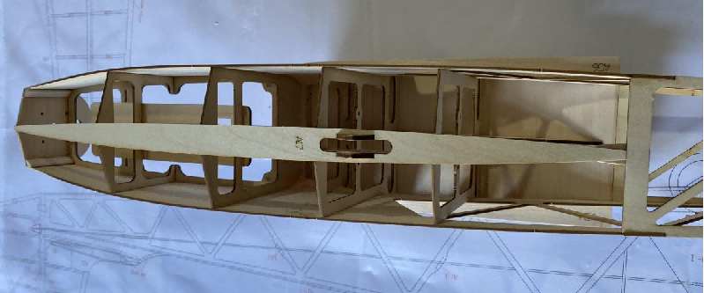
23-24 Glue the bottom covering(2mm balsa sheets).
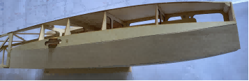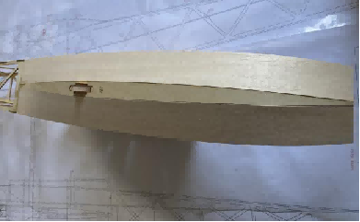
25-26 Glue the A3 bulkhead to the fuselage and cover it with 2mm balsa wood.
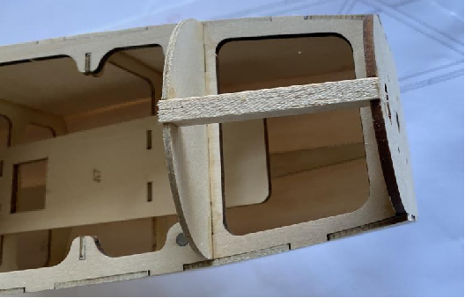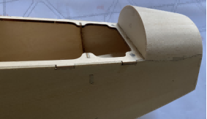
27 Glue the top covering of the wing platform. Sand the edges for a better fit.
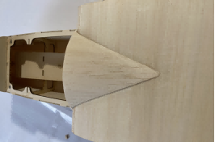
28-29 Glue magnets to the cockpit cover base. Glue the servo cover bulkheads A4, A5, and A9.
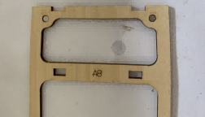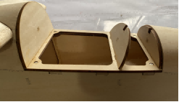
30-31 Glue 6x6mm balsa strips to the sides of the cockpit cover for reinforcement. Secure the windshield with self-tapping screws.
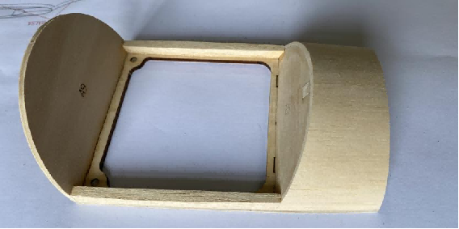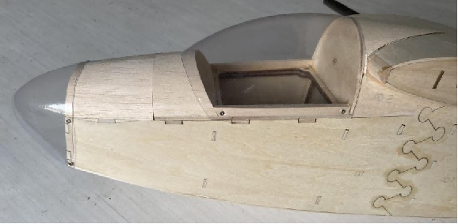
32 Insert a 8mm round wooden stick and glue it in place.
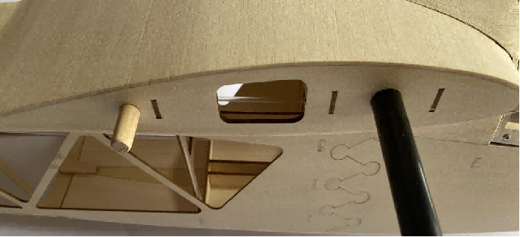
33-34 Glue 3mm balsa sheet to the tail wing platform. Glue 8x8mm balsa strips to the rear for filling.
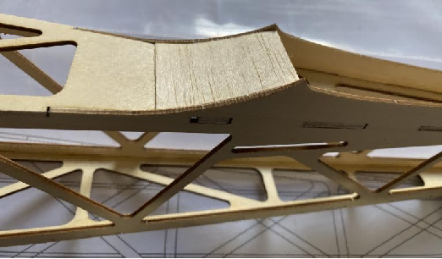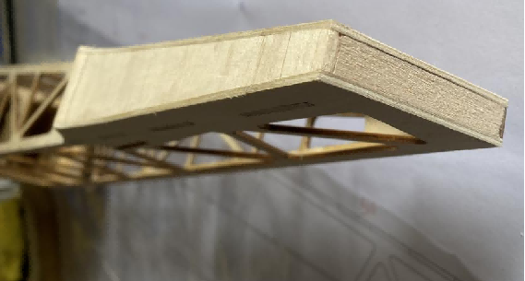
35-37 Glue the steel wire tube mounting plates A50 and A51 and insert PVC tubes.
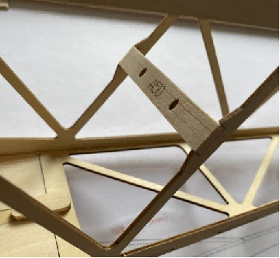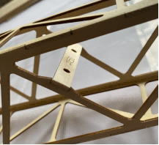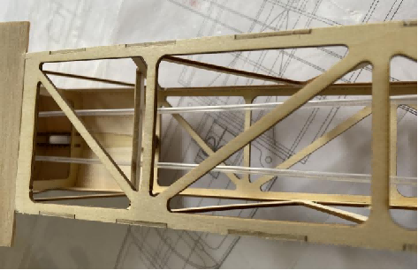

2 Tail&WINGS Assembly

38-40 Assemble the wing ribs according to the part numbers and glue the upper and lower covering.
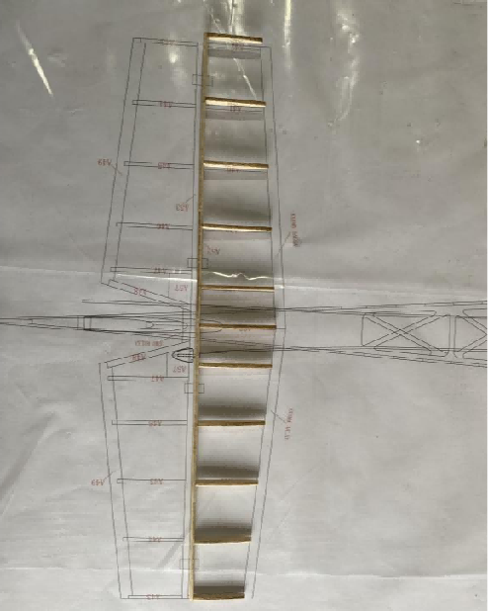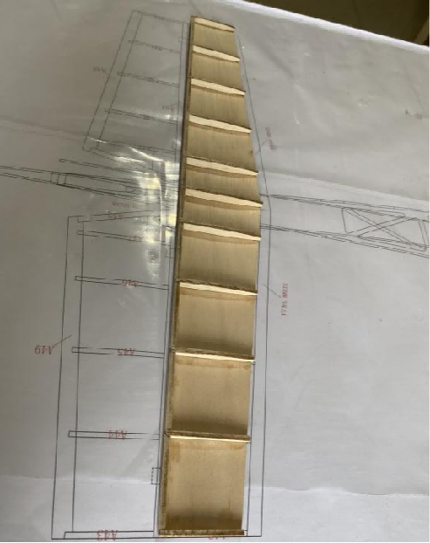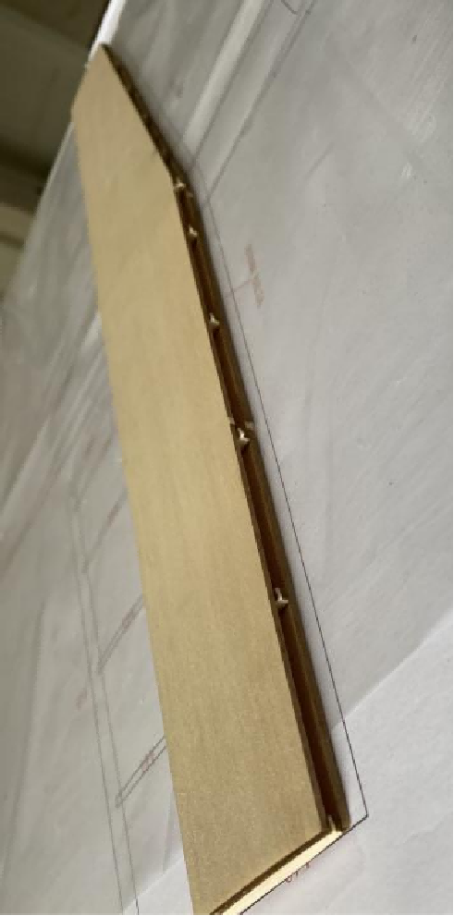
41-42 Sand the leading edge covering and glue 8x8mm balsa strips. Sand the leading edge into an airfoil shape.
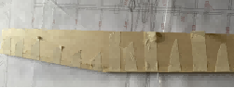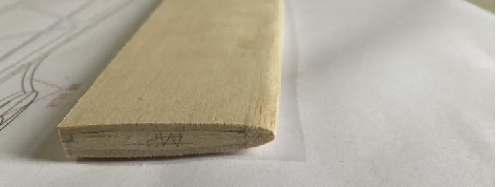
43-44 Assemble the elevator according to the drawing numbers and glue 5mm balsa wood to the middle for reinforcement.
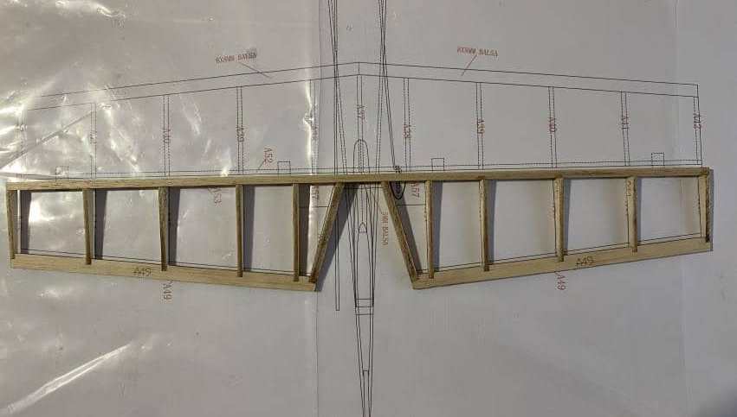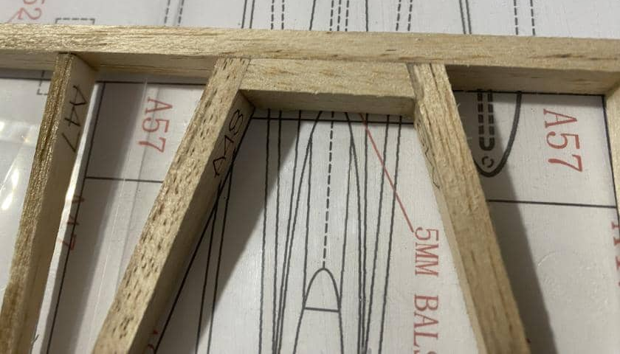
45-47 Glue the horns mounting platesA57. Sand the middle part into an arc shape and the leading edge into a V shape.
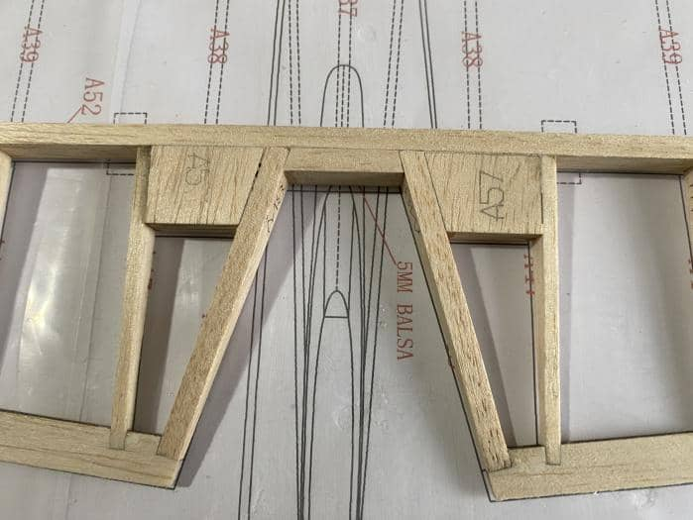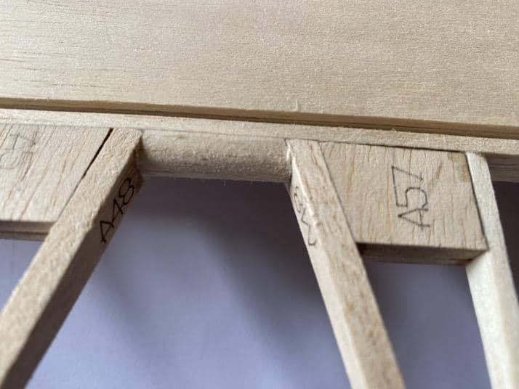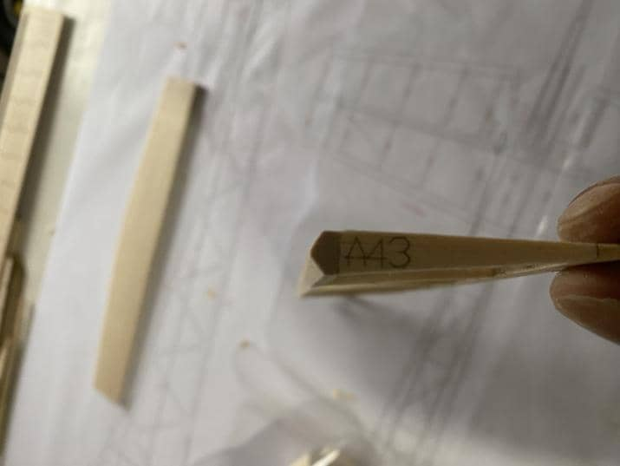
48-51 Glue two A22 pieces together and assemble the vertical tail according to the part numbers. Sand the leading edge into an airfoil shape.
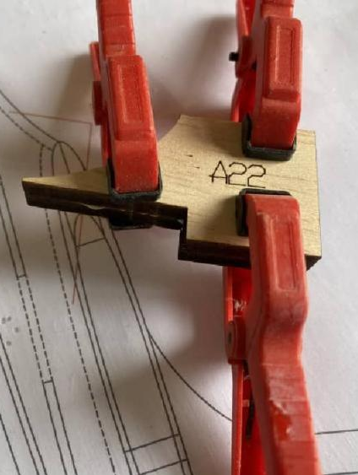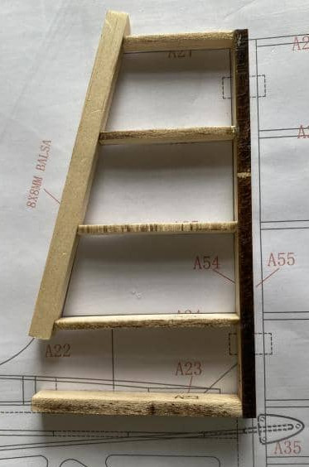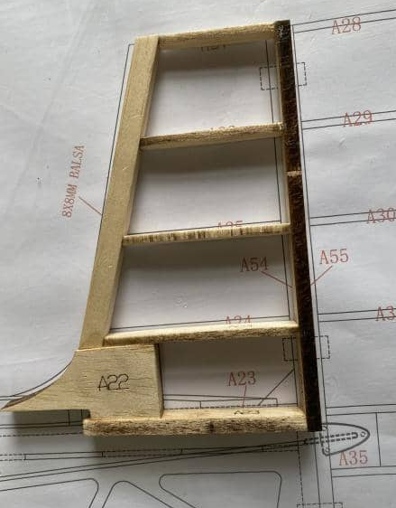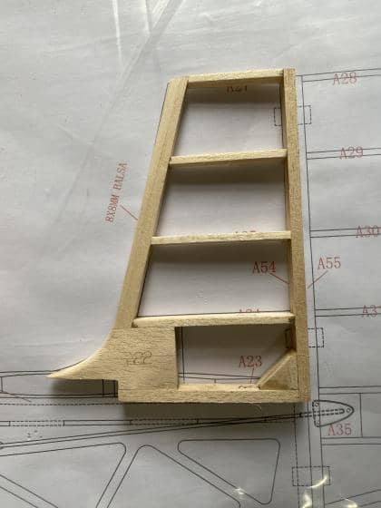
52-53 Assemble the rudder according to the part numbers.
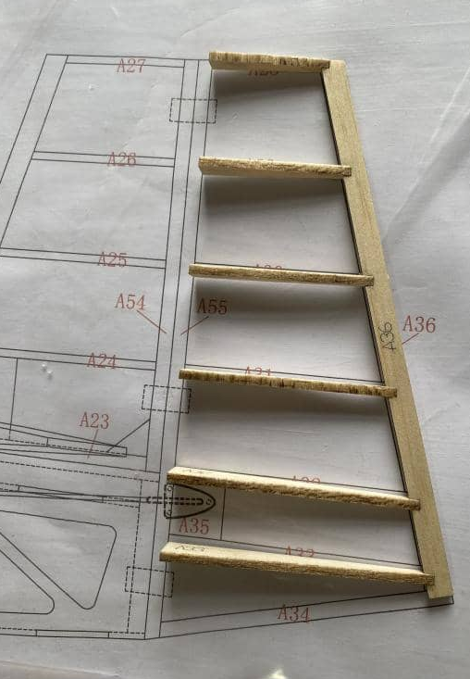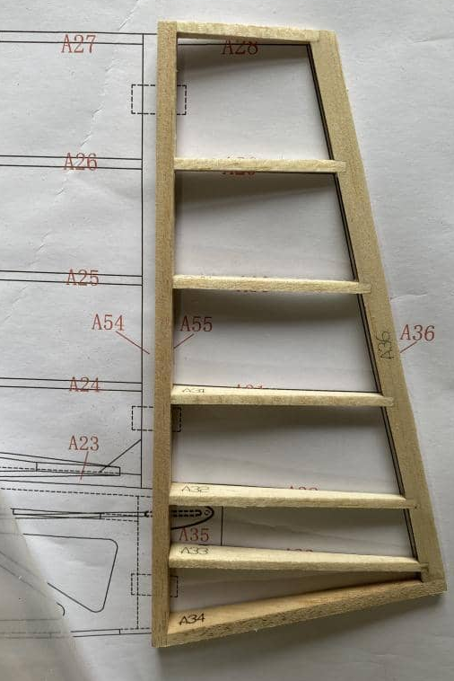
54-55 Glue the A35 and sand the leading edge into a V shape.
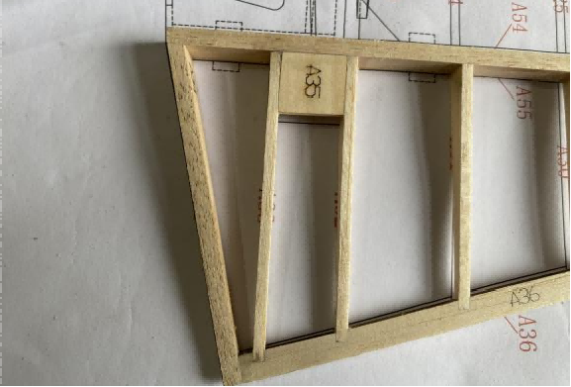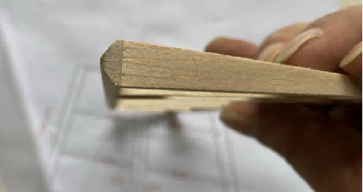
56-58 Assemble the wing ribs, install the 6x6 balsa stick as the main beam, and insert PVC tube and carbon tube for positioning.
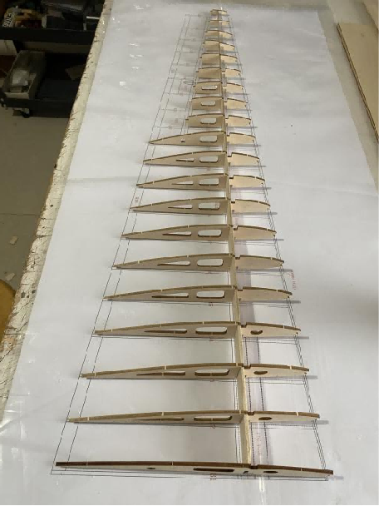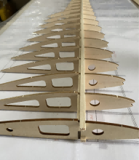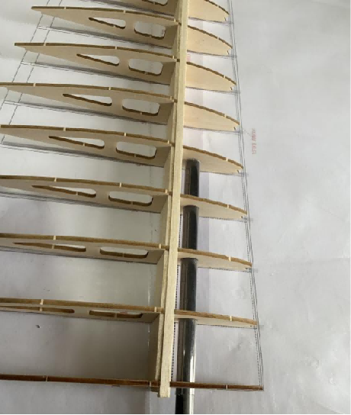
59-61 Glue the trailing edge B22 and B36 of the wing and glue 8x8mm balsa wood strips as the leading edge.
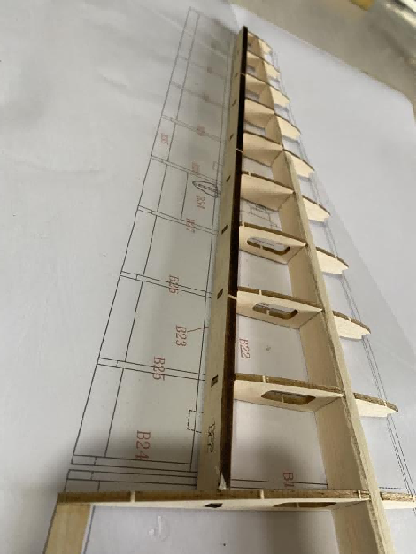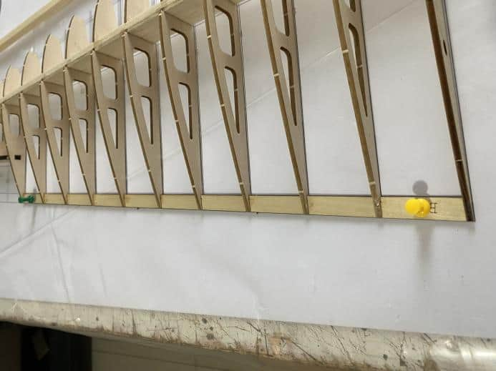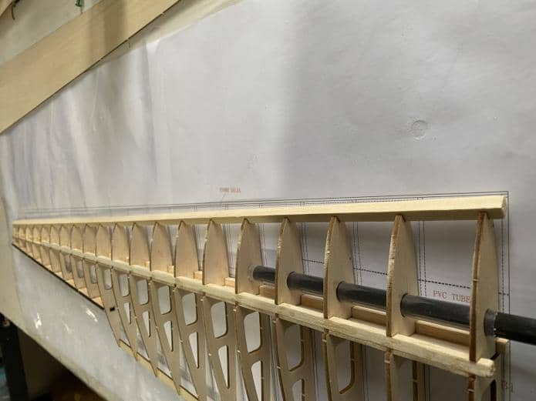
62-63 Glue the upper and lower covering of the wing.
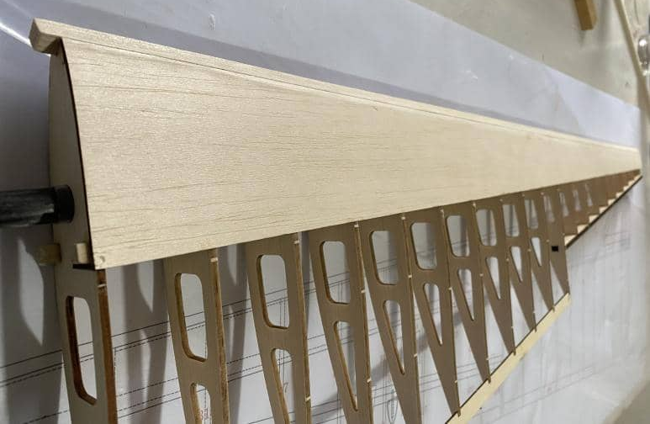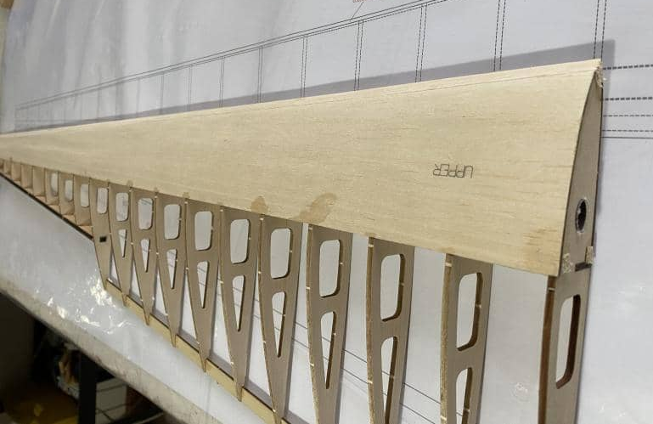
64-65 Glue 2mm balsa covering.
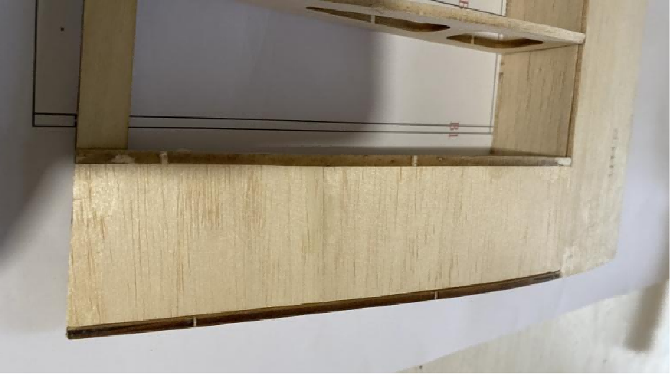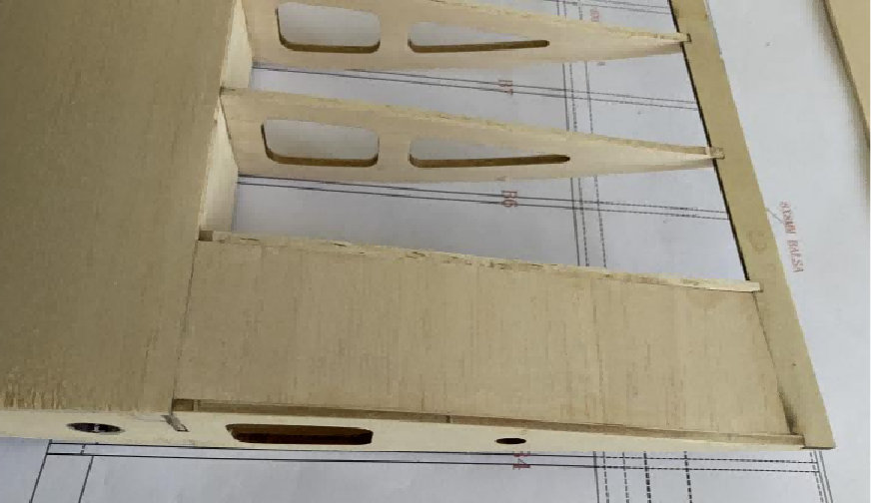
66 Sand the leading edge of the wing.

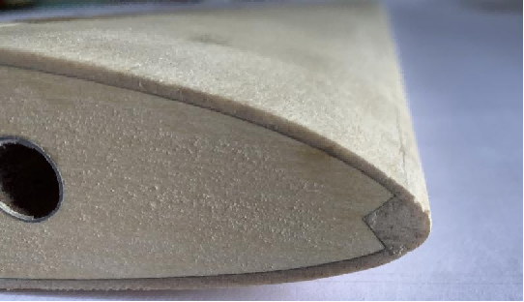
67-68 Assemble the servo mount, cut off the excess to allow the servo wires to pass through. (The servo needs to be reset to neutral before installation and will be non-removable after installation.)
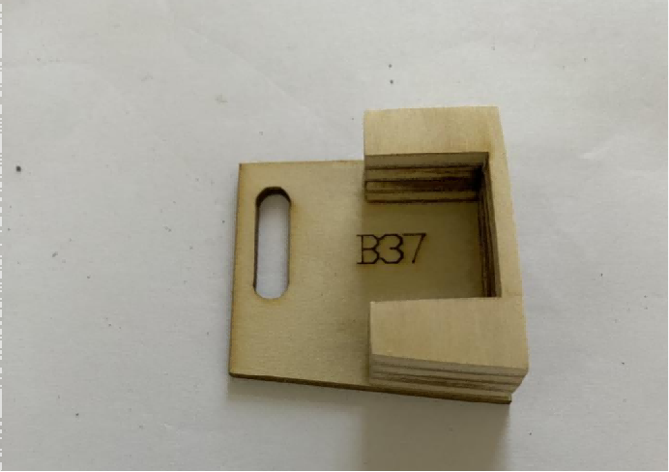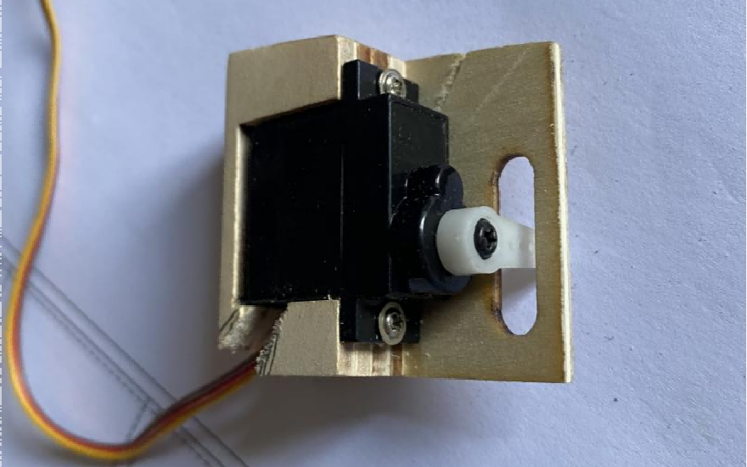
69-70 Insert the servo mount into the wing rib and fix it with glue. Use 2mm balsa wood to fill the upper surface.
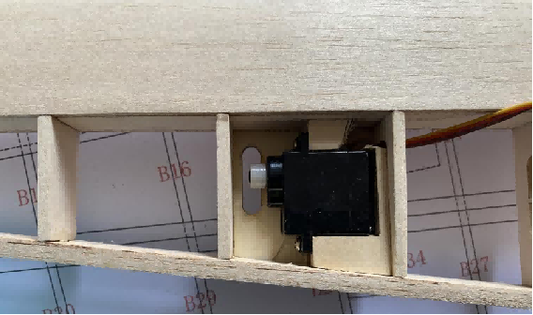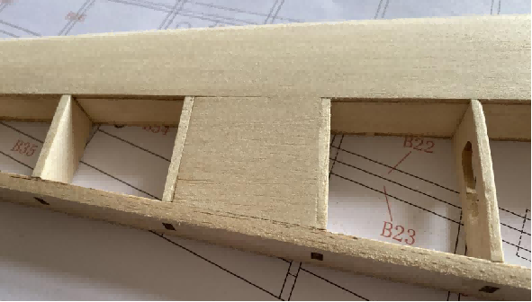
71-72 Assemble the ailerons according to the part numbers.
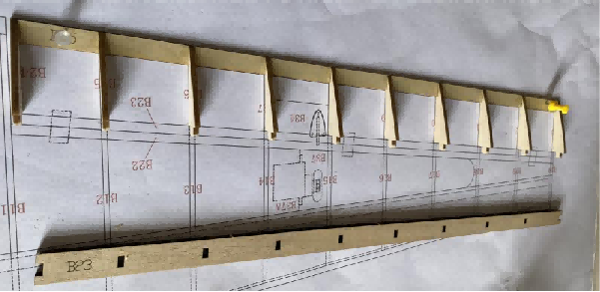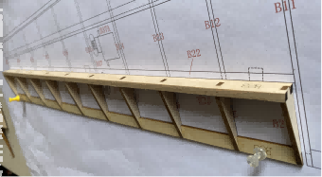
73-74 Glue the aileron horn mount B34 and sand the leading edge into a V shape.
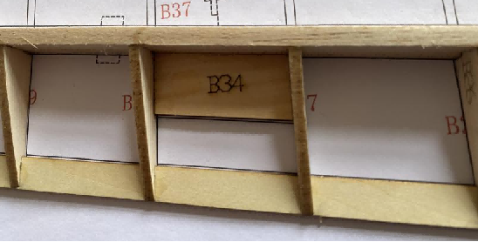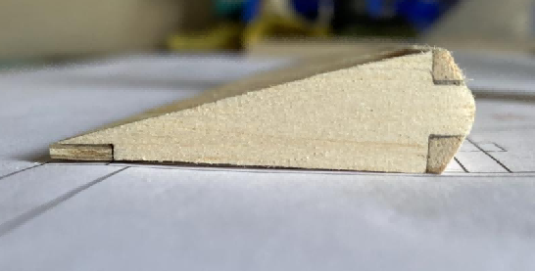
75-78 Connect the movable surfaces with paper hinges and complete the assembly of all components.
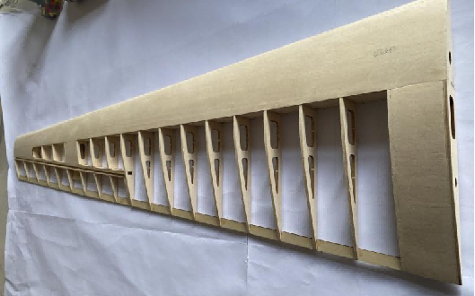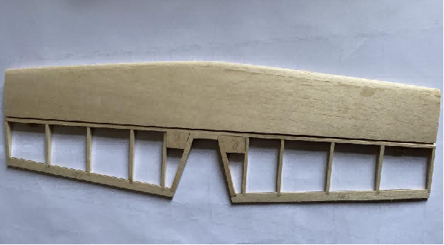
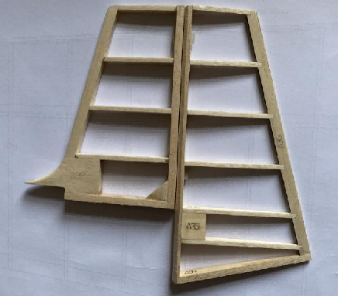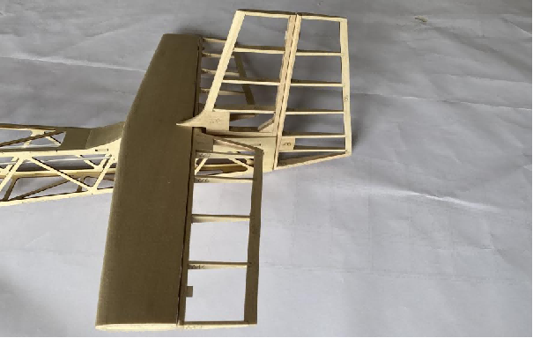

3 Structural views
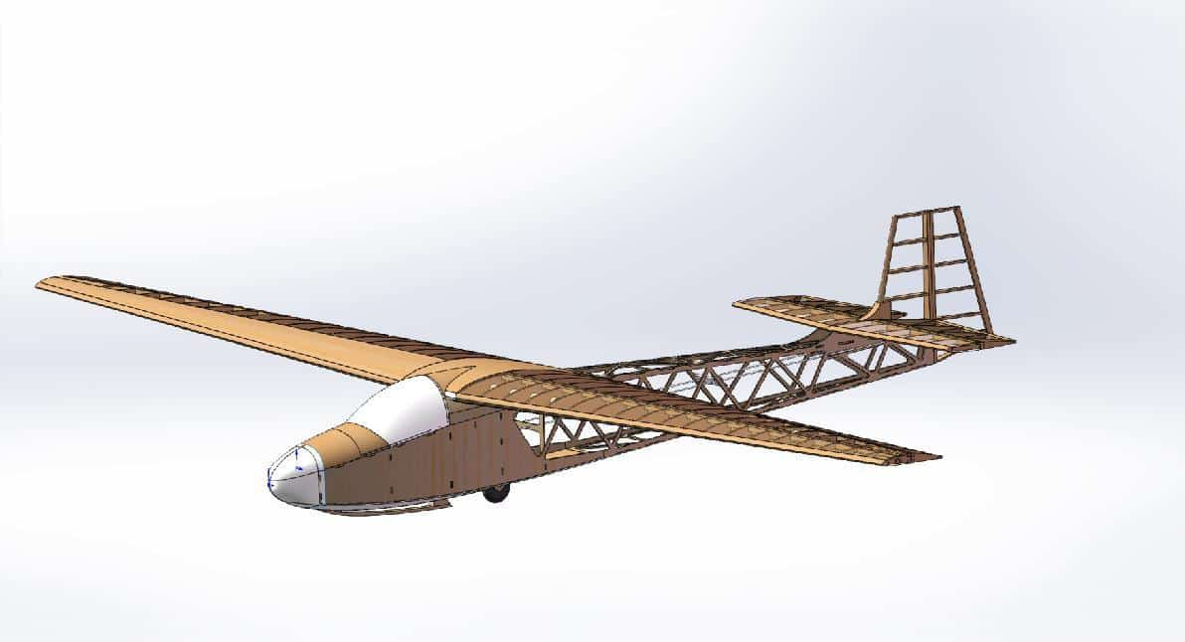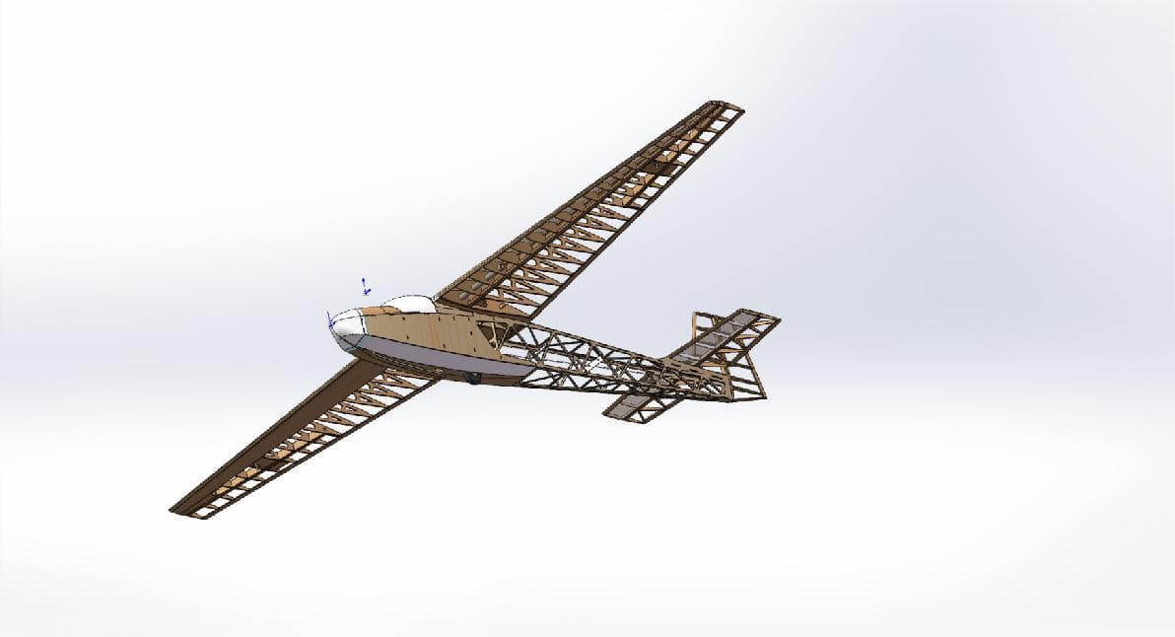

4 FINISHED
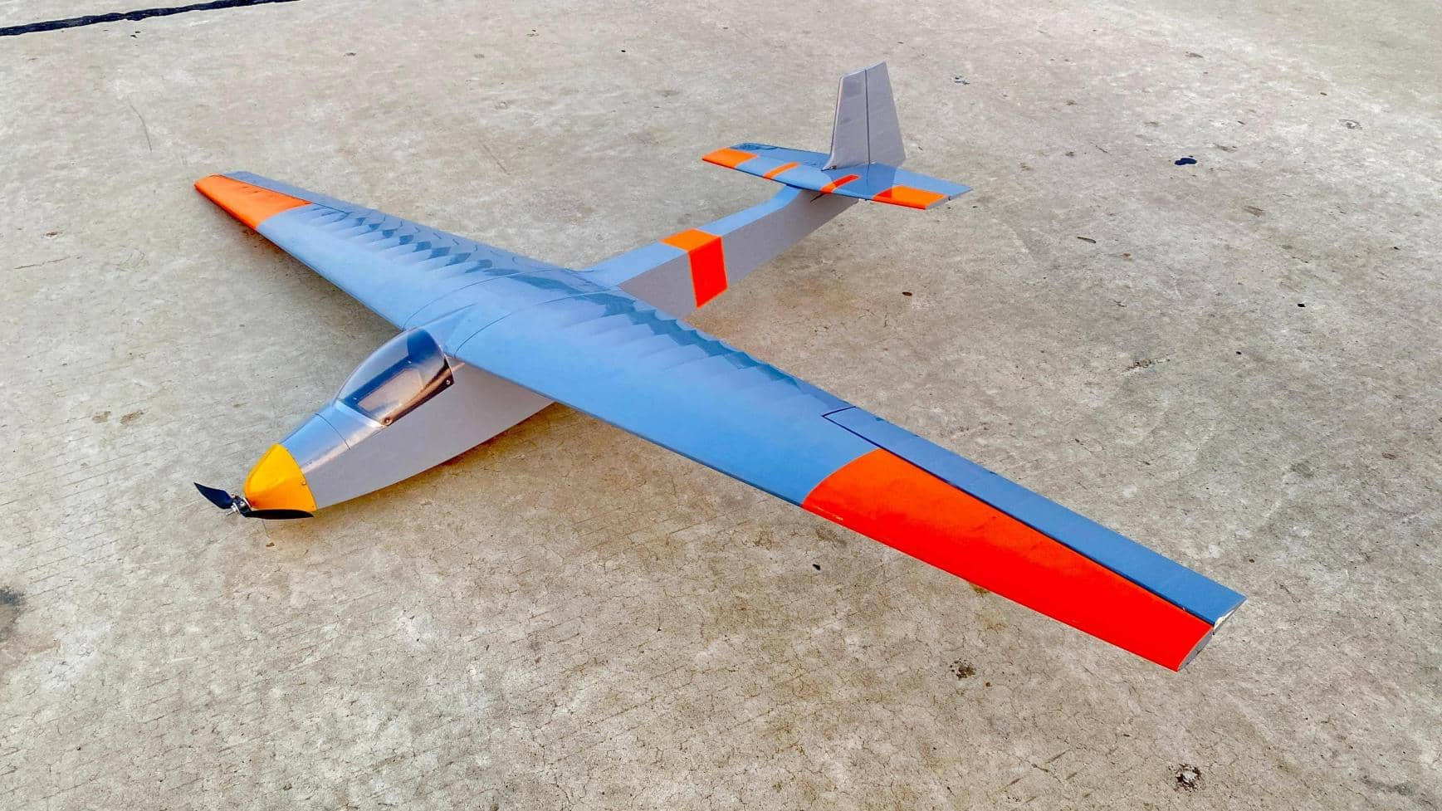


Address：No.30, 4th Rd. Linji Community Yingzhong Town Zhongxiang 431900 CN.
Sales: sales@valueplanes.com
Tech: tech@valueplanes.com
Tel:0086 18608628766 158 7294 1801

