Grunau Baby – 1200mm
PRECISION LASER CUT KIT
Building instruction

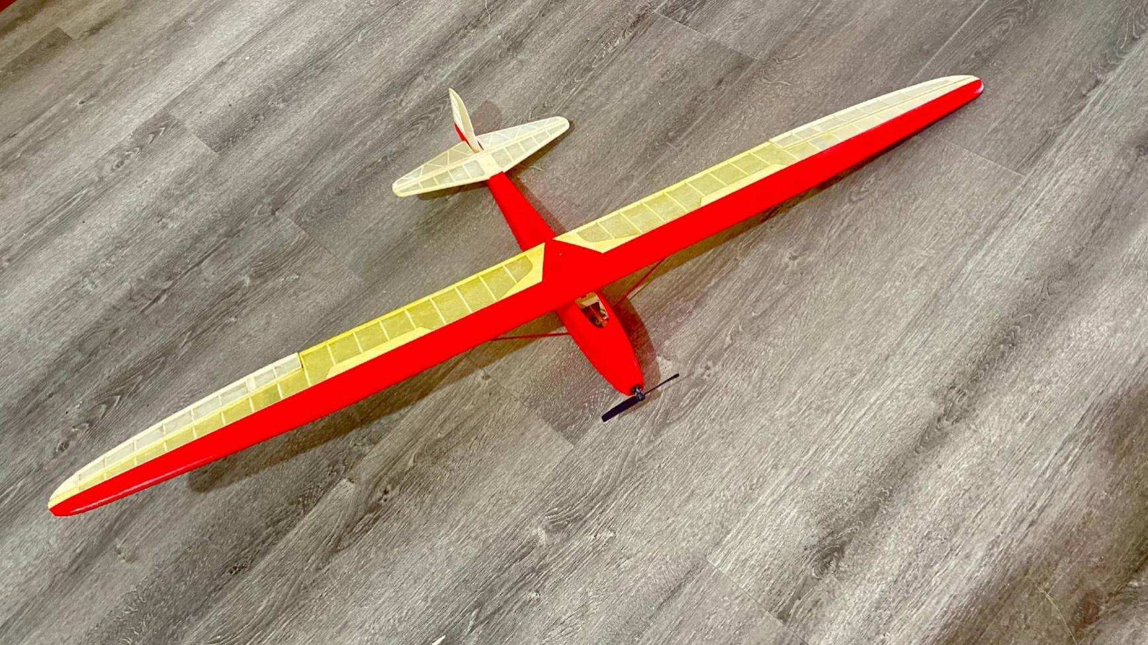

introduction

Product list & kit features

General Information

Building Instructions

- Fuselage
- Wing
- Tail

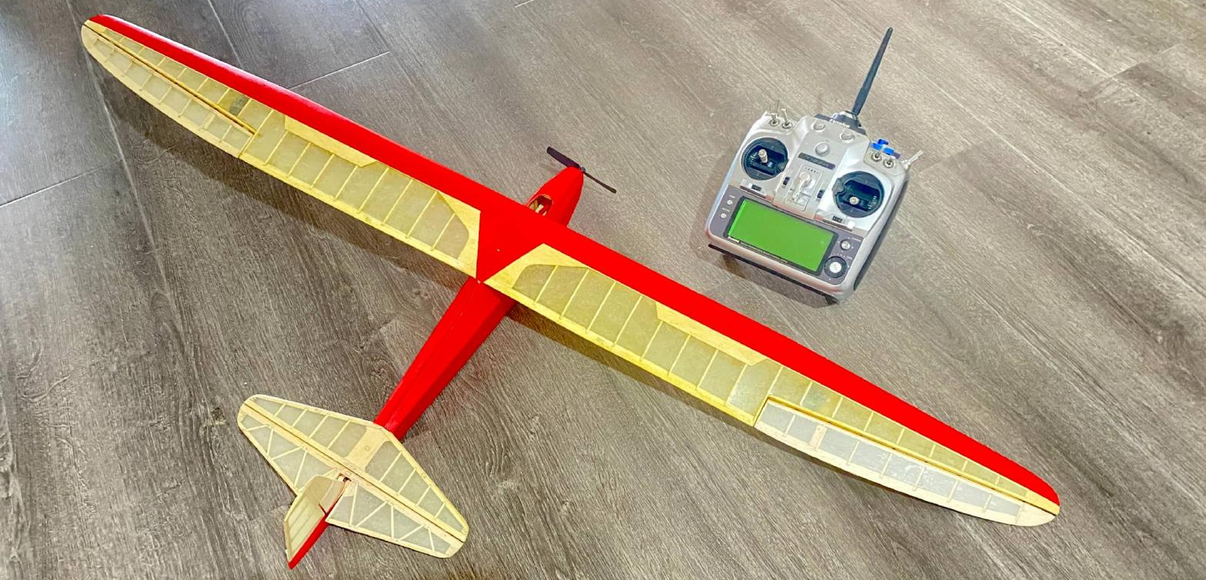

Specifications:
Wingspan 1200mm (47.2”)
Length 550mm (21.6”)
Flying Weight ~ 210g (7.4oz)
Motor MC1106 3800-4000kv
ESC 5A
Servos 3.7g × 4
Batteries 2S, 450mAh
Prop 4”
introduction

The Schneider Grunau Baby was a single seat sailplane first built in Germany in 1931.
Around 6,000 examples constructed in some 20 countries. It was relatively easy to build from plans, it flew well, and the aircraft was strong enough to handle mild aerobatics and the occasional hard landing.
It was designed by Edmund Schneider with the assistance of Wolf Hirth and Hugo Kromer as a smaller version of Schneider's ESG 31 of the previous year, incorporating an elliptical wing design based on work done by Akaflieg Darmstadt.
It was named after Grunau, the town where Schneider's factory was located, now Jeżów Sudecki in Poland.
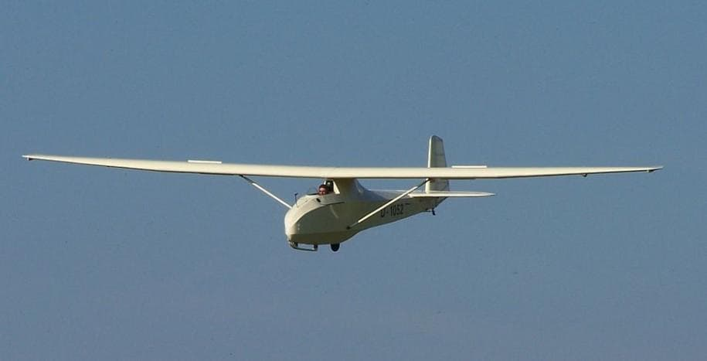
Contents
1x Balsa sheets pack 1:1 Building plan
1x Batten sets 1x Building instructions
1x Accessories bag 1x PVC windshield
Steel pushrods with PVC tube
KIT FEATURES
- The design is based on the Schneider Grunau Baby.
- Extremely lightweight, state-of-the-art design and all wood construction.
- Ultra light flying weight ensures high gliding performance.
- Full scale simulation metal parts.
- Extensive clear plan and full page colour instructions with many photos.
- Only adhesives and coverings are required to complete the airframe.

GENERAL INFORMATION
Be sure to read the safety instructions carefully before operating your model.
• Always follow the procedures and settings recommended in the instructions.
• If you are flying a remote controlled model aircraft for the first time, we recommend that you ask an experienced model pilot for help.
• Remote controlled models are not toys in the usual sense and should only be used and operated by young people under 14 years of age under the strict supervision of an adult.
• The construction and operation requires technical understanding, careful craftsmanship and safety conscious behavior.
• Mistakes or negligence during construction or flying can result in considerable damage to property or personal injury.
• Since the manufacturer and seller have no influence on the proper construction/assembly and operation of the models, these risks are expressly pointed out and the manufacturer and seller cannot be held liable.
• Propellers on aircraft and all moving parts in general pose a constant risk of injury. Avoid touching such parts at all costs.
• Note that motors and controllers can reach high temperatures during operation. Avoid touching such parts at all costs.
• Never stay in the danger area of rotating parts with electric motors with connected drive battery.
• Overcharging or incorrect charging of LiPo batteries can cause the batteries to catch fire or even explode. Make sure the polarity is correct before connecting the battery
• Protect your equipment and models from dust, dirt and moisture. Do not expose the equipment to excessive heat, cold or vibration.
• Always check your equipment for damage and replace defects with original spare parts.
• Do not use equipment that has been damaged or has got wet, even if it is dry again!
• Do not make any changes to the remote control parts which are not described in these instructions.
• Before the first flight, check the wing symmetry, tail unit and fuselage. All parts of the model should have the same spacing from the left and right wing or tail plane to the centre of the fuselage or the same angle.
Check for the correct direction and free movement of all the control surfaces.

Attention, danger of injury!
• Always keep a safe distance from your model aircraft.
• Never fly over spectators, other pilots or yourself.
• Always perform flight figures in a direction away from the pilot or spectators.
• Never endanger people, animals, vehicles or buildings.
• Never fly near power lines or residential areas.
• Do not operate your model near locks or public shipping.
• Do not operate your model on public roads, motorways, paths and squares, etc., but only in approved locations.
• Do not operate the model in thunderstorms.
• Before each flight, check your remote control system for sufficient function and range.
• After flying, remove all batteries from the model.
Do not “aim” the transmitter antenna at the model during operation. In this direction, the transmitter has the lowest radiation. The best position of the antenna is to the side of the model.

Building instruction
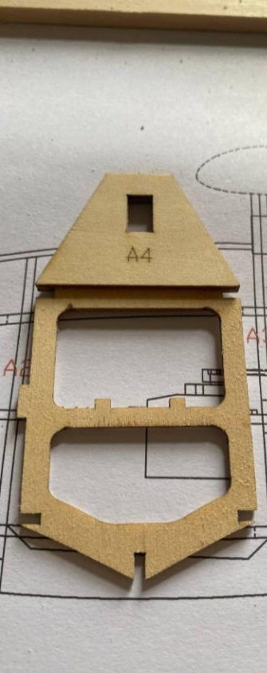
Fuselage

Glue the strengthening piece A4 to the Former A3 as per the photo below.

Glue the formers to the bottom keel in their designated positions according to the drawing
Ensure the side of the formers with laser engraved numbers faces forward and are square to the keel.
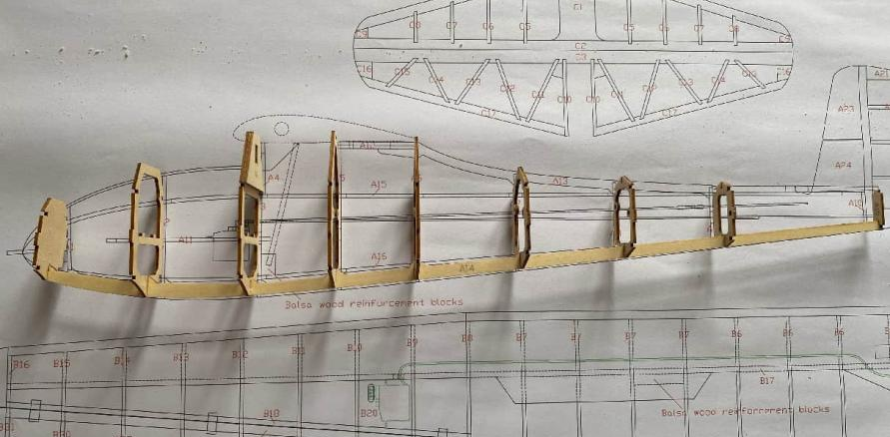

Glue the side longerons to the formers
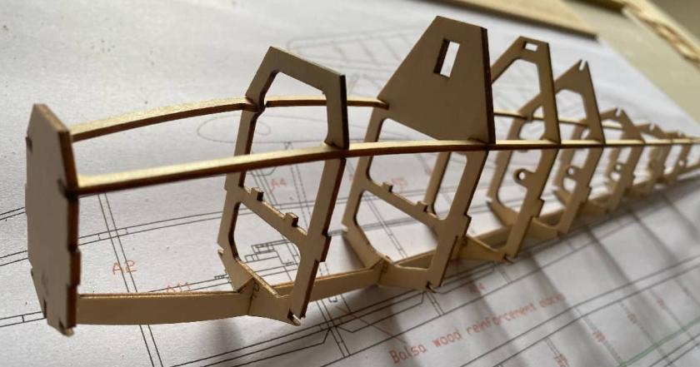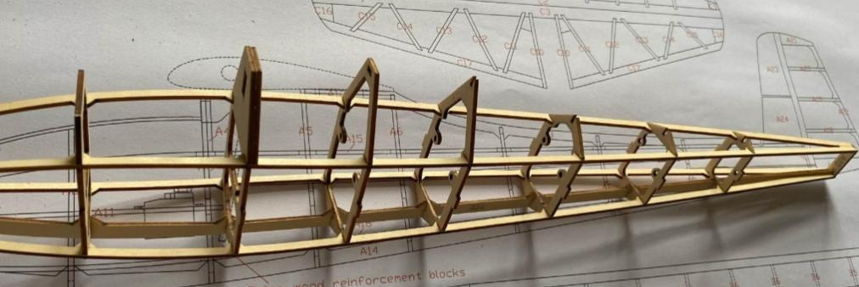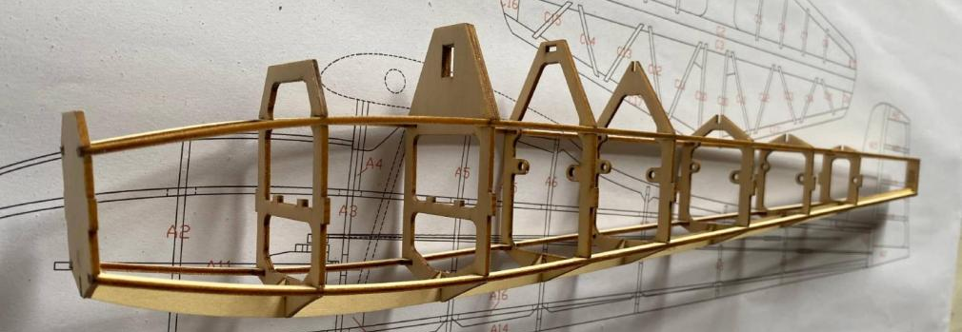

Glue the top keel in place.
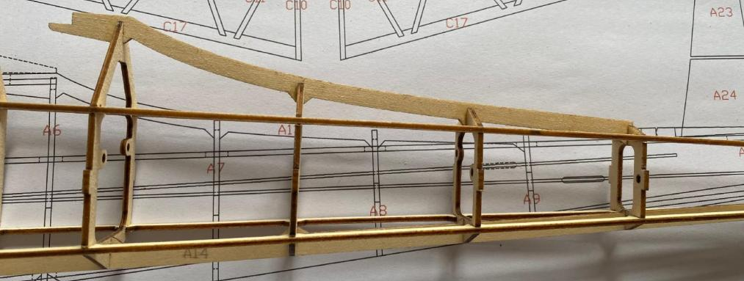

Install the claw/T nut/blind nut on the bottom of A12
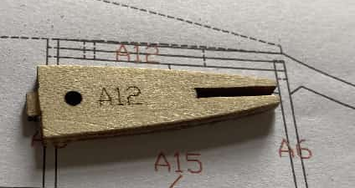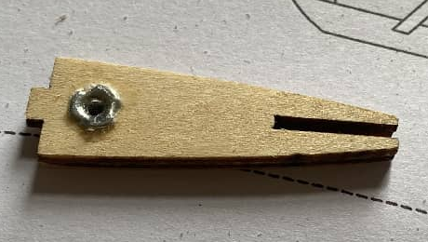

Attach A12 to the fuselage as per the photo below.
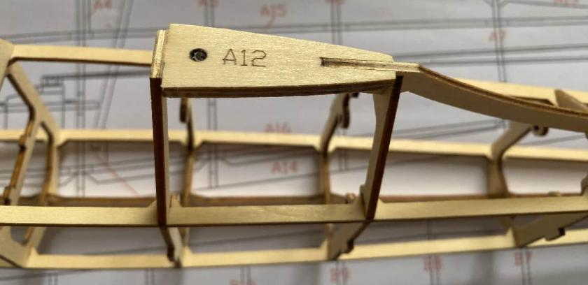
Sand both sides of A12 to match formers as per photo below.
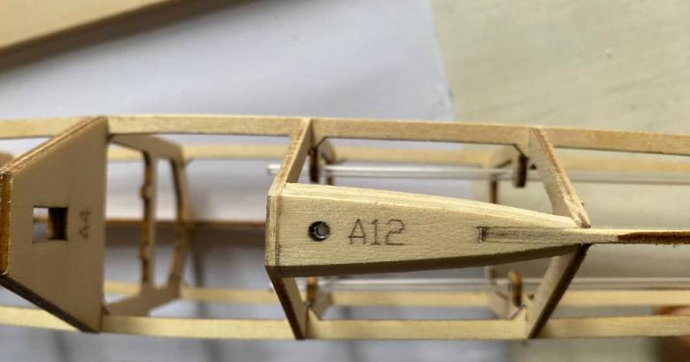

Glue the PVC tubes for elevator and rudder pushrods inside the frame as per the photo below.
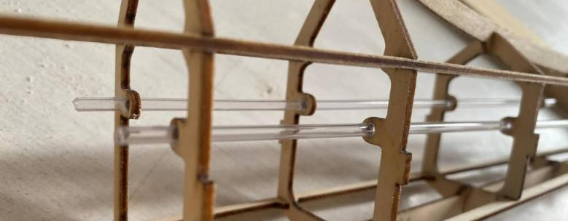
Reinforce A3 with balsa wood. This reinforcement will secure the struts.
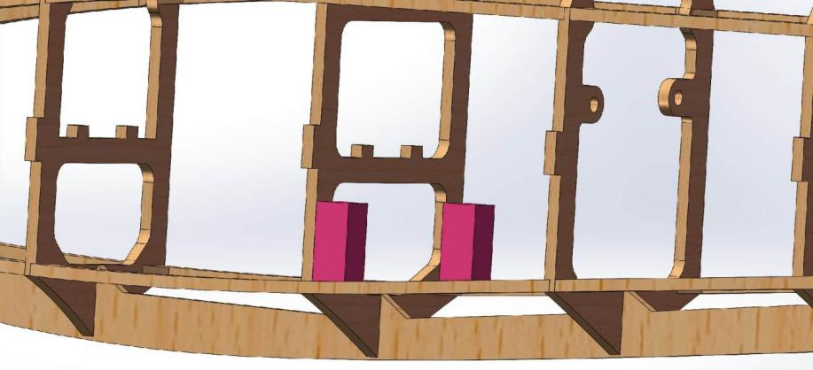

Glue the fuselage sides, carefully distinguishing between left and right.
Check the tube exits at the rear for the correct orientation.
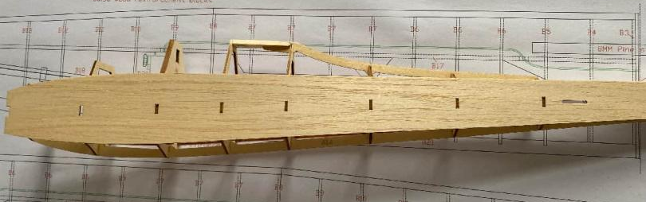

Glue the sheeting on the top and the bottom of the fuselage as per the photos below
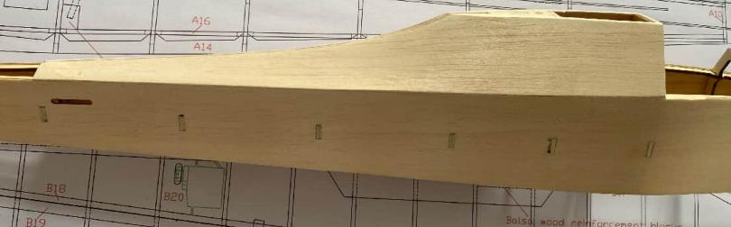
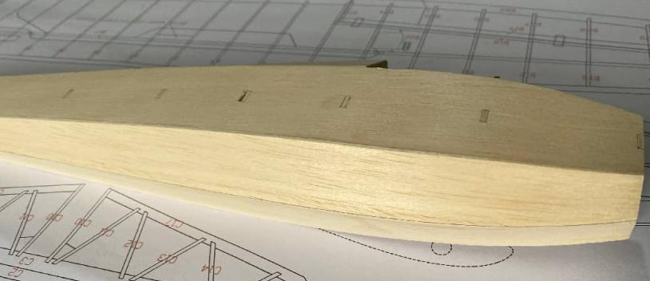
Sand flush to fuselage sides as per above photo.
Glue the 2 halves of the motor mount together. Secure the motor to the motor bulkhead
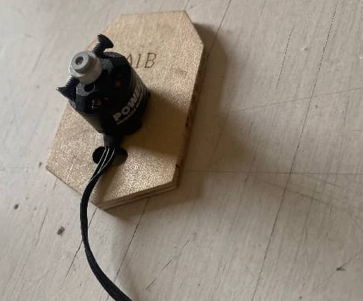
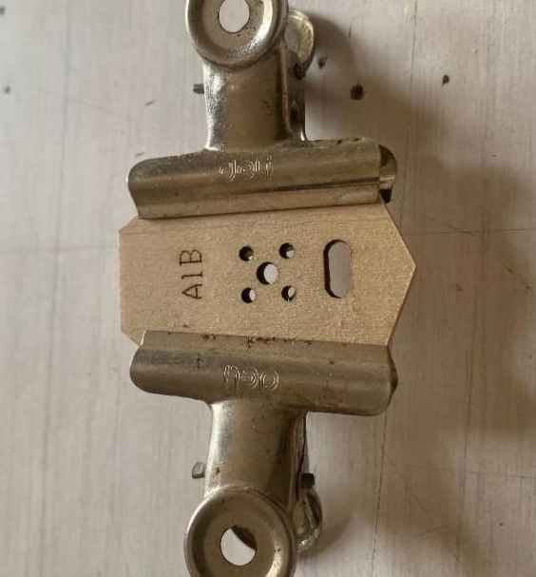

Glue the motor bulkhead to the fuselage.
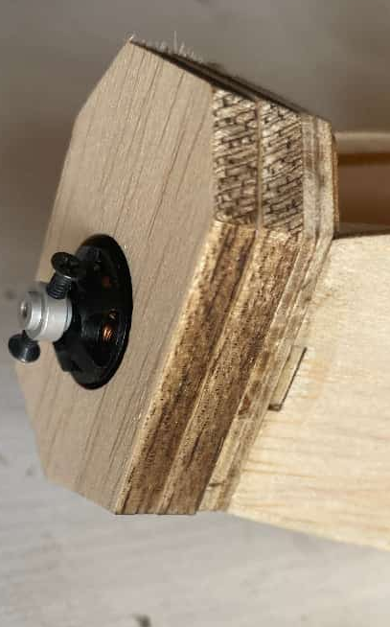
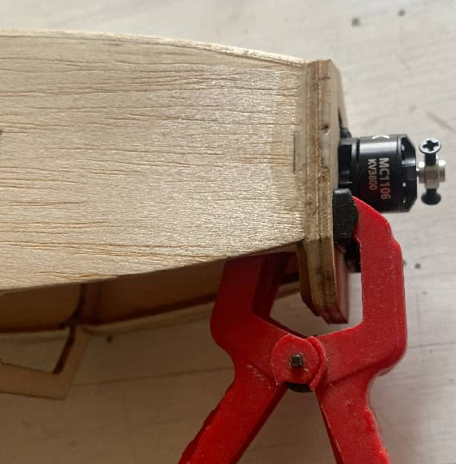
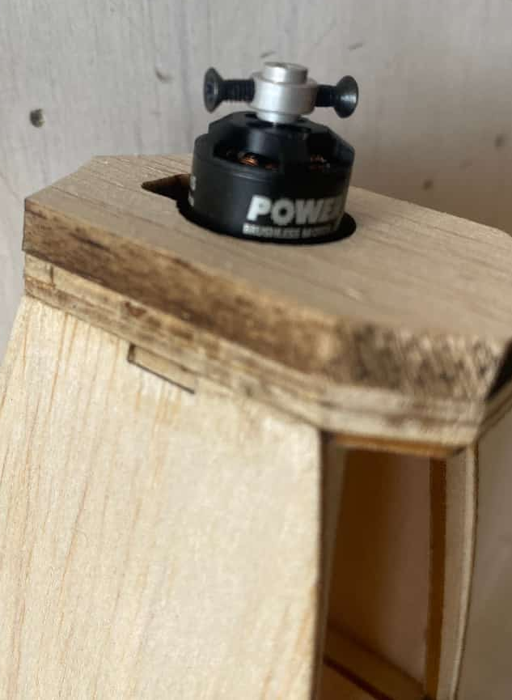
Glue parts A1C and A1D together to form the nose.

Install the servos into A11.
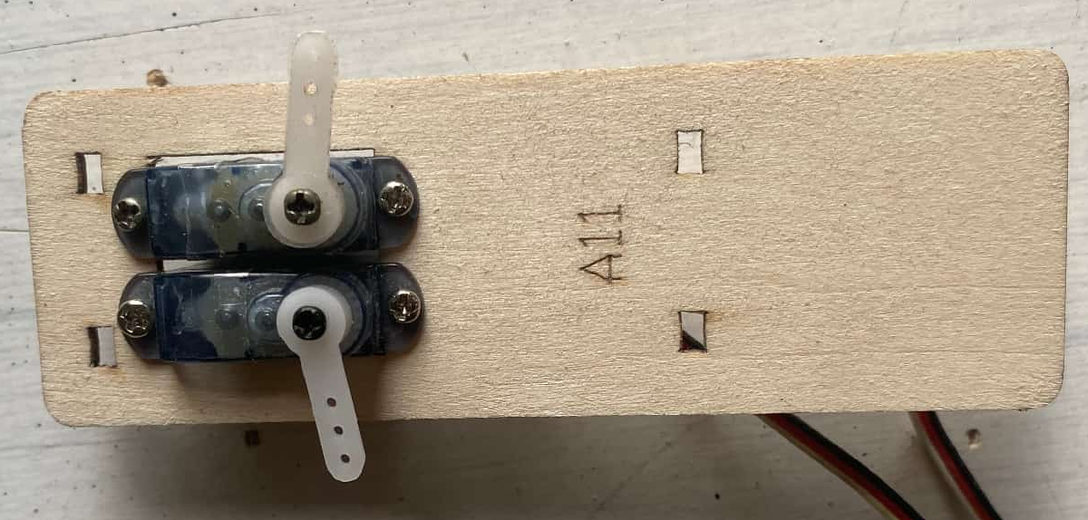

Before installing A11 into the fuselage, install the receiver and ESC into the fuselage bottom.
Test the direction of the motor and modify if necessary.
Set the servos in the neutral position and connect to the music wire pushrods in the clear plastic tubes as per the photo below.
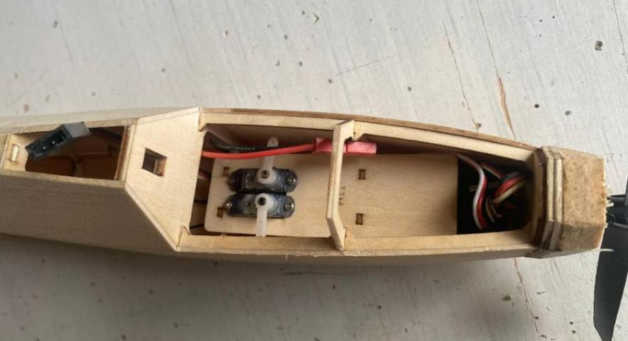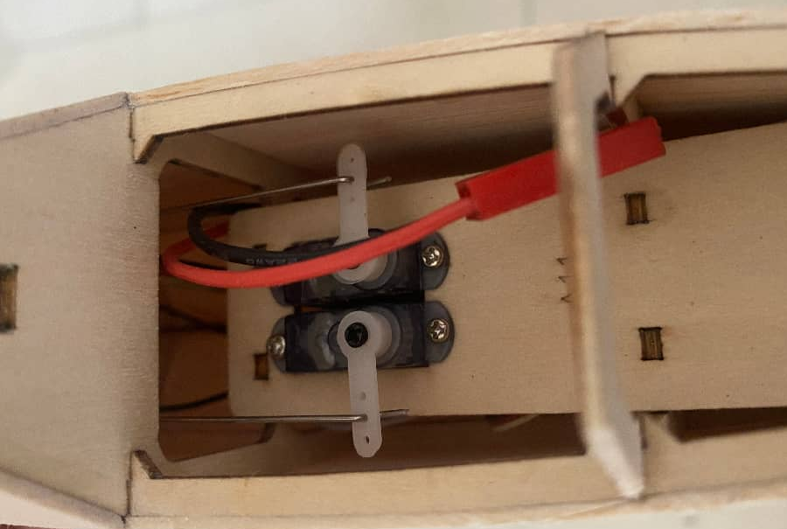

Glue balsa sheet to the sides and top of the nose.
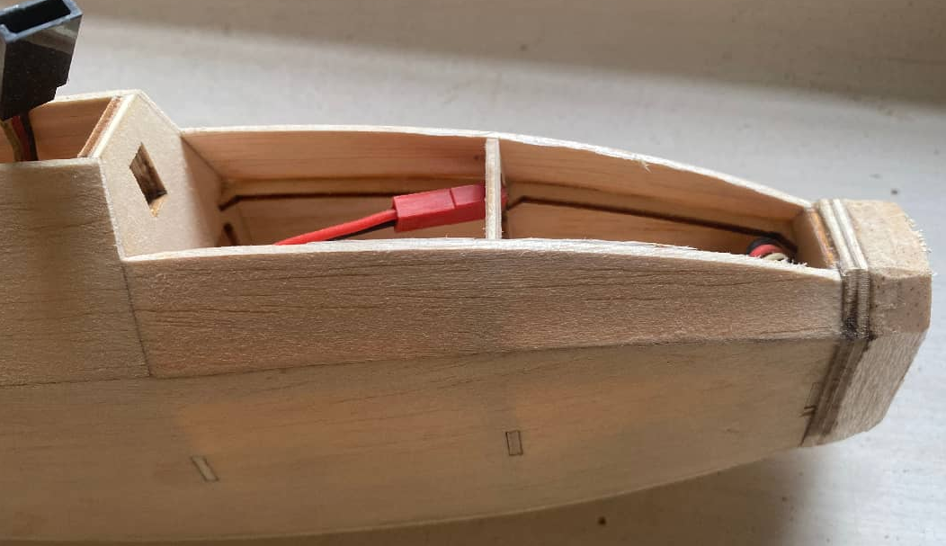

Then cut and sand to shape as per photo below.
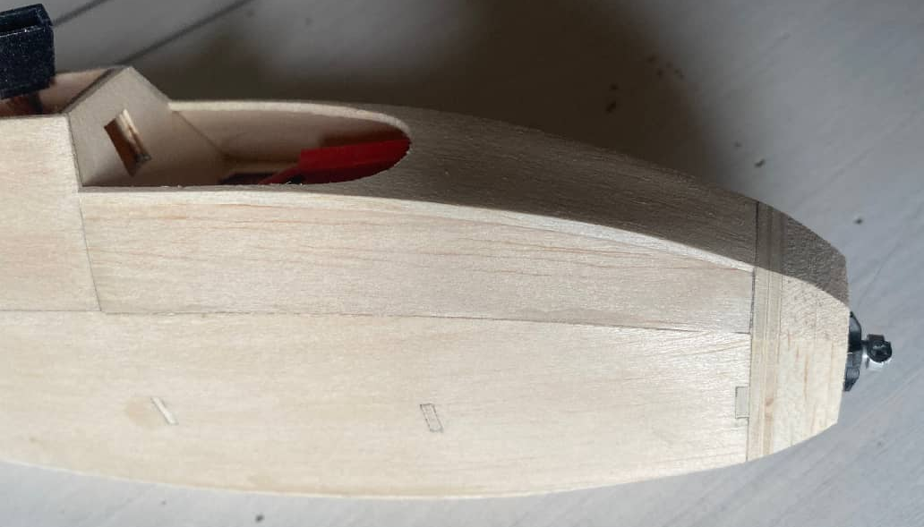

Bond two A24 balsa pieces together and sand as per photo below.
Then attach to the fuselage. Ensure they remain vertical relative to the fuselage.
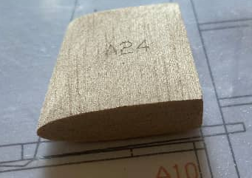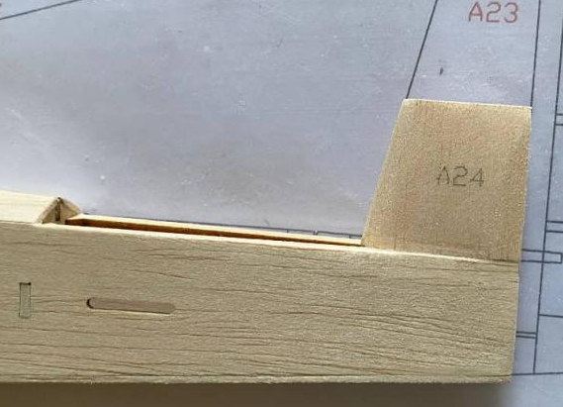

WINGS Assembly
Assemble the wings by aligning the rib numbers, then glue on the trailing edge.
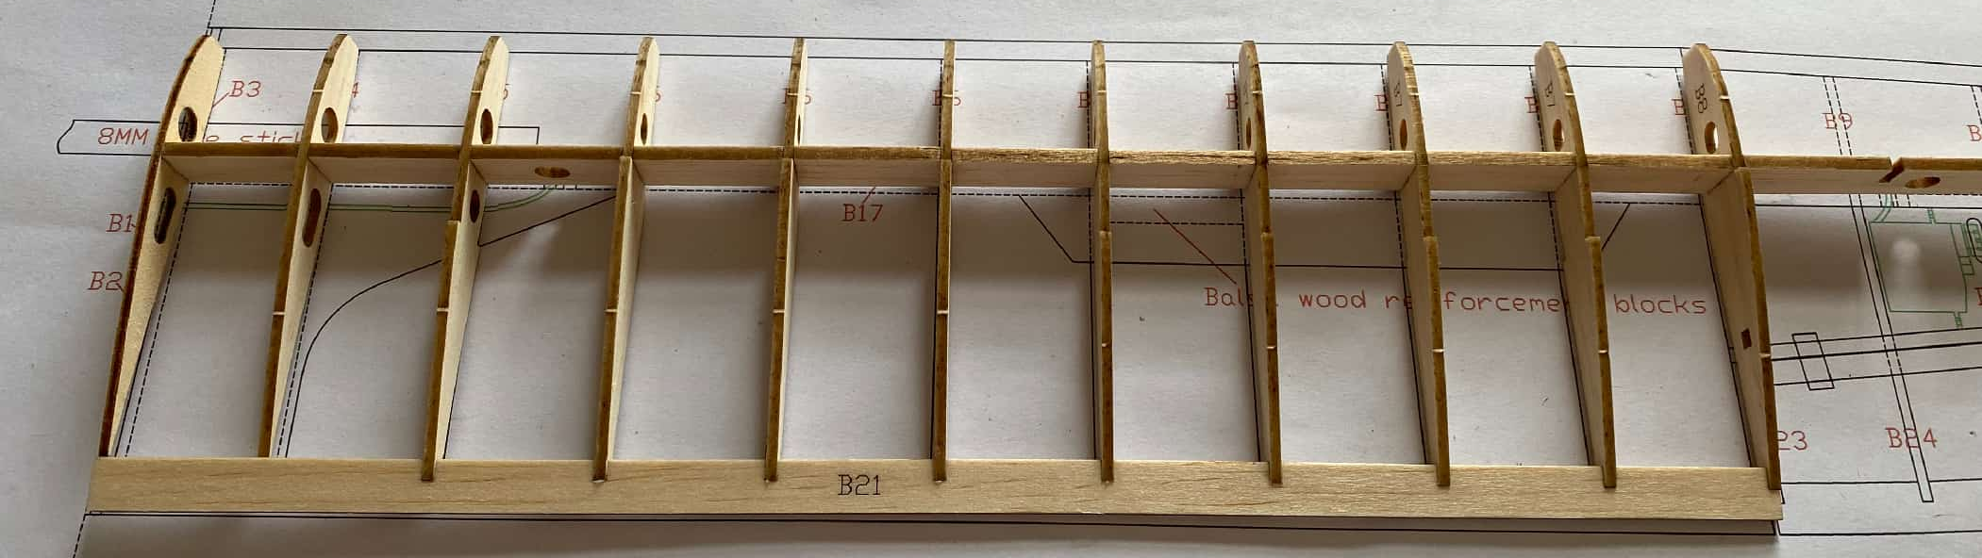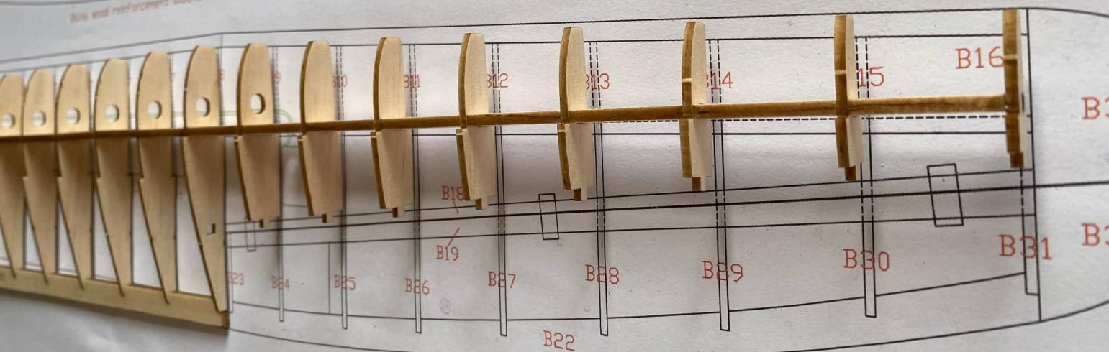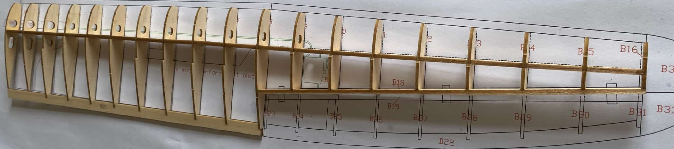

Glue on the leading edge sheeting on the top of the wing (photo shows the wing upside down).
Install the aileron servo extension wire.
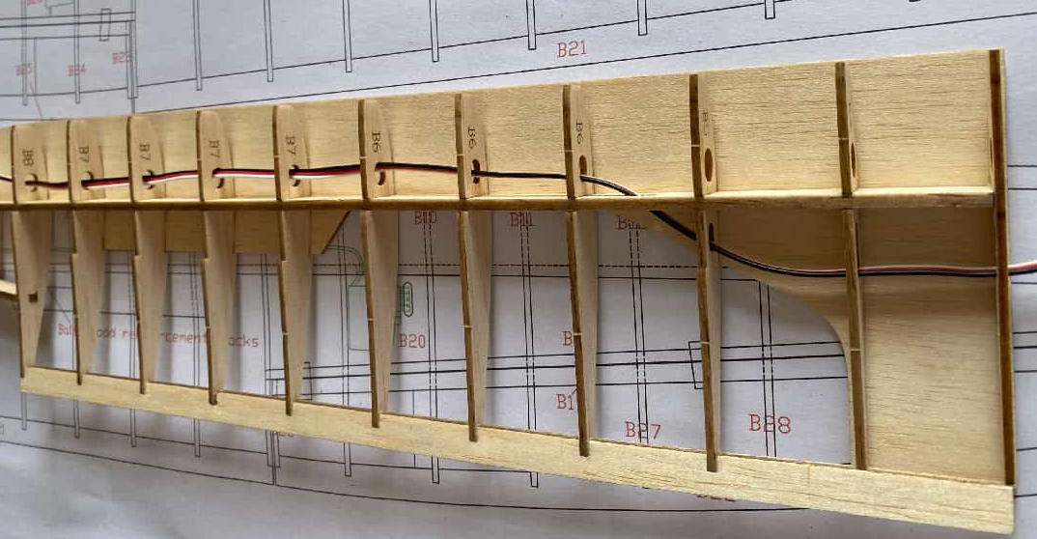
Please note that the red section is a balsa reinforcement piece used for fixing the wing struts.
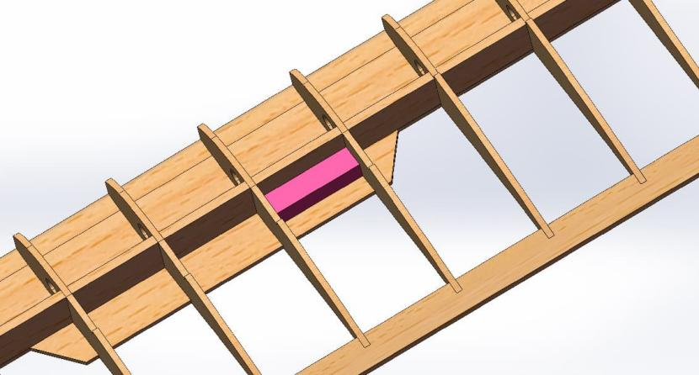
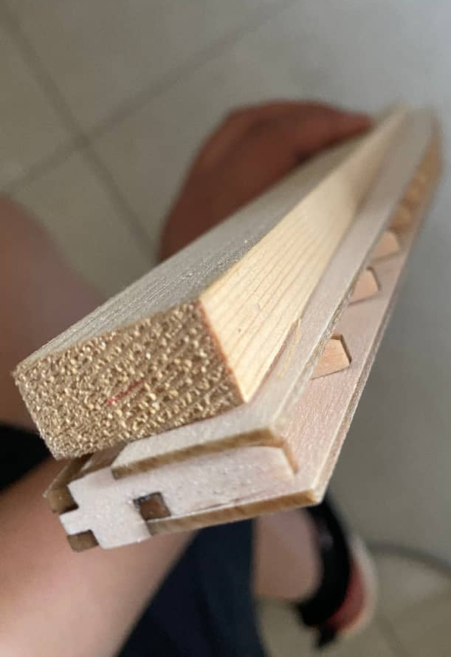
Glue on the lower wing skin, using a straight object (such as a straight pine stick) as a guide to ensure the upper wing surface remains flat during gluing.

Glue the leading edge and wing tips to the wings.
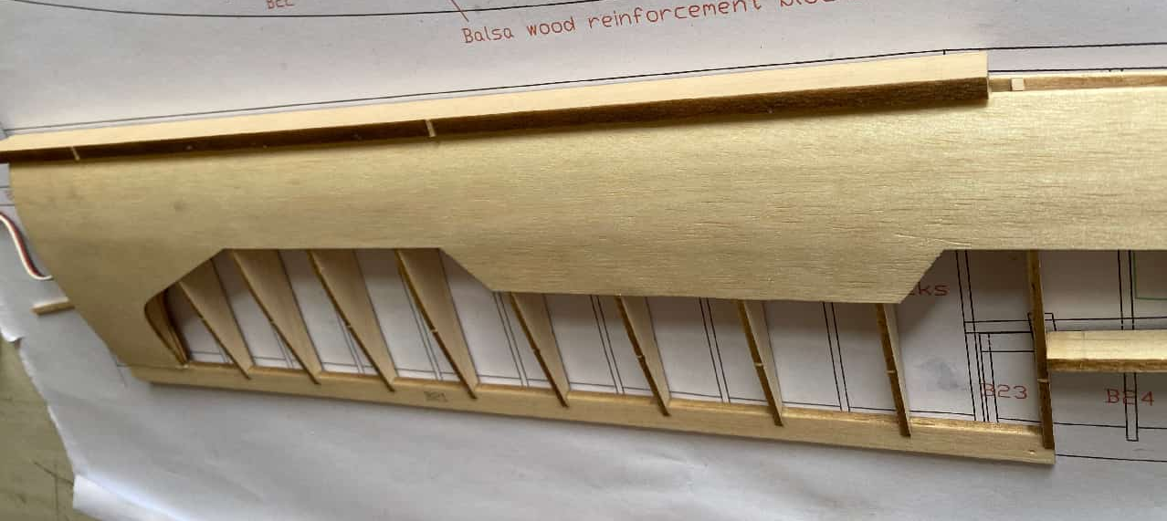

Sand to shape as per the photo below
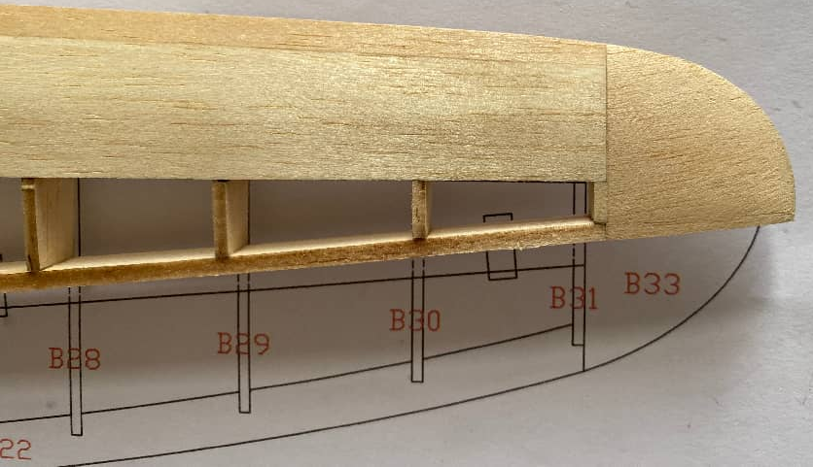

Sand the wing trailing edge, using paper tape to protect the ribs from over sanding.
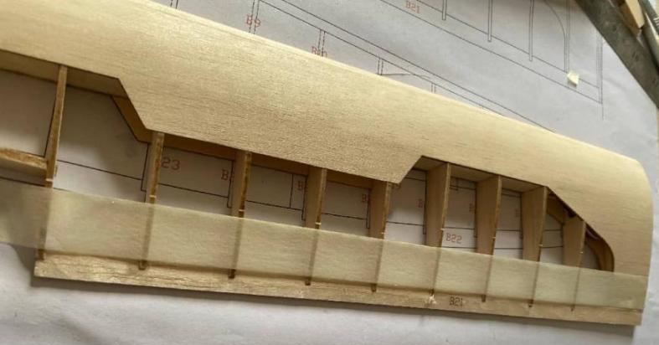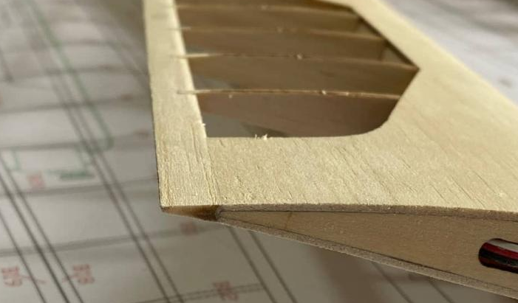

Glue in the aileron servo mount.
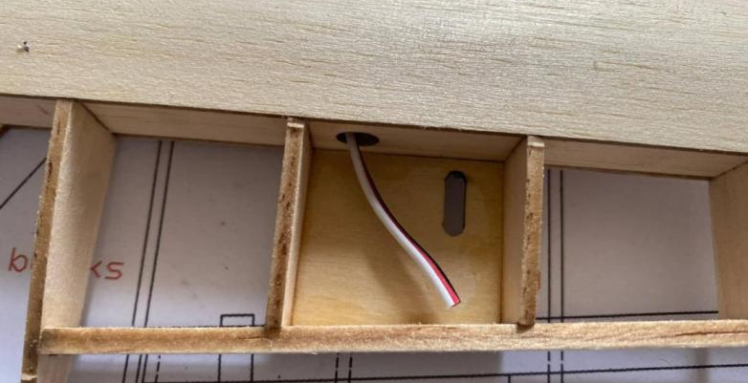

Glue the central wing stiffening/joining plate. Route the servo wires through it, and glue the plate to one half of the wing.
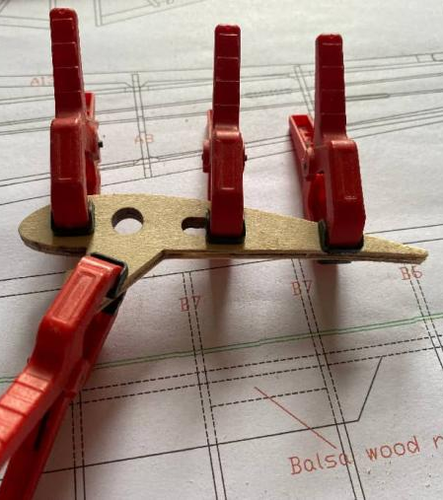
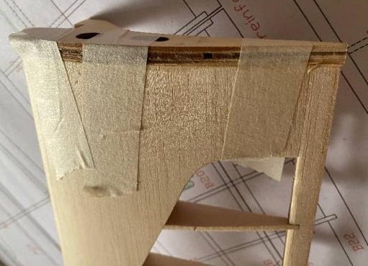
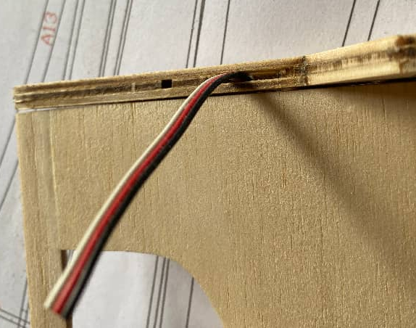

Route both of the aileron servo wires through the central stiffening plate.
Then glue the 2 wing halves together ensuring they are perfectly aligned.
Please note the small hole in the wing joiner this is for the wing fixing screw.
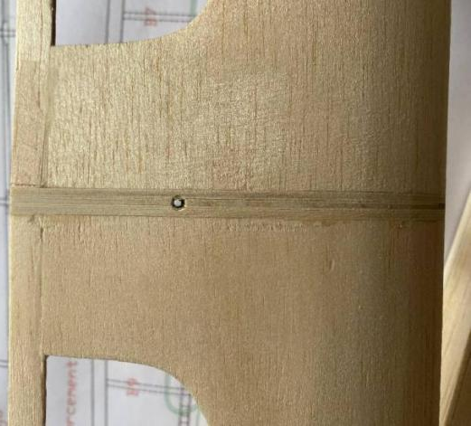
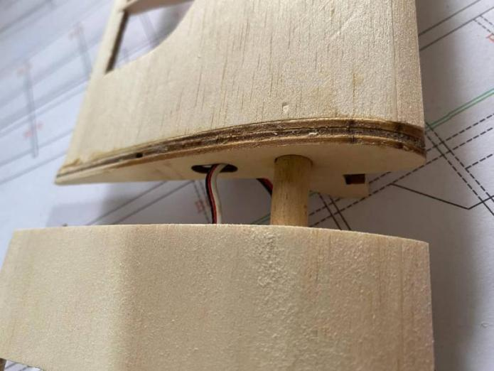

Glue the aileron components according to part numbers. Reinforce the B25 rib with a balsa strip.

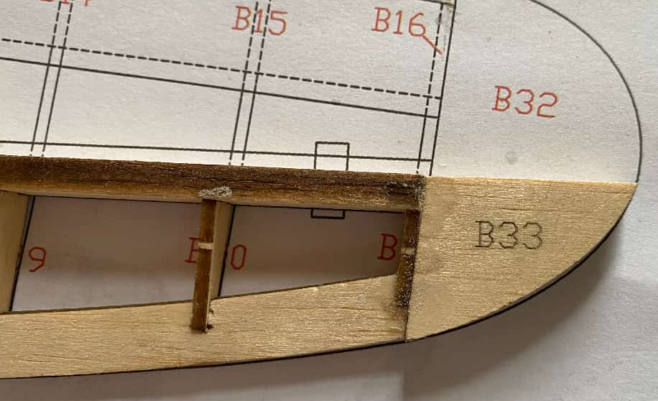
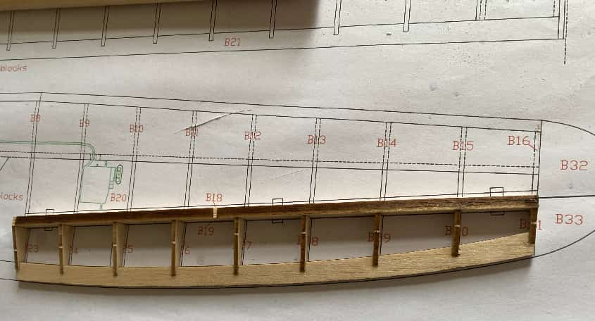
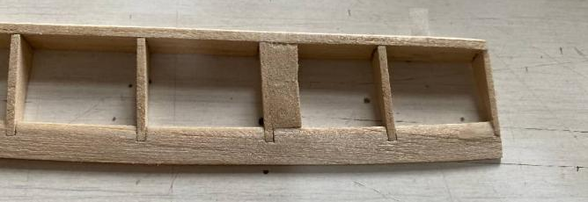

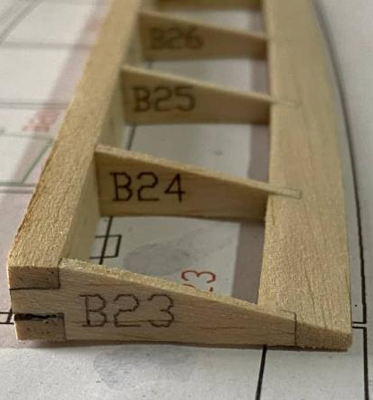
Sand the aileron trailing edges and shape and the leading edges into a V-profile as per photos below.
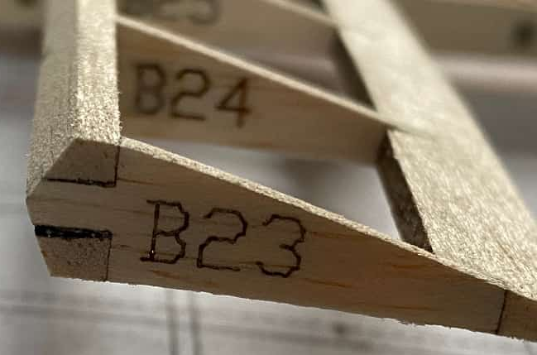

Tail assembly
Glue the horizontal stabilizer according to part numbers, and sand the leading edges.
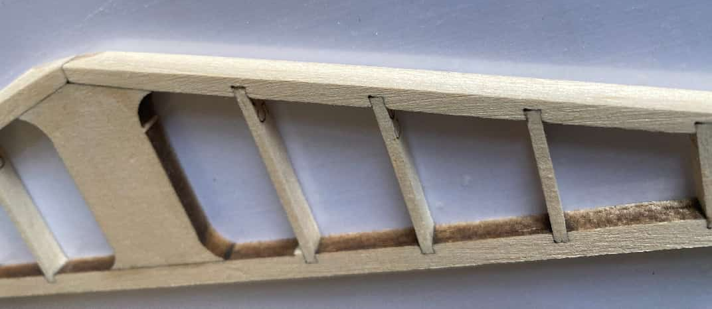
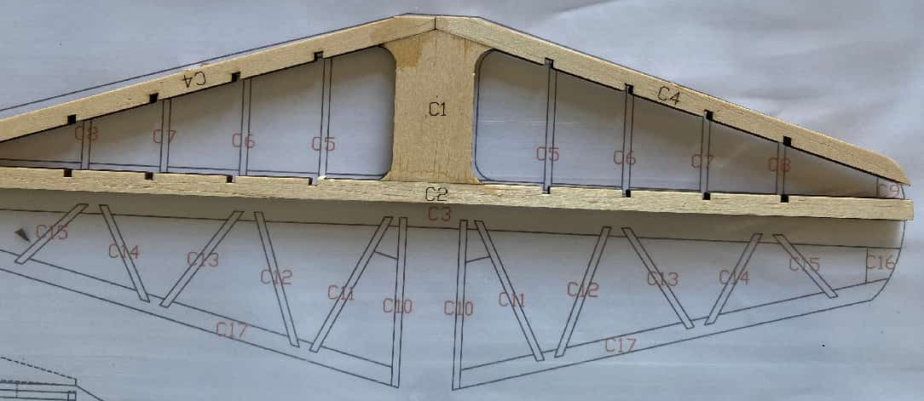

Glue the elevators according to part numbers, shaping the leading edges into a V-profile as per the photos below.
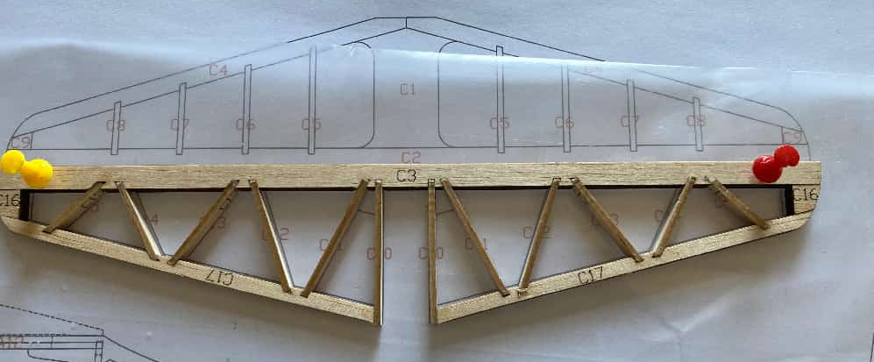
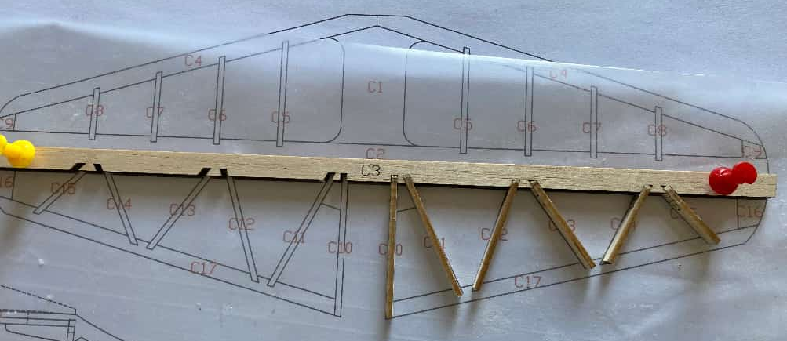

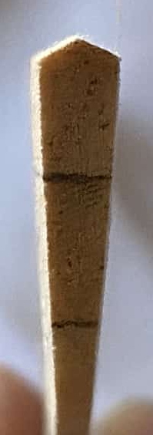

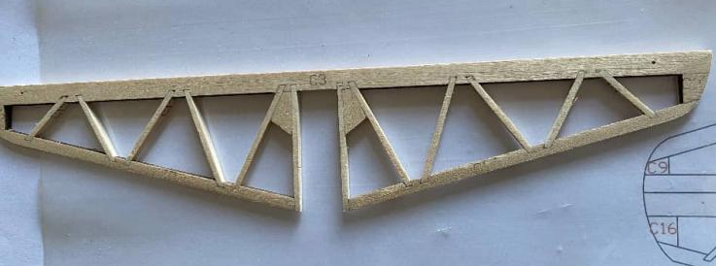

Glue the rudder according to part numbers, shaping the leading edges into a V-profile as per the photos below.

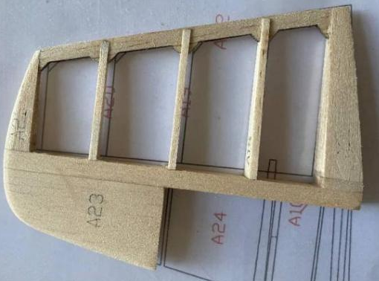
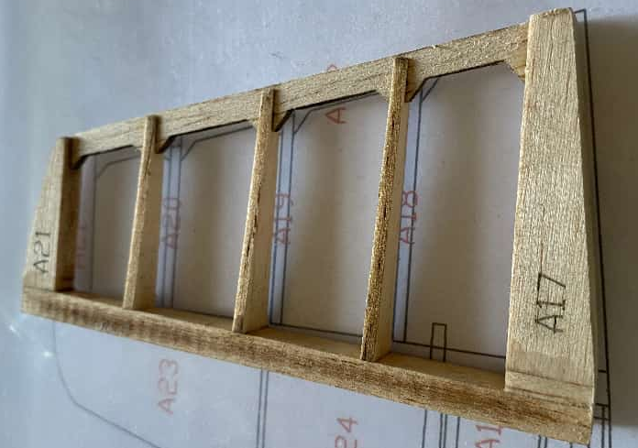
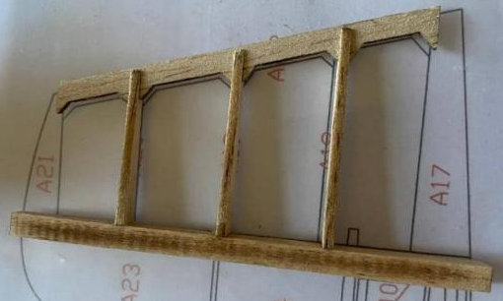
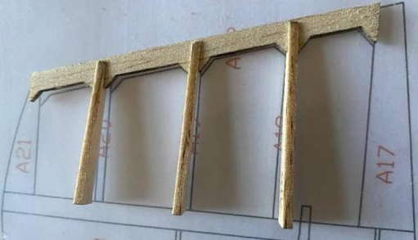
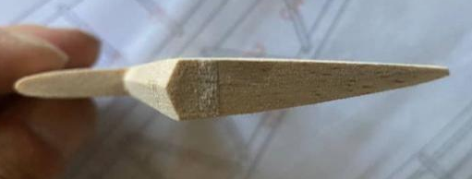

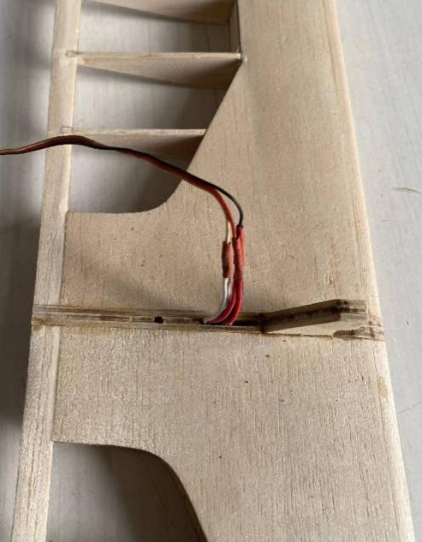
Centralise the aileronservos and secure them to the aileron servo mounting plate with UHU glue.
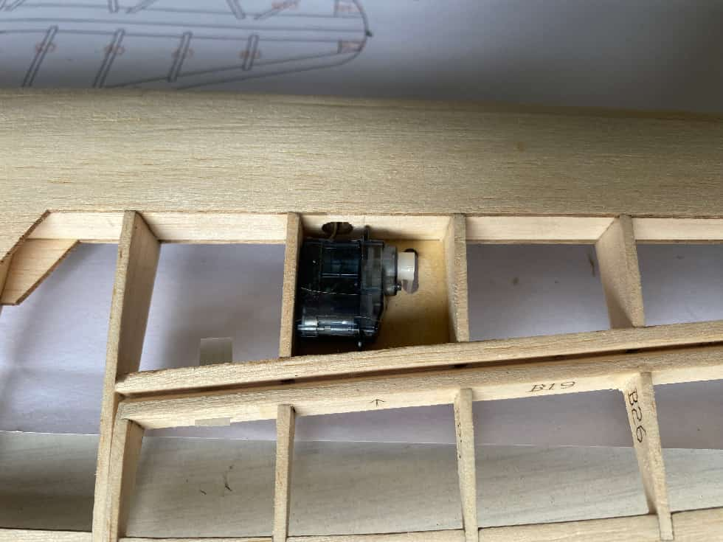
4 assembly

It is easier to cover the model in your choice of covering before installing the moving surfaces for the final time.

Install the aileron and rudder pushrods as per the photos below
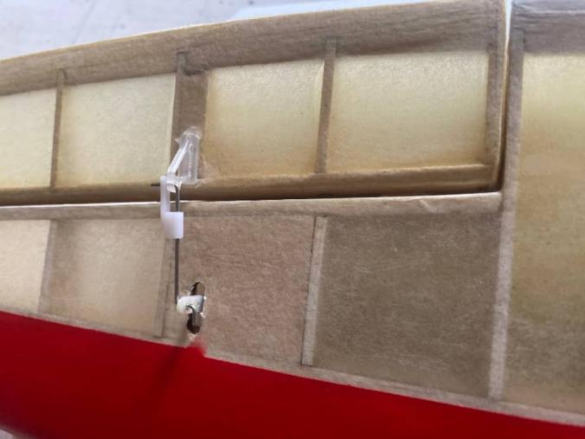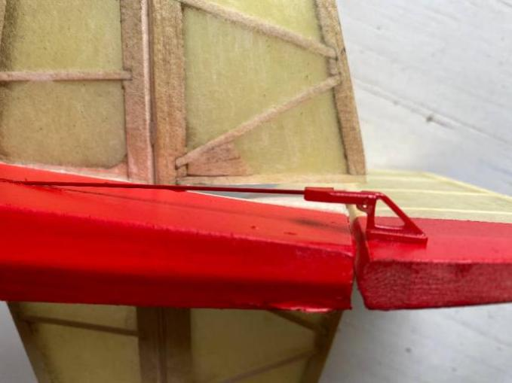

The wing is attached to the fuselage via a bolt as per the photo below
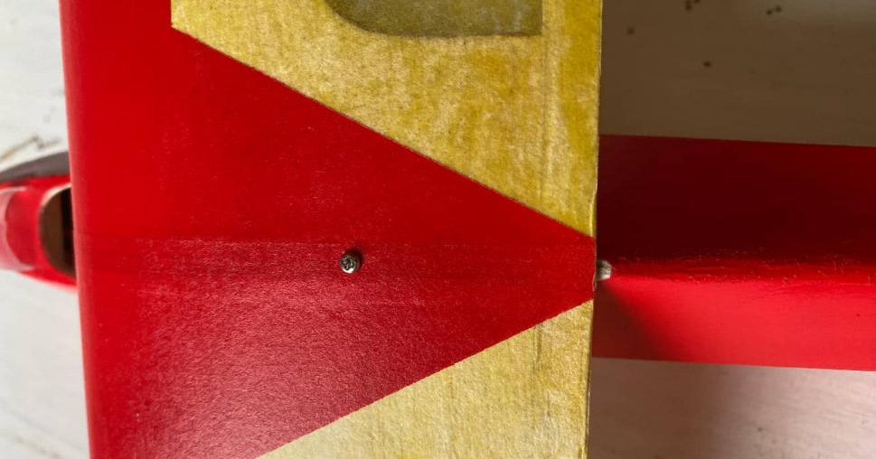

Install the wing struts by inserting wooden dowels into the reinforcement locations on the fuselage and wings, securing them with glue—ensure the wings remain perpendicular to the fuselage.

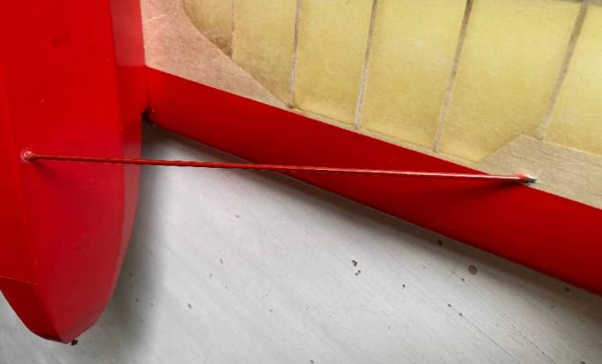

Secure the windscreen with glue as per the photo below.
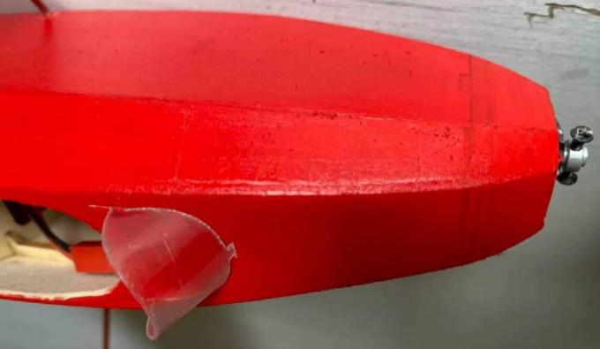

Suggested Control Throws
Elevator Up 10mm, Down 8.5mm
Ailerons Up 12mm, Down 12mm
Rudder Left 20mm, Right 20mm
C of G 36mm from the leading edge of the wing
Structural views
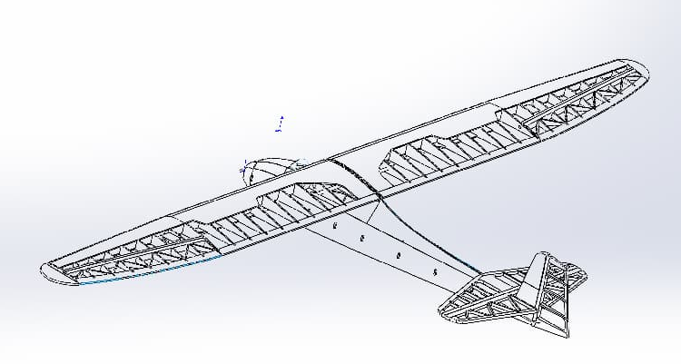
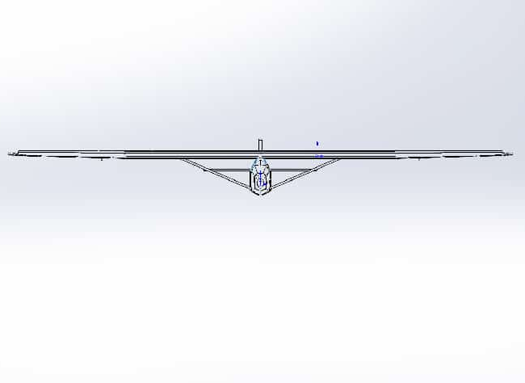
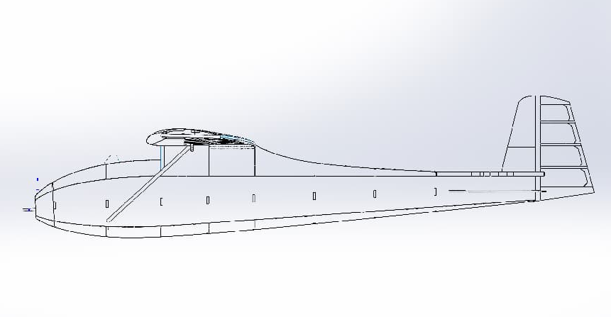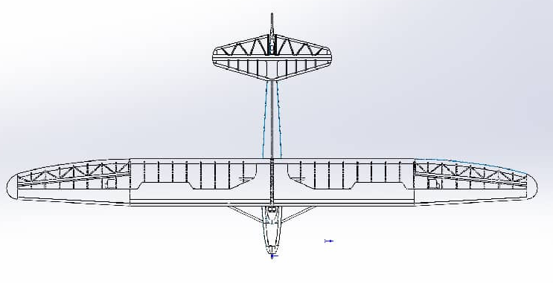
FINISHED
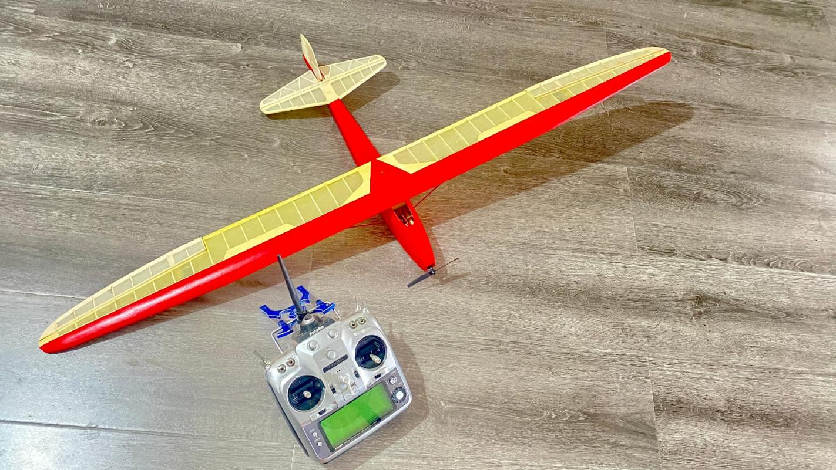


Address：No.30, 4th Rd. Linji Community Yingzhong Town Zhongxiang 431900 CN.
Sales sales@valueplanes.com
Tech tech@valueplanes.com
Website www.valueplanes.com
Tel 0086 18608628766 158 7294 1801

