LIPPISCH G108 KIT
Building instruction
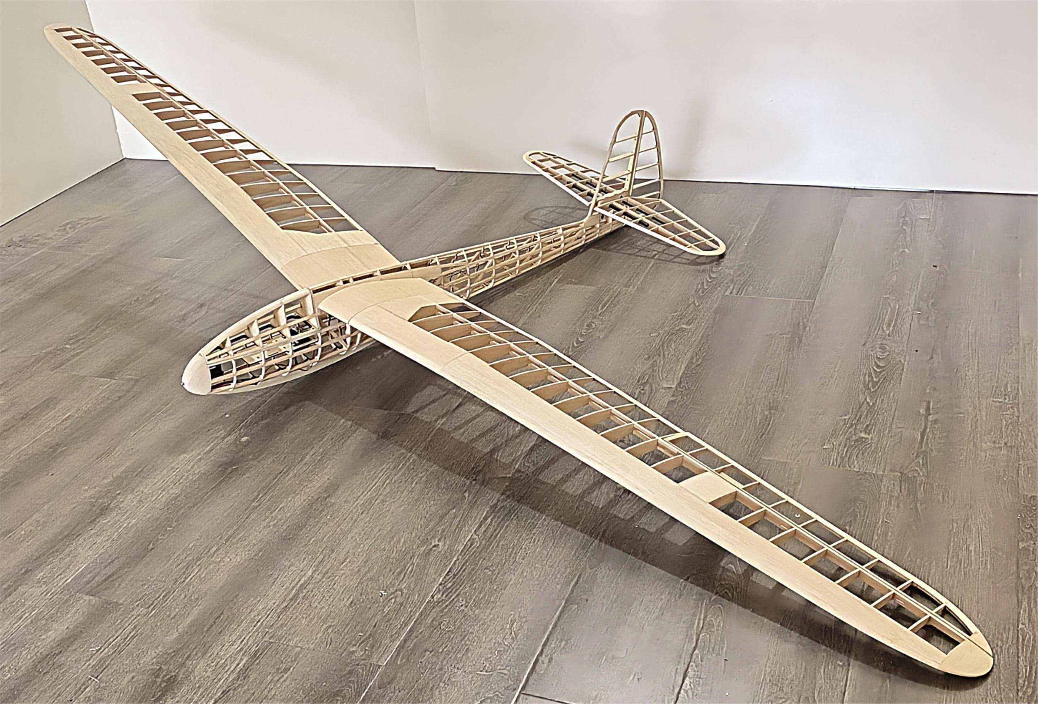

LASER-CUTTING KIT

Specifications:
Wingspan : 2750mm Length : 1400mm
Flywing Weight : 1700g
Suggested: Motor: 2814 1000kv
Prop: 12" ESC: 40A
Batteries: 3S 2200mah
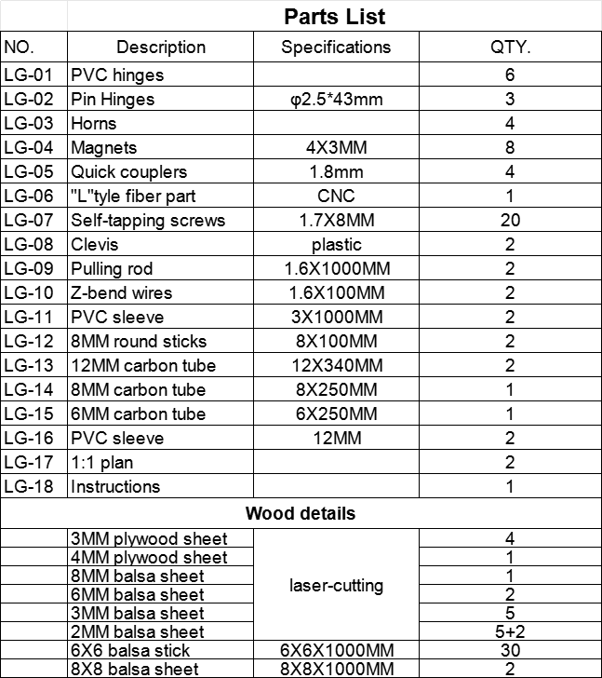
KIT FEATURES
- Extremely lightweight.
- Fast-release wing and movable tailplane.
- Complete hardware pack.
- Extensive clear drawings and full-page colour instructions with hundreds of pictures .
- Only adhesives and coverings are required to complete the airframe.

GERNERAL INFORMATION
Be sure to read the safety instructions carefully before operating your model.
• Always follow the procedures and settings recommended in the instructions.
• If you are using remote-controlled model aircraft, helicopters, cars or ships for the first time, we recommend that you ask an experienced model pilot for help.
• Remote-controlled models are not toys in the usual sense and may only be used and operated by young people under 14 years of age under the supervision of adults.
• Their construction and operation requires technical understanding, careful craftsmanship and safety-conscious behaviour.
• Mistakes or negligence during construction, flying or driving can result in considerable damage to property or personal injury.
• Since the manufacturer and seller have no influence on the proper construction/assembly and operation of the models, these risks are expressly pointed out and any liability is excluded.
• Propellers on aircraft and all moving parts in general pose a constant risk of injury. Avoid touching such parts at all costs.
• Note that motors and controllers can reach high temperatures during operation. Avoid touching such parts at all costs.
• Never stay in the danger area of rotating parts with electric motors with connected drive battery.
• Overcharging or incorrect charging can cause the batteries to explode. Make sure the polarity is correct.
• Protect your equipment and Models from dust, dirt and moisture. Do not expose the equipment to excessive heat, cold or vibration.
• Always check your equipment for damage and replace defects with original spare parts.
• Do not use equipment that has been damaged or got wet due to a fall, even if it is dry again!
• Do not make any changes to the remote control which are not described in these instructions.
•Before the first flight, check the wing symmetry, tail unit and fuselage. All parts of the model should have the same spacing from the left and right wing or tail plane to the centre of the fuselage or the same angle.

Attention, danger of injury!
• Always keep a safe distance from your model aircraft.
• Never fly over spectators, other pilots or yourself.
• Always perform flight figures in a direction away from the pilot or spectators.
• Never endanger people or animals.
• Never fly near power lines or residential areas.
• Do not operate your model near locks or public shipping.
• Do not operate your model on public roads, motorways, paths and squares, etc., but only in approved locations.
• Do not operate the model in thunderstorms.
• Before each flight, check your remote control system for sufficient function and range.
• After flying, remove all batteries from the model.
Do not „aim“ the transmitter antenna at the model during operation. In this direction, the transmitter has the lowest radiation. The best position of the antenna is to the side of the model.
Use of devices with image and/or sound recording function:

Building instruction

1 Fuselase Assembly

- Splice the base plate.
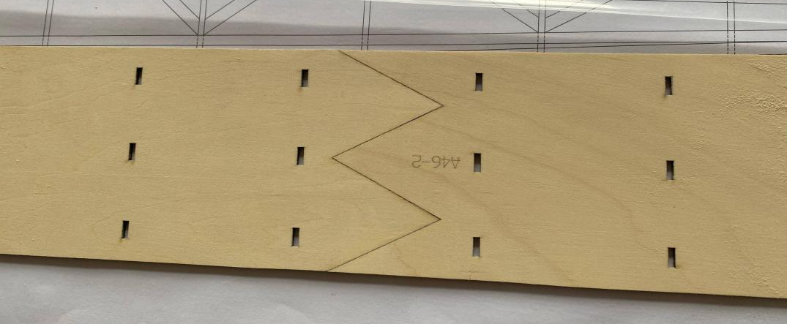

- Glue the reinforcing plate to the motor base.
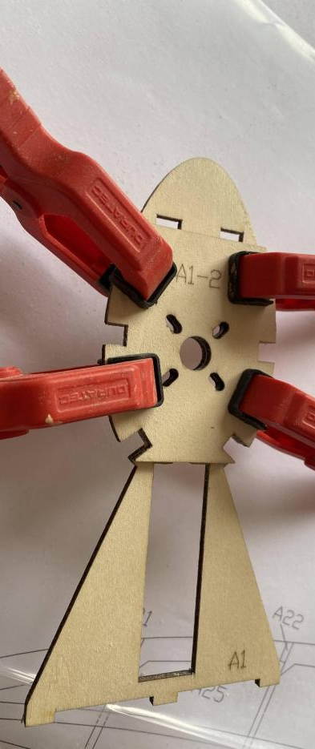

- Assemble fuselage bulkheads in accordance with their respective part numbers (Keep parts number
consistently forward).
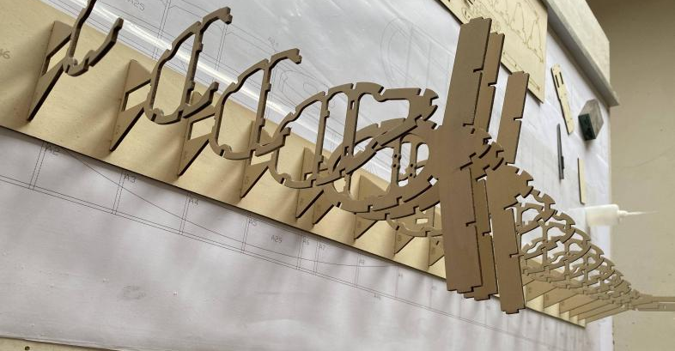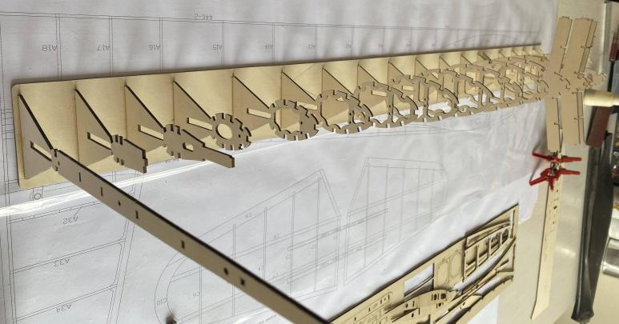

- Glue magnets to Part A27 and install it onto the body.
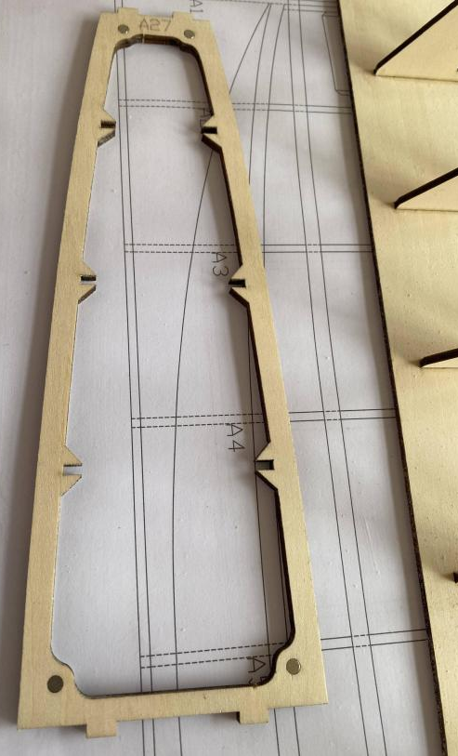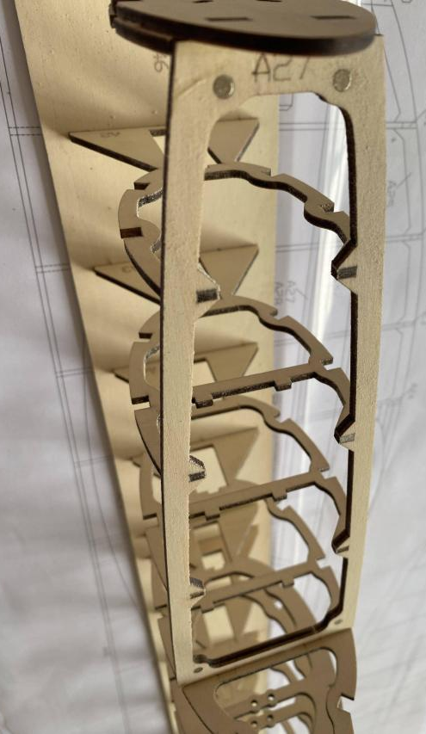

- Glue Part A29 to the lower section of the fuselage.
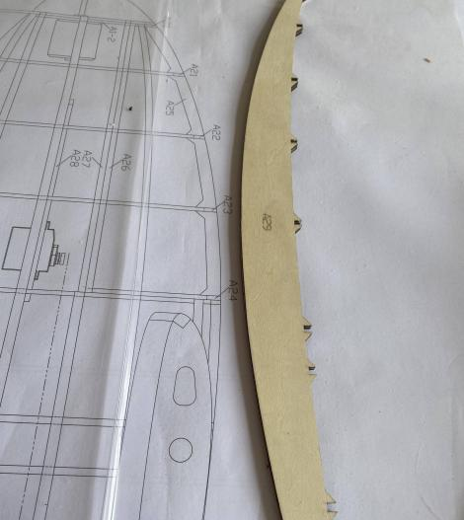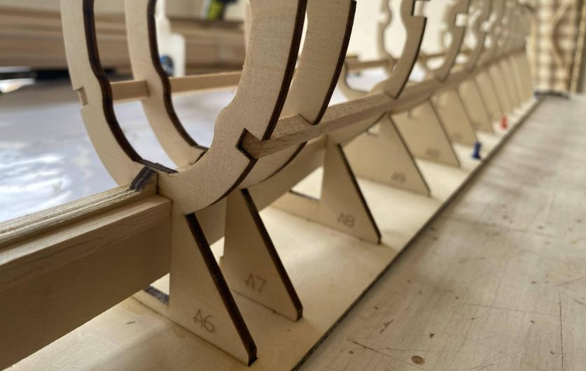

- Glue balsa sheets to both upper and lower sections, as well as both sides of the fuselage (B1 is
used for temporary positioning of partition bulkheads A6, A7, and A8; refrain from gluing at this
stage. B1 will be glued at step 17 ).
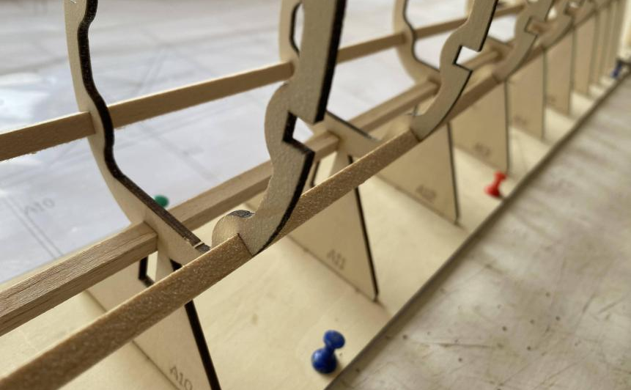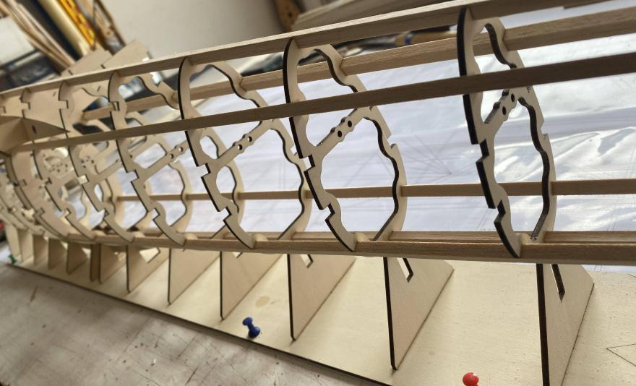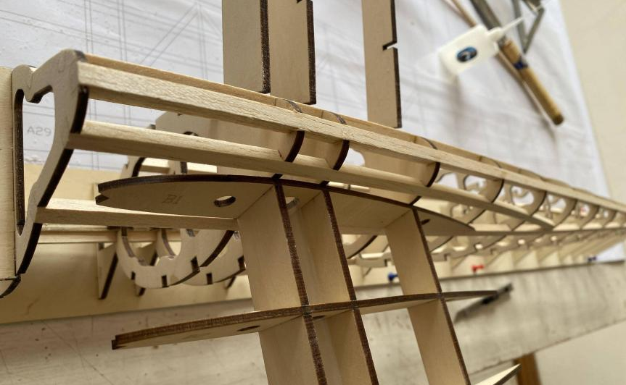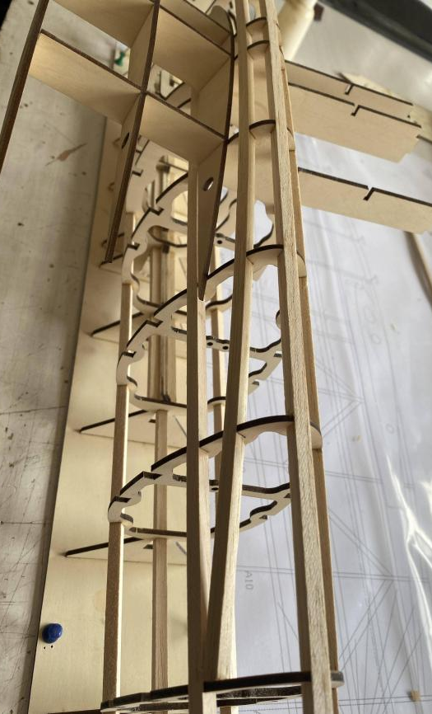

- Glue tail parts A30 and A32 onto the fuselage.
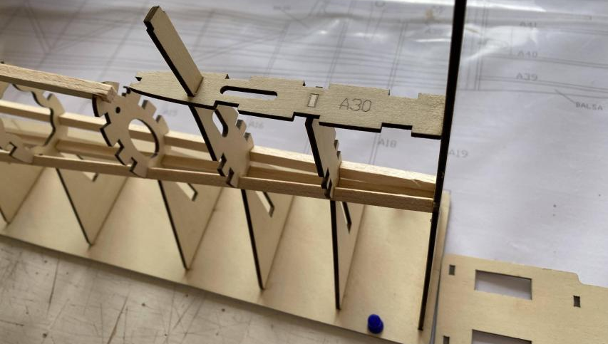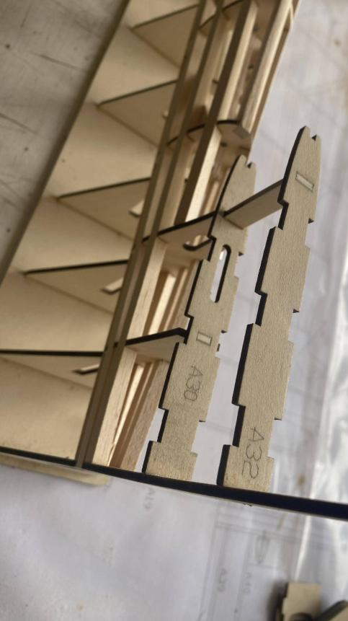

- Install the diagonally braced balsa sticks on the fuselage (utilizing balsa sticks for
positioning reference).
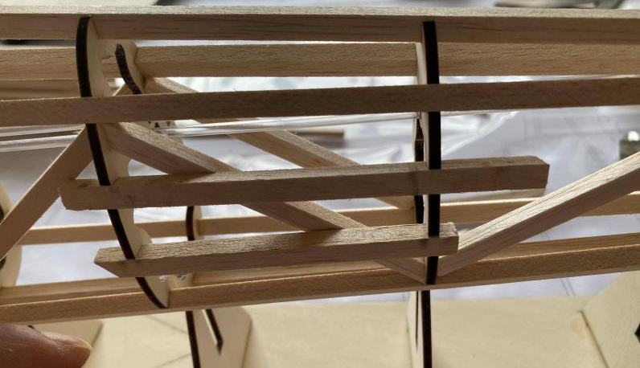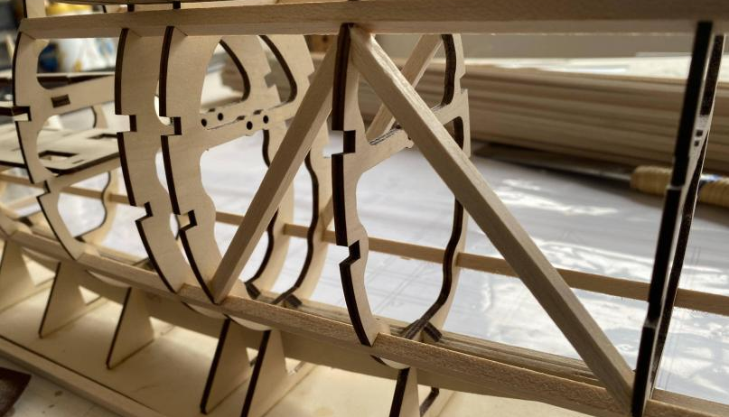

- Mount 2mm PVC sleeve into the structure.
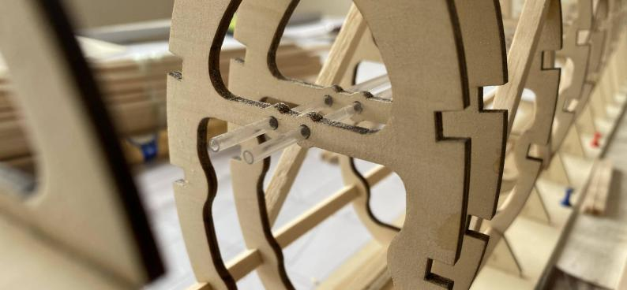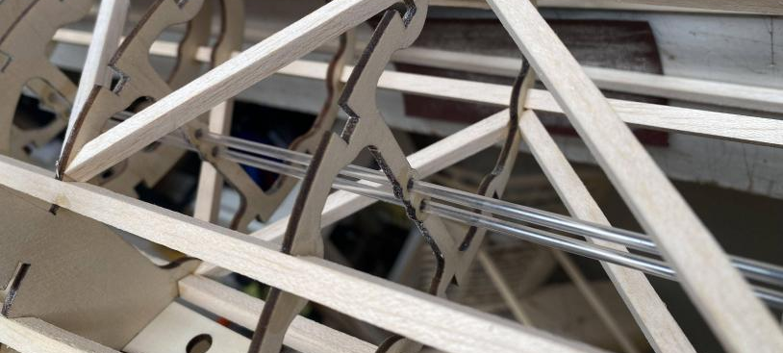

- Glue part A31 (ensure that fiber parts are placed in advance before A31 sealed on both sides).
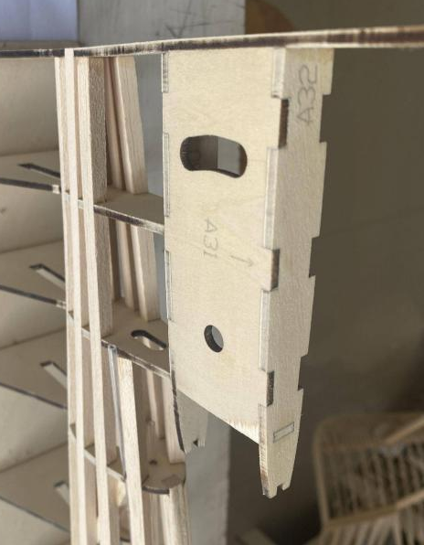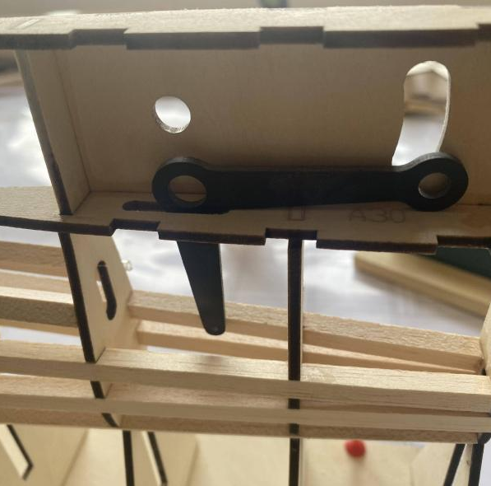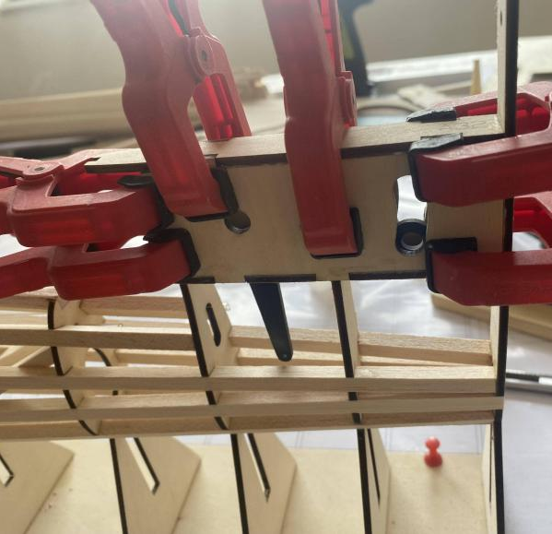

- Install vertical tail, glue balsa wood to leading edge followed by polishing, then glue 6MM
balsa sheets to rear edge.
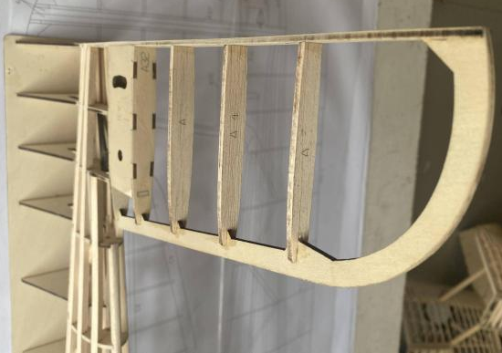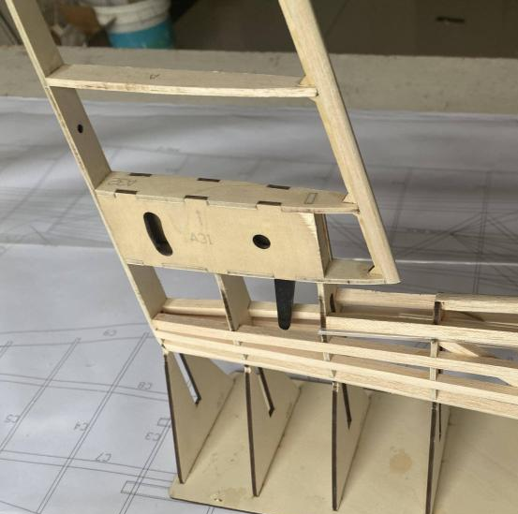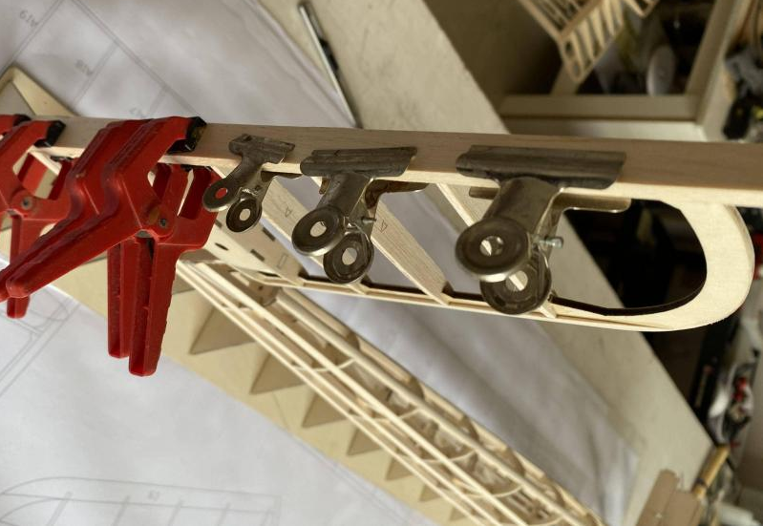

- Superimpose multiple pieces of 6MM balsa and glue onto the fuselage and polish them accordingly.
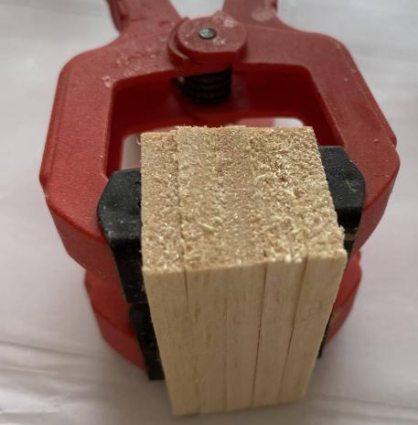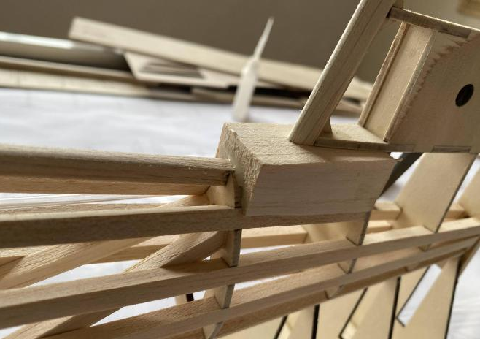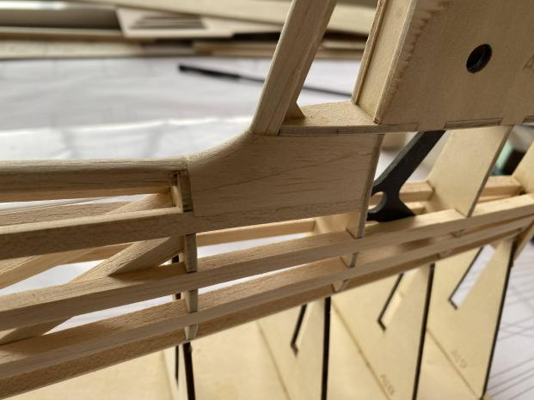
- Install elevator pulling connecting rod and clevis, seal fuselage sides with 3MM balsa sheets.

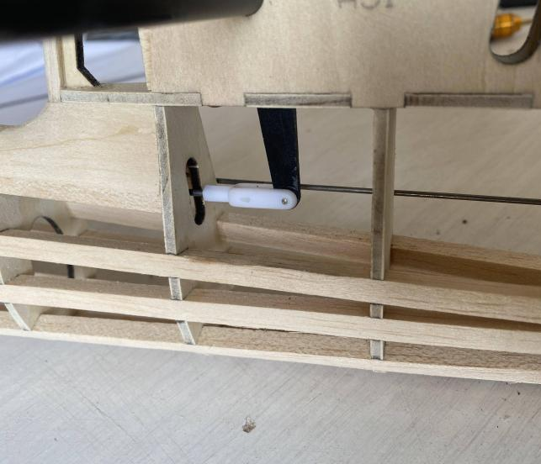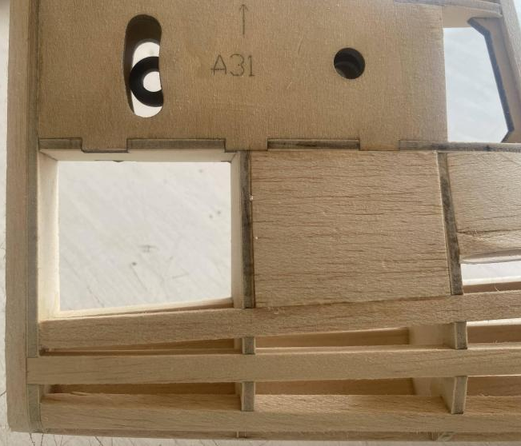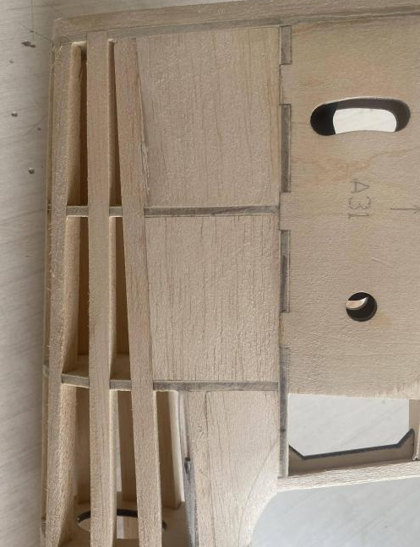

- Assemble hatch cover, install magnets on part A26.
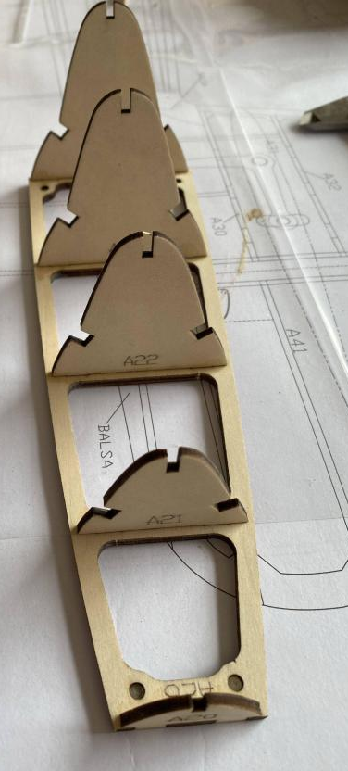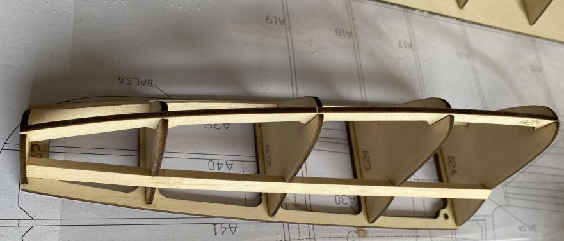

- Glue 8MM balsa stick on top of hatch cover and polish it.
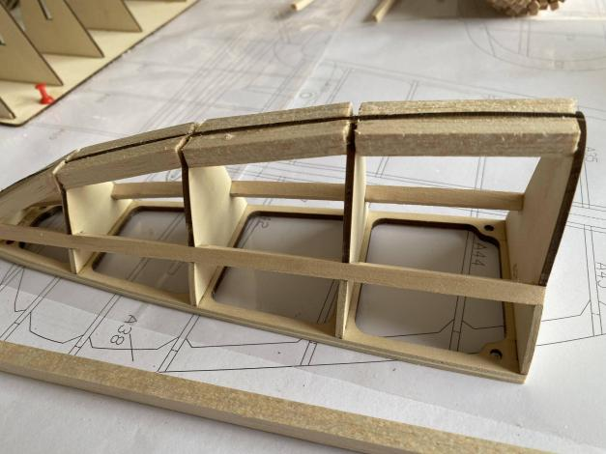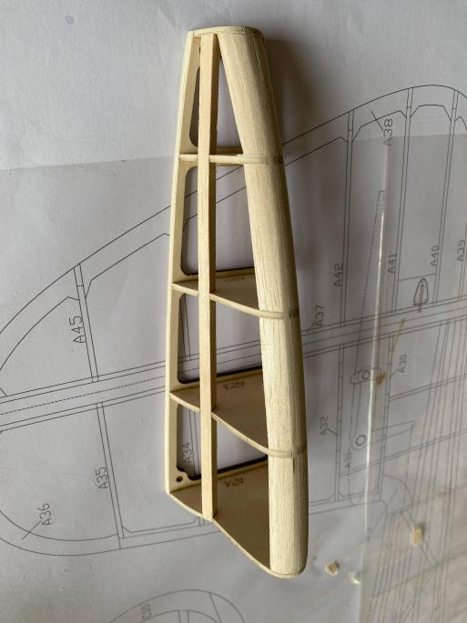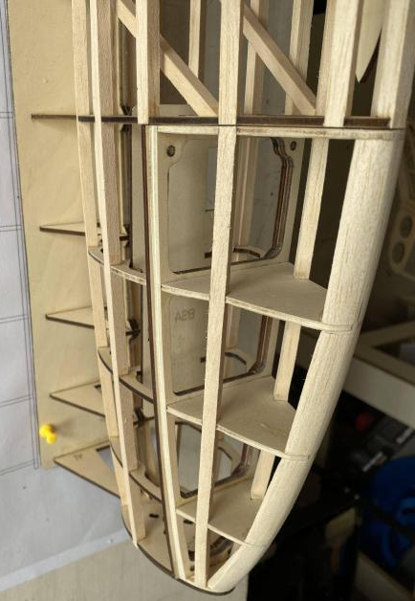

- Glue 3MM balsa sheet on both sides of the fuselage.
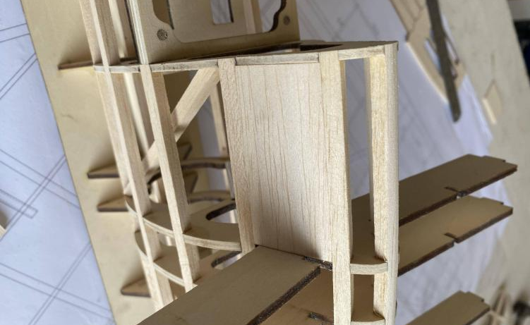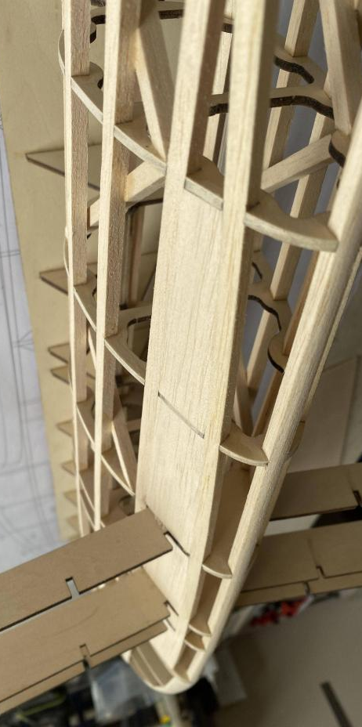

- Glue B1 to the fuselage, ensuring that the balsa sheets are drilled to accommodate the servo extension wires.
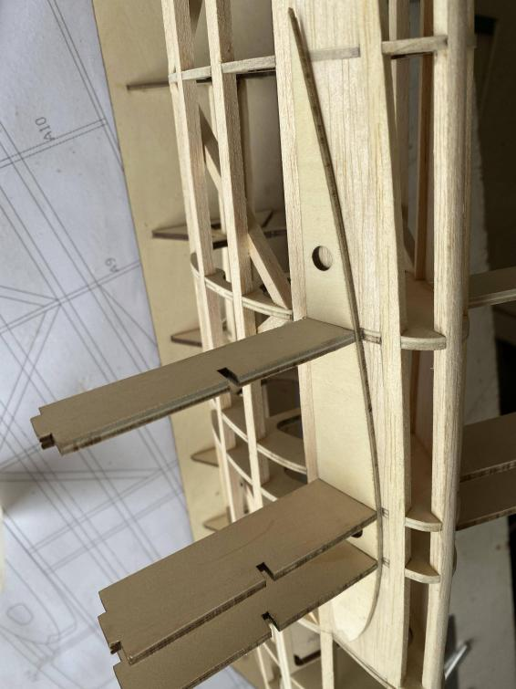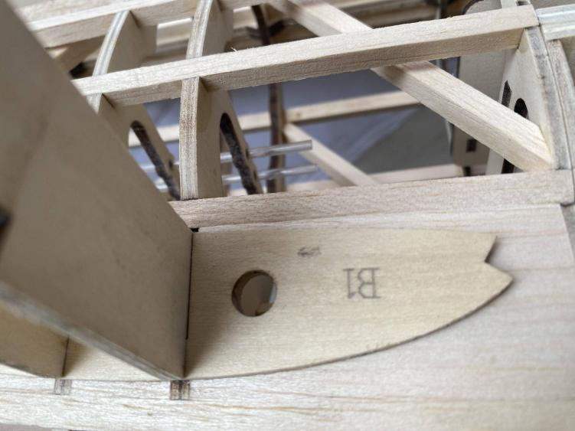
- Install B2 and B3, and insert the PVC sleeve.
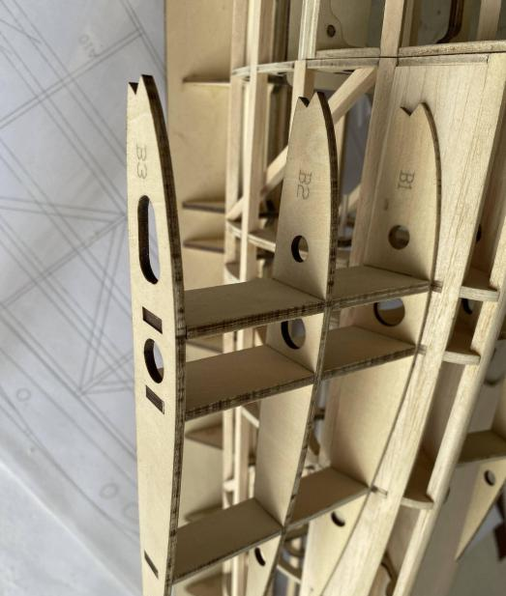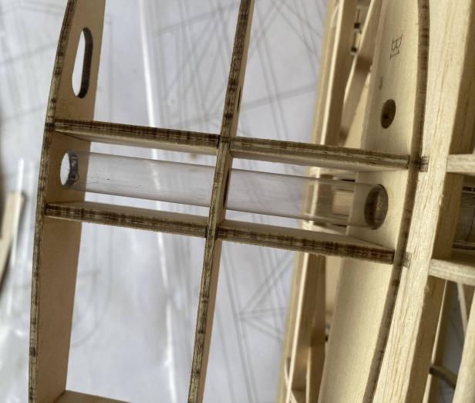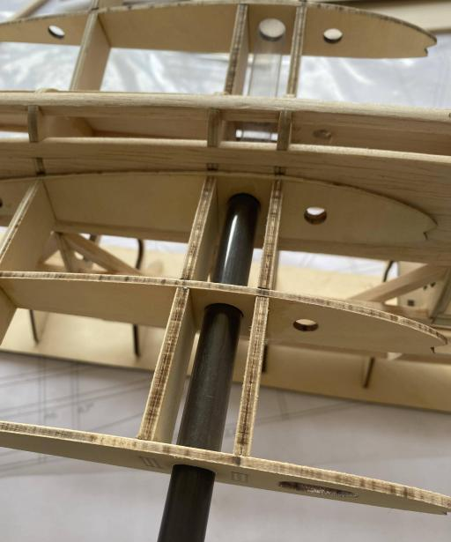
- Glue 8X8MM balsa strips to the leading edge and then glue 2MM balsa cover.
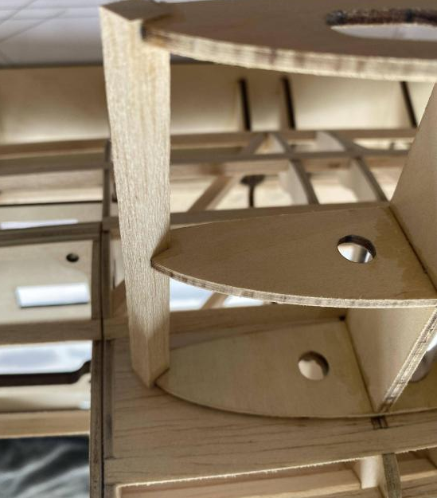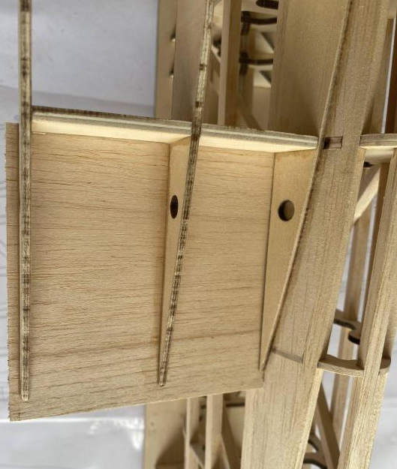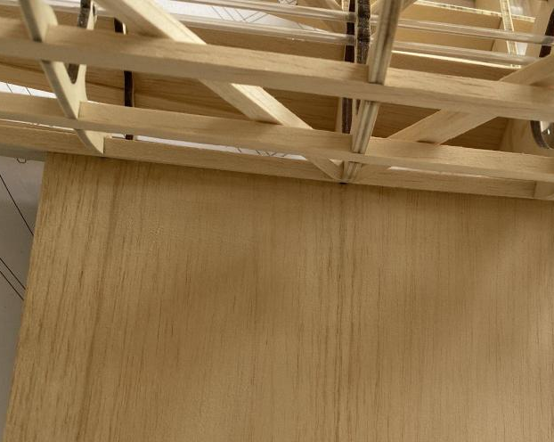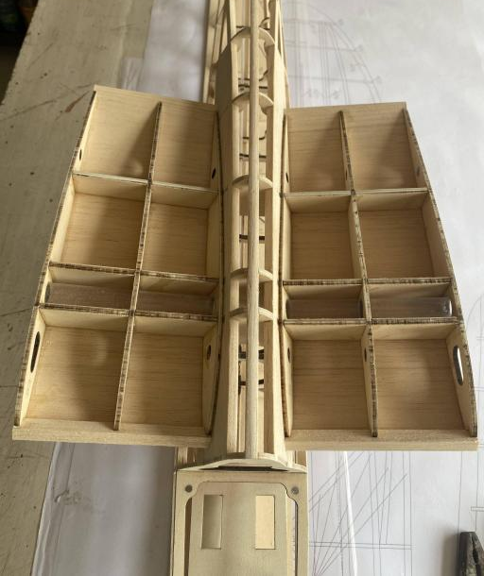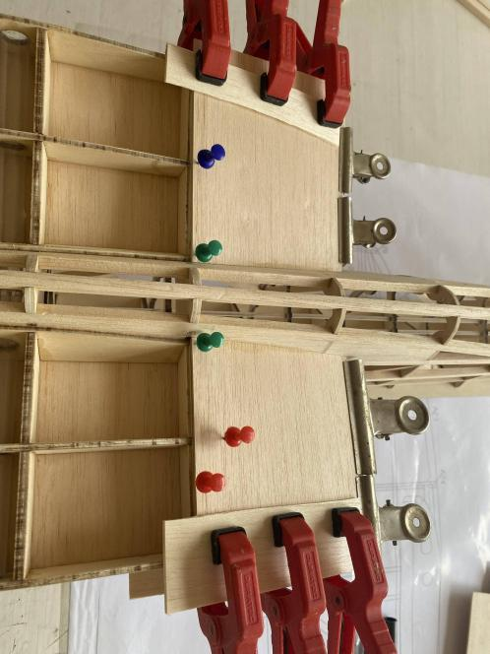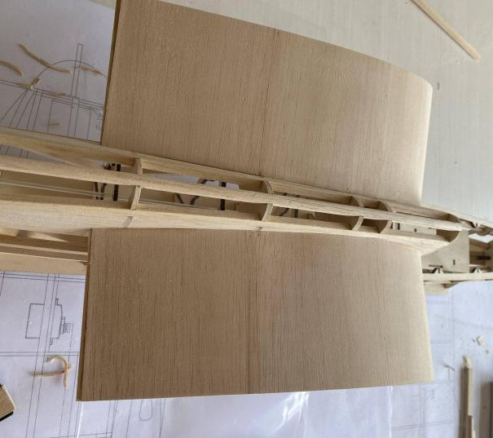

- Trim off the base.
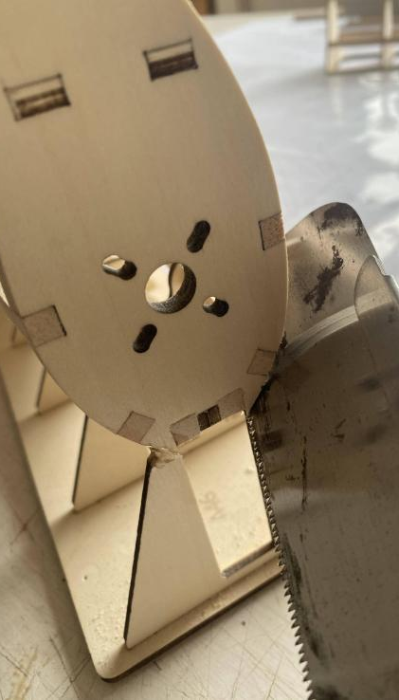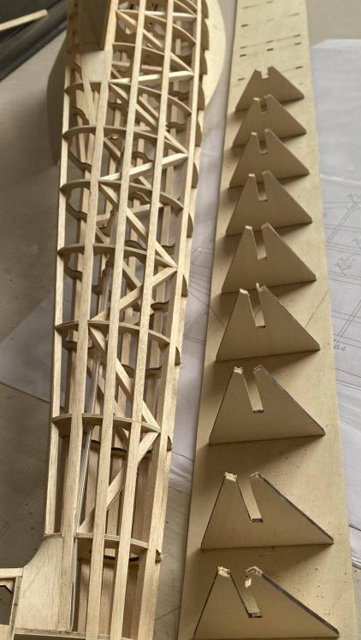

- Mount the motor, glue and sanding balsa block as the nose. (A long shaft motor is required; additional bearing insalled on front-end motor shaft can be used for vibration reduction.)
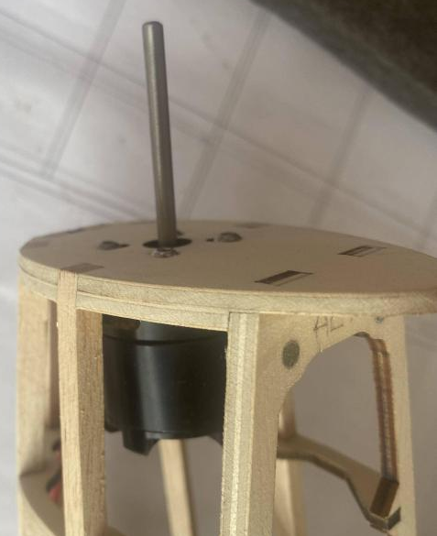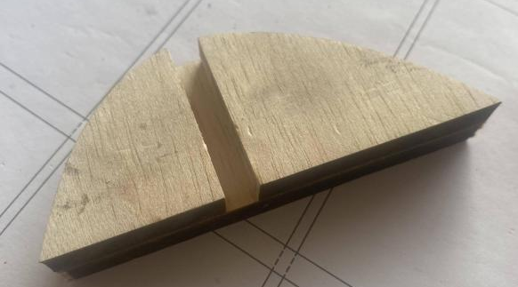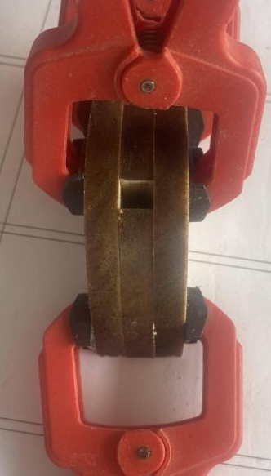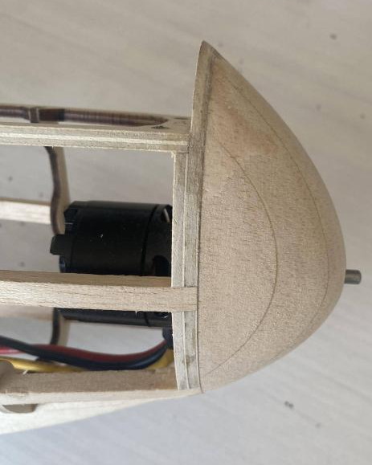
- Install the servos.
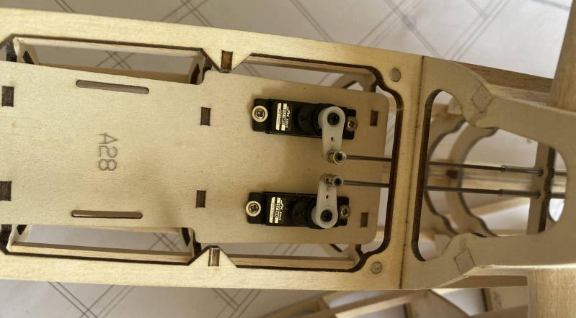

2 Tail&Wings Assembly
- Construct the rudder.
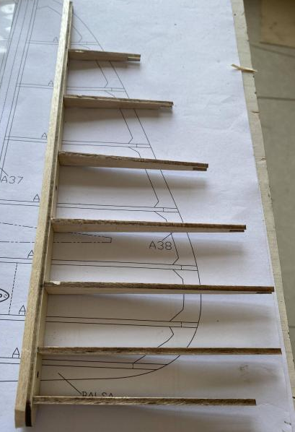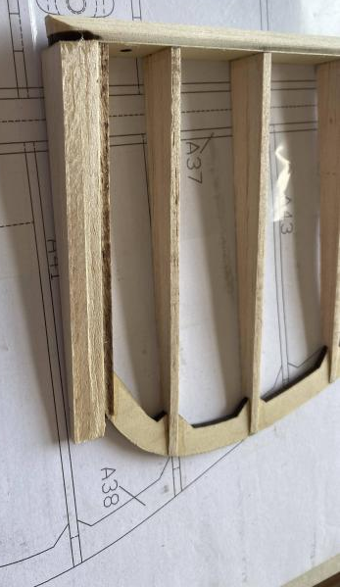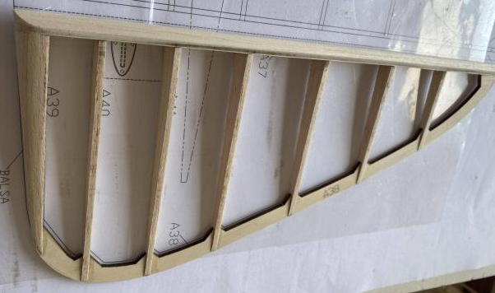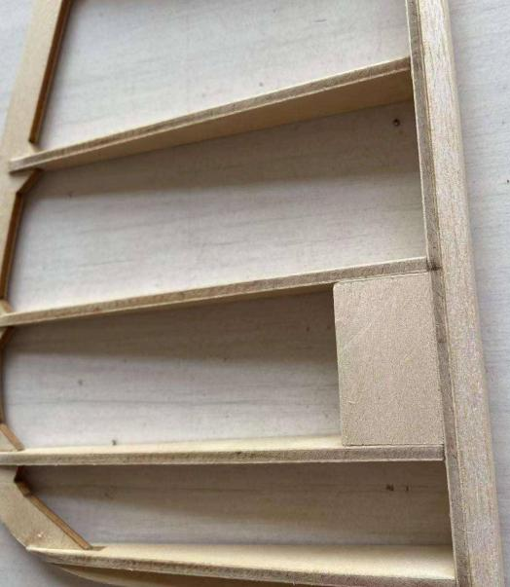
- Assemble the elevator ,using carbon tube positioning.
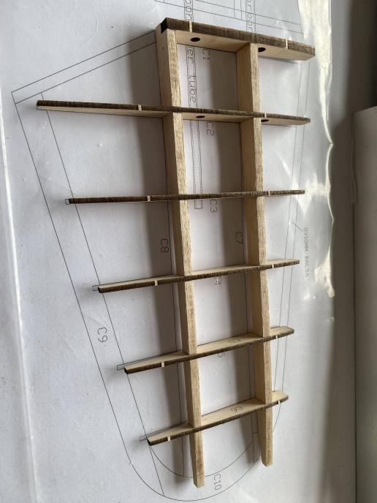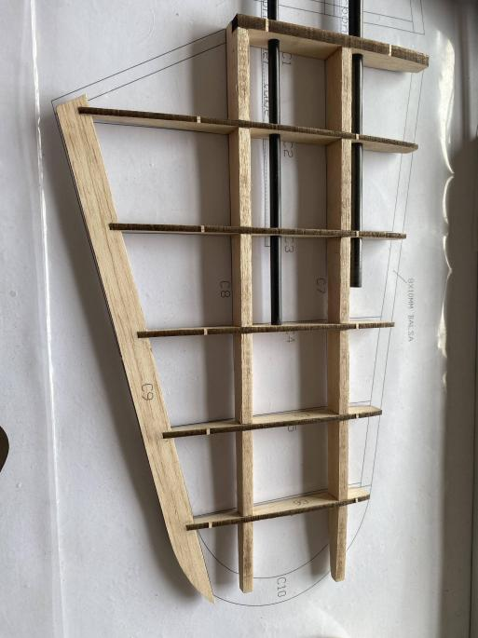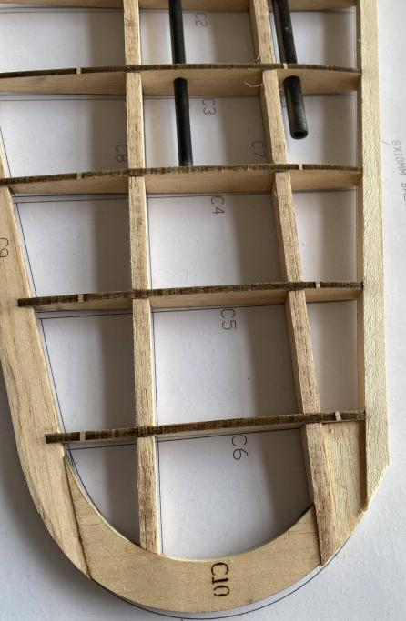
- Polish both leading and trailing edges.
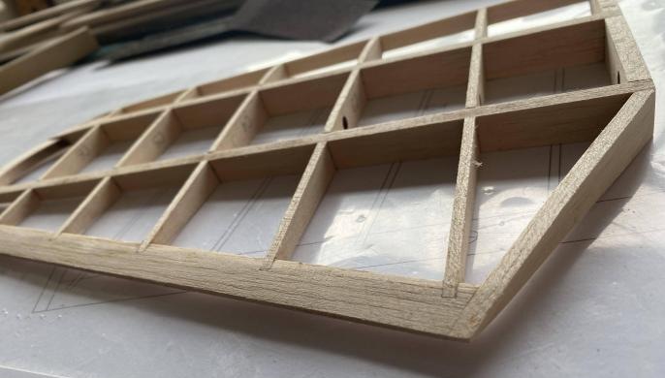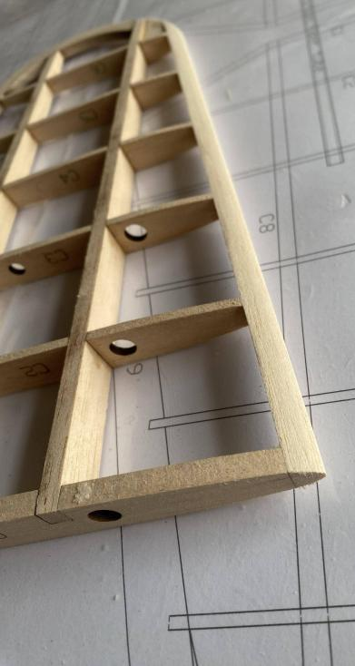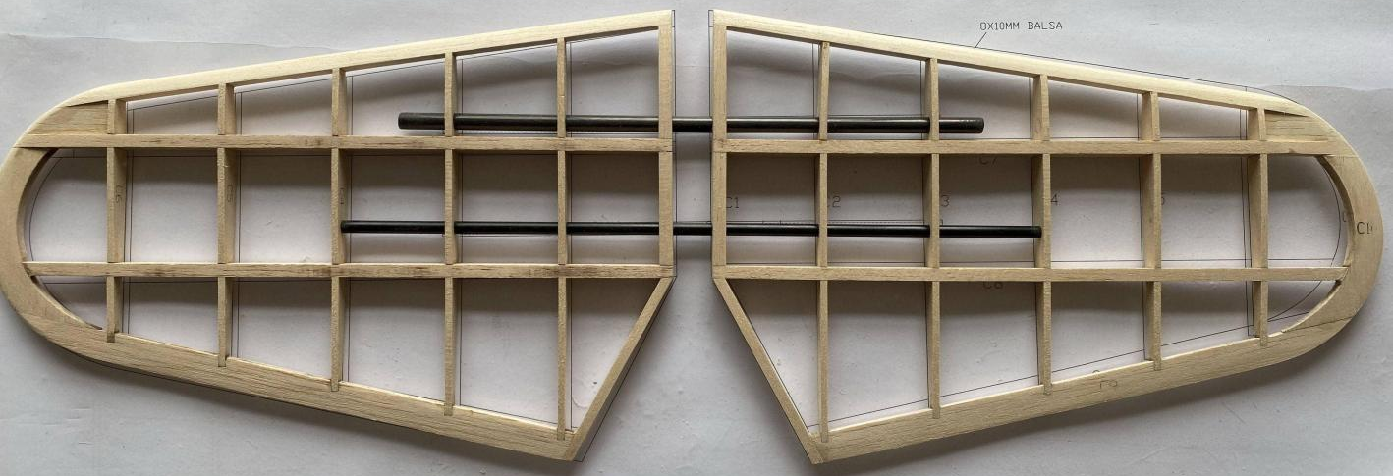
- Assemble main beams according to their numbers, then glue wing ribs accordingly.
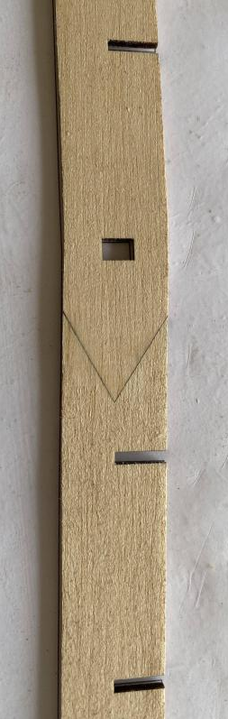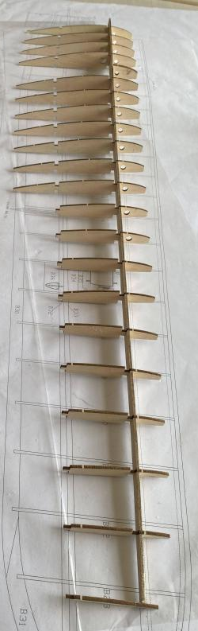
- Install PVC sleeves for positioning with carbon tubes, then glue balsa strips onto main beams.
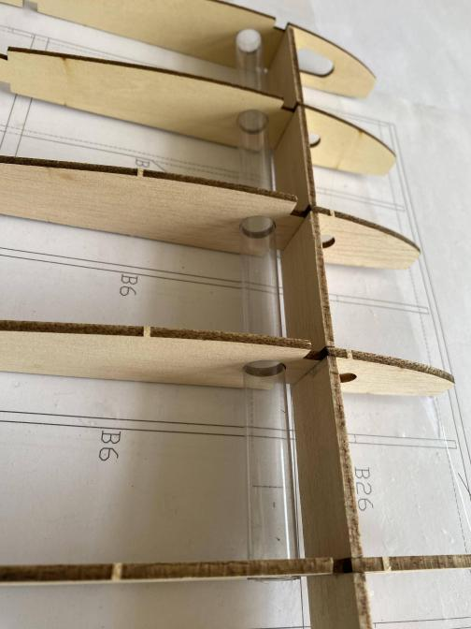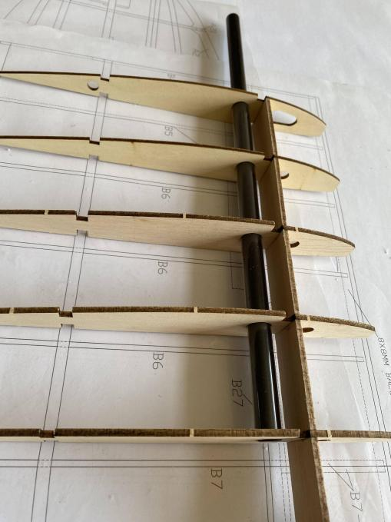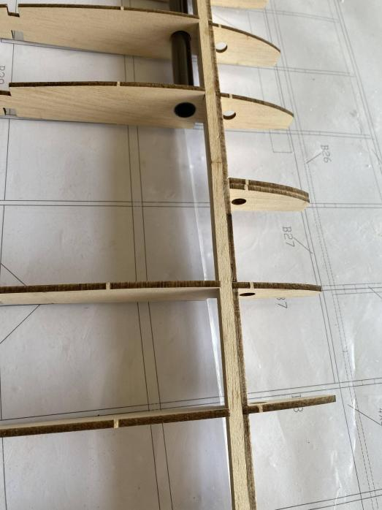
- Glue reinforcing plates B27 on wing main girder splices, followed by installation of wing ribs.
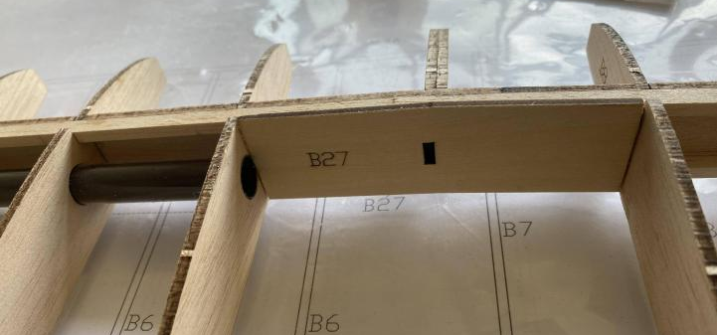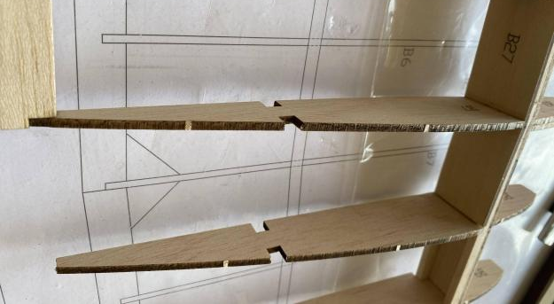
- Glue wing trailing edge and reinforce balsa strips.
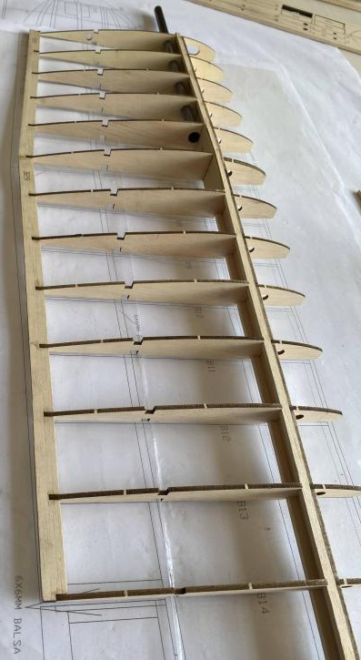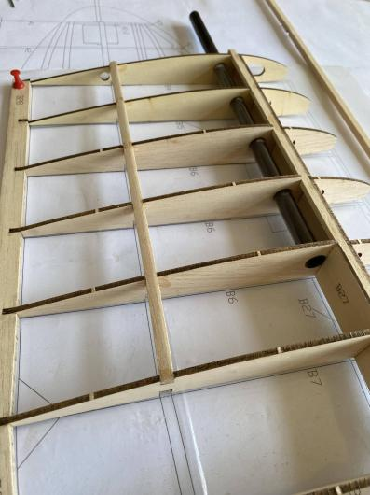
- Glue B33 to wing ribs and then joint 6X6MM balsa sticks.
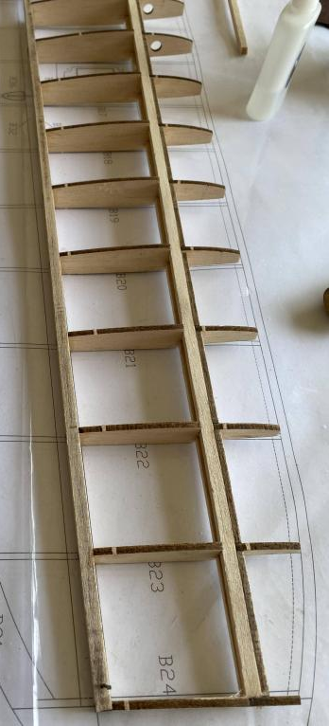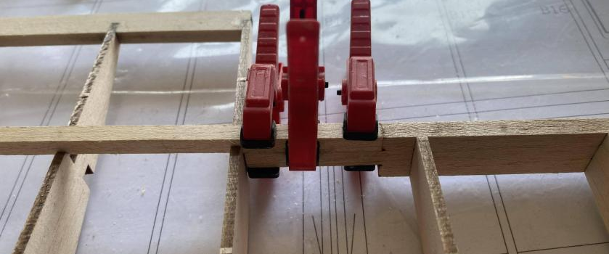
- Glue upper and lower wing coverings.(Servo extension wires must be installed advanced.)
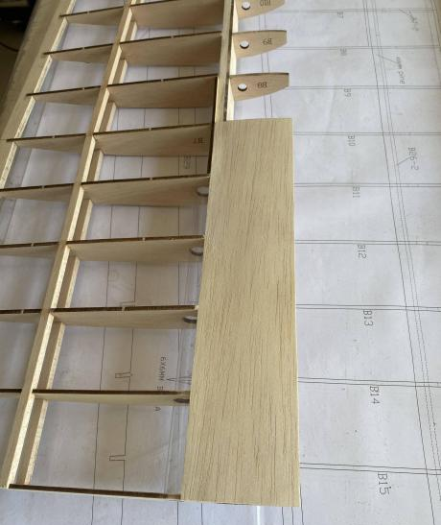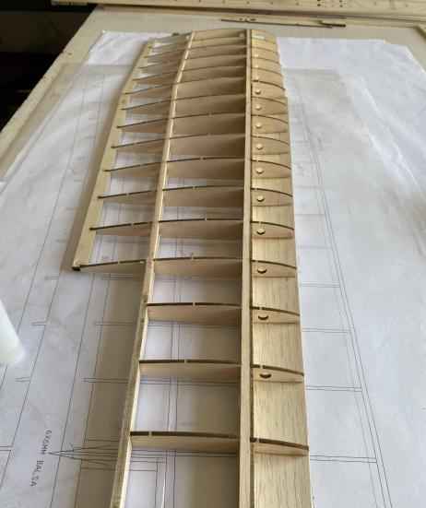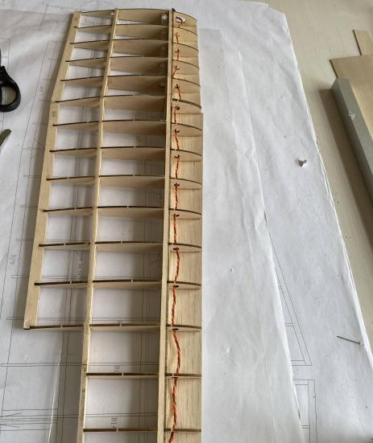
- Glue 8MM balsa on leading edge of wings and 2MM balsa cover in middle section of wings.
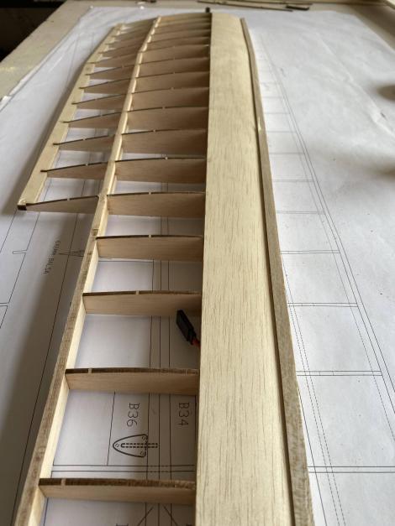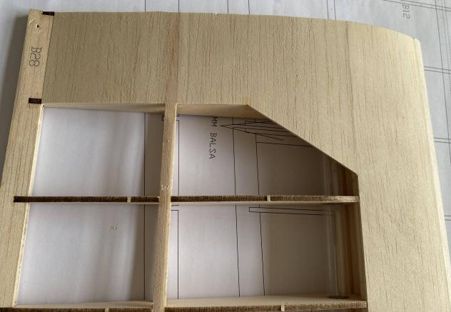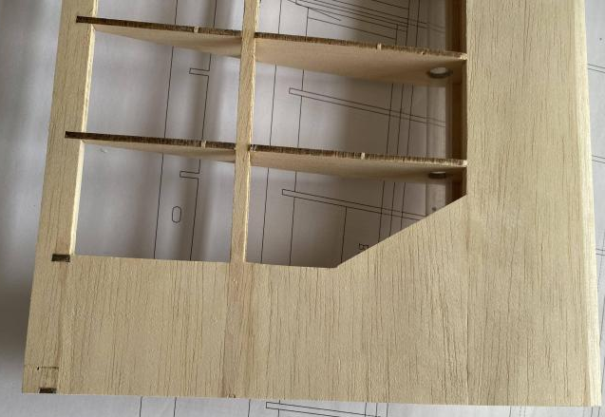
- Polish front and rear edges of wings while using paper tape as a precaution against over-polishing.
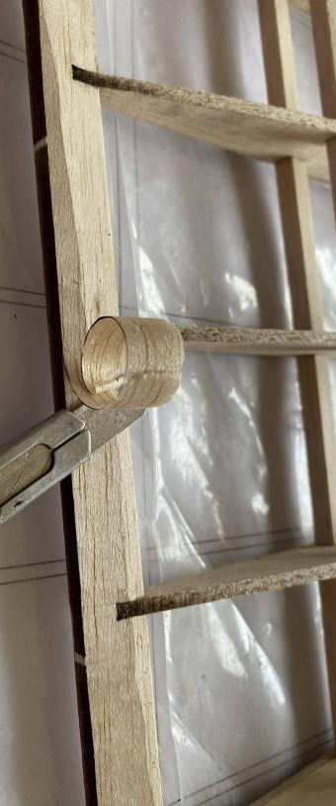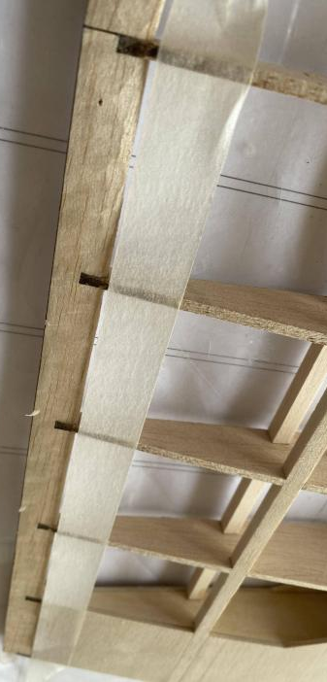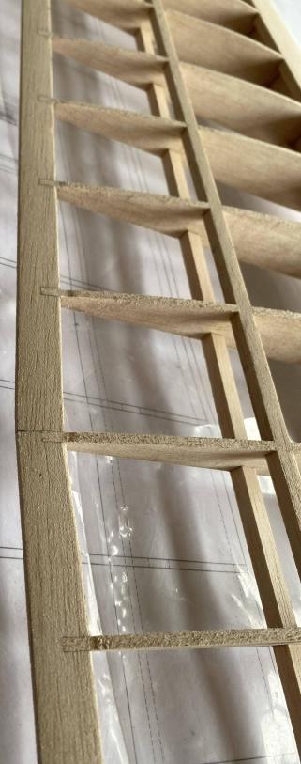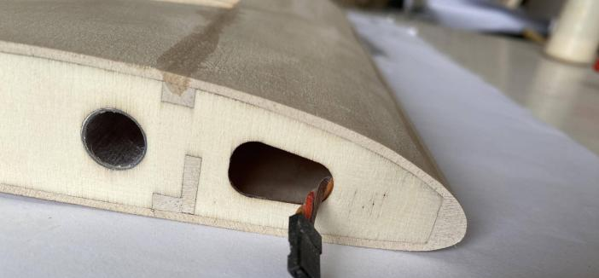
- Glue wing-tip and sand it.
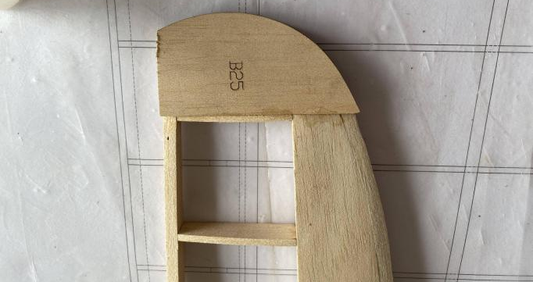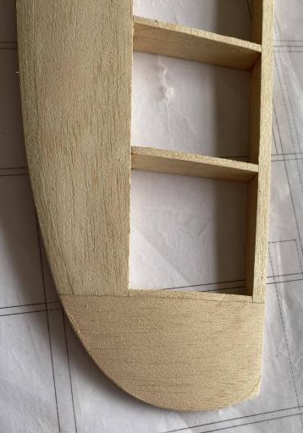
- Install aileron servo mount, glue 2MM balsa on the top, then strengthen by gluing pine block.
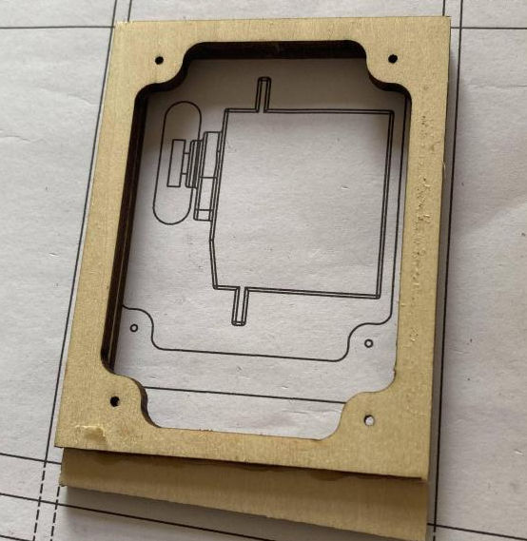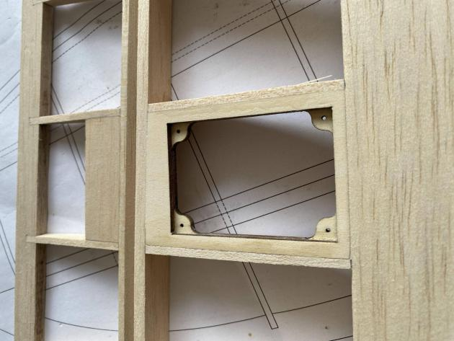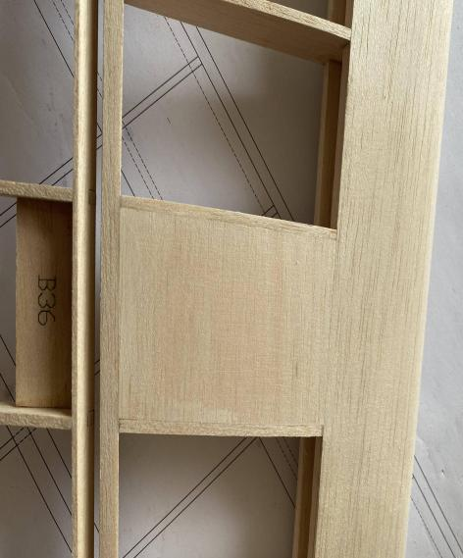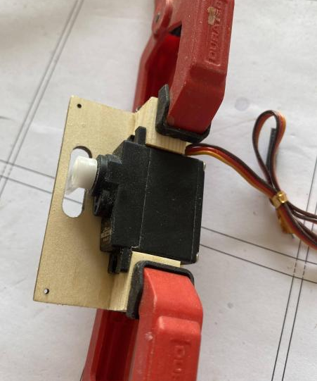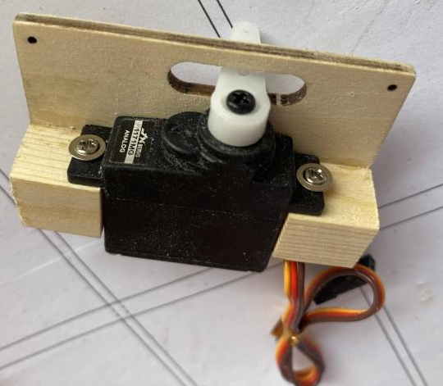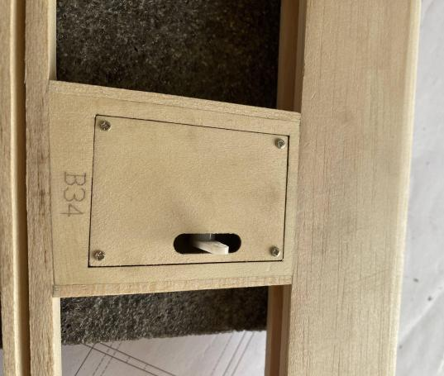
- Assemble ailerons according to drawing specifications; polish leading edge into a triangular shape.
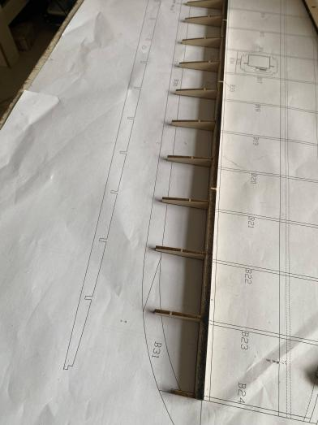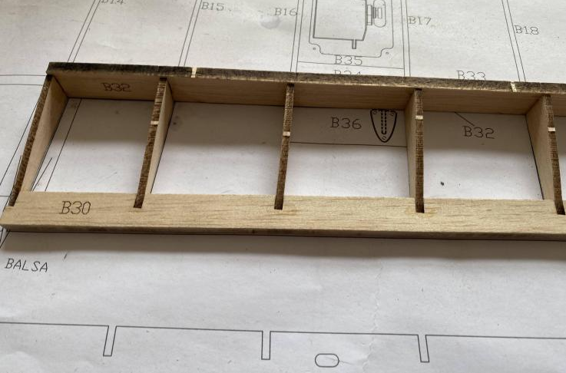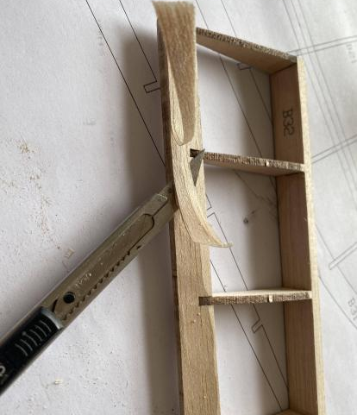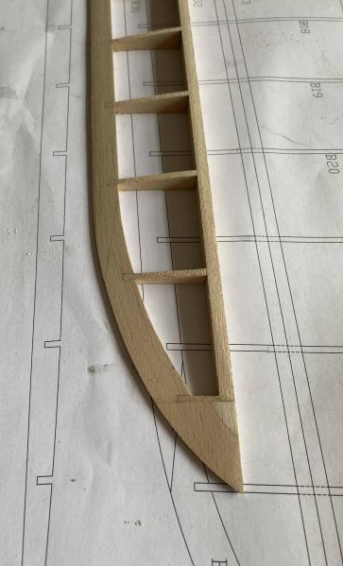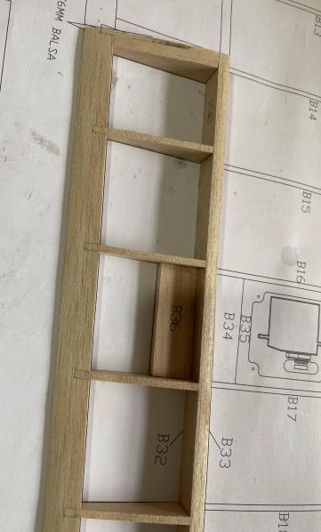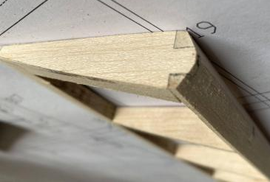
3 integral construction
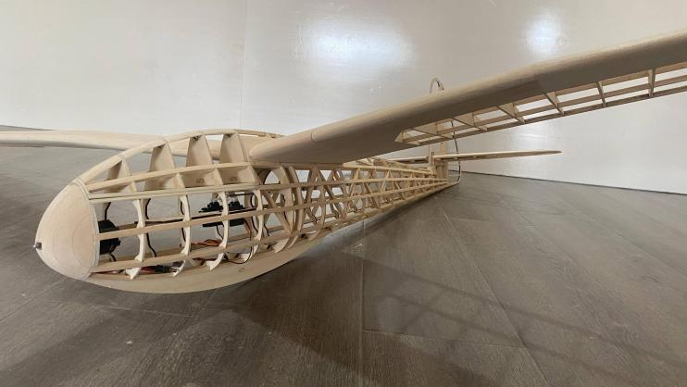
4 FINISHED
