 封面
SLINGSBY t45 swallow L
LASER-CUTTING KIT
Building instruction

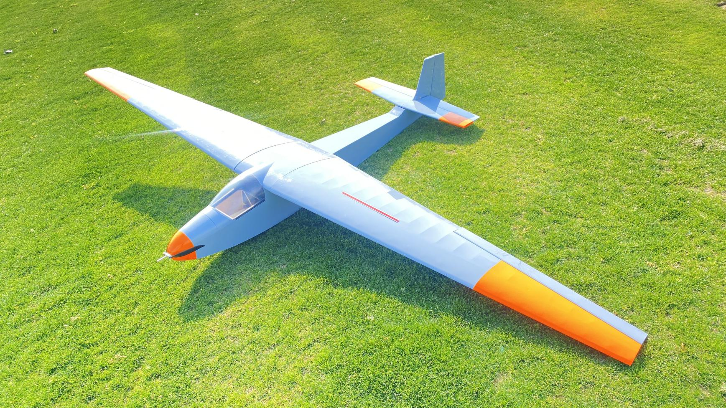

Produced by ValuePlanes
Catalog

introduction----------------------------------------------------------------------------------------P1

product list& KIT FEATURES -----------------------------------------------------------------P1

GERNERAL INFORMATION-------------------------------------------------------------------------P2

Building instruction---------------------------------------------------------------------------P3

- Fuselage Frame Assembly---------------------------------------------------------------P3
- TAIL&WING CONSTRUCTION-------------------------------------------------------------------------P10
- Structural views---------------------------------------------------------------------------------------------------P17

Specifications:
Wingspan : 3250mm Length : 2050mm
Flywing Weight : 4900g
Suggested power : Motor: Boost40 900kv ESC: 55A
Servos: DS3100×3 , DS8040×1 Batteries: 4S 5000mah
Props: 13inches folding prop
Surface area:102.6 dm² Wing load : 47.7g/dm²

introduction
The Slingsby Type 45 Swallow was designed as a club sailplane of reasonable performance and price. One of the most successful of Slingsby's gliders in sales terms, over 100 had been built when production was ended by a 1968 factory fire..The Swallow flew for the first time on 11 October 1957 and it remained in production for 11 years. About 115-120 Swallows were completed,though two were destroyed at the factory in a fire. Part of the uncertainty lies with kits issued by Slingsby for construction abroad. The short-span first prototype was later rebuilt as the Reussner Swift. The RAF used five Swallows, known as Swallow T.X. Mk.1, in its Air Training Corps. Approximately nine Swallows were used by branches of the Royal Air Force Gliding and Soaring Association at airfields across the world,and the equivalent Royal Navy association had four.25 were sold in Spain, nine in Pakistan and four in Burma. Most of the rest flew with clubs in the UK, though a few went to Commonwealth countries and the USA.
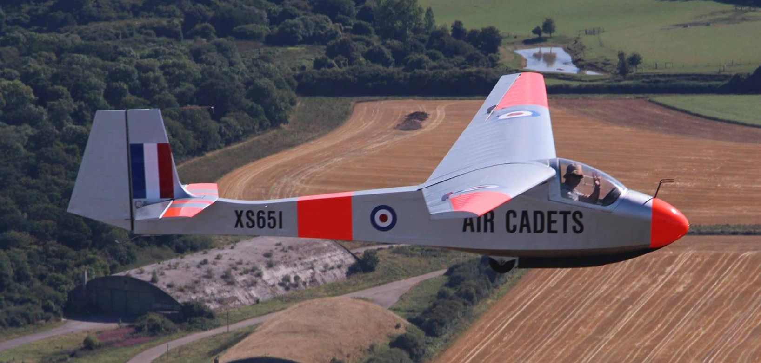
product list
Balsa sheets pack*1 1:1 installation drawing*1
Batten sets Operation instruction*1
Accessories bag*1 PVC windshield&canopy*1
Carbon tube*1
steel pull rod with PVC tube*1
KIT FEATURES
- Scheme-based on Slingsbby T45 Swallow.
- Extremely lightweight, state-of-the-art all-wood construction.
- Ultra-light take-off weight ensures high gliding performance.
- Full-scale simulation metallic structure.
- Extensive clear drawings and full-page colour instructions with hundreds of pictures .
- Only adhesives and coverings are required to complete the airframe.

GERNERAL INFORMATION
Be sure to read the safety instructions carefully before operating your model.
• Always follow the procedures and settings recommended in the instructions.
• If you are using remote-controlled model aircraft, helicopters, cars or ships for the first time, we recommend that you ask an experienced model pilot for help.
• Remote-controlled models are not toys in the usual sense and may only be used and operated by young people under 14 years of age under the supervision of adults.
• Their construction and operation requires technical understanding, careful craftsmanship and safety-conscious behaviour.
• Mistakes or negligence during construction, flying or driving can result in considerable damage to property or personal injury.
• Since the manufacturer and seller have no influence on the proper construction/assembly and operation of the models, these risks are expressly pointed out and any liability is excluded.
• Propellers on aircraft and all moving parts in general pose a constant risk of injury. Avoid touching such parts at all costs.
• Note that motors and controllers can reach high temperatures during operation. Avoid touching such parts at all costs.
• Never stay in the danger area of rotating parts with electric motors with connected drive battery.
• Overcharging or incorrect charging can cause the batteries to explode. Make sure the polarity is correct.
• Protect your equipment and Models from dust, dirt and moisture. Do not expose the equipment to excessive heat, cold or vibration.
• Always check your equipment for damage and replace defects with original spare parts.
• Do not use equipment that has been damaged or got wet due to a fall, even if it is dry again!
• Do not make any changes to the remote control which are not described in these instructions.
•Before the first flight, check the wing symmetry, tail unit and fuselage. All parts of the model should have the same spacing from the left and right wing or tail plane to the centre of the fuselage or the same angle.

Attention, danger of injury!
• Always keep a safe distance from your model aircraft.
• Never fly over spectators, other pilots or yourself.
• Always perform flight figures in a direction away from the pilot or spectators.
• Never endanger people or animals.
• Never fly near power lines or residential areas.
• Do not operate your model near locks or public shipping.
• Do not operate your model on public roads, motorways, paths and squares, etc., but only in approved locations.
• Do not operate the model in thunderstorms.
• Before each flight, check your remote control system for sufficient function and range.
• After flying, remove all batteries from the model.
Do not „aim“ the transmitter antenna at the model during operation. In this direction, the transmitter has the lowest radiation. The best position of the antenna is to the side of the model.
Use of devices with image and/or sound recording function:

Building instruction

1 Fuselage Frame Assembly
1-3: Join the side panels of the fuselage. Both side panels should be consistent.
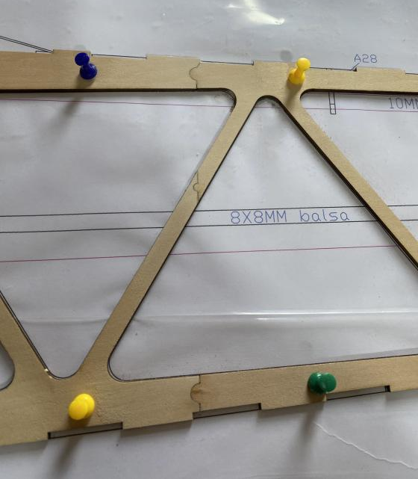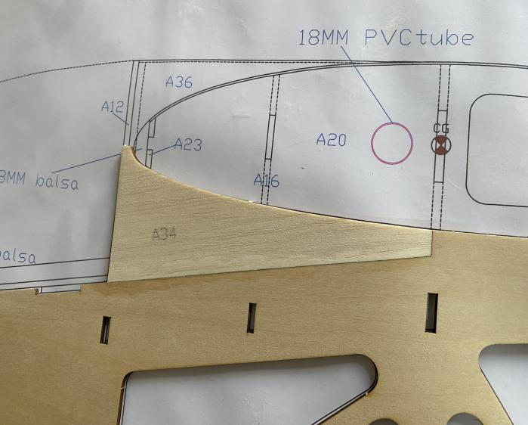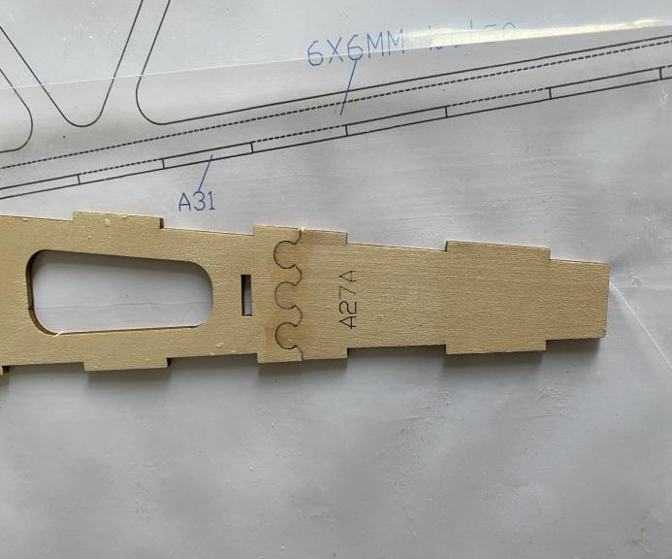
4: Install the fuselage bulkhead and the middle wing rib.
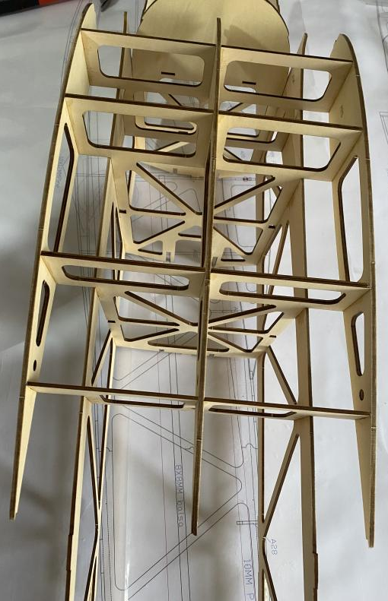
5: Insert the middle wing rib into the PVC pipe,position with the carbon tube , and fix it with glue.
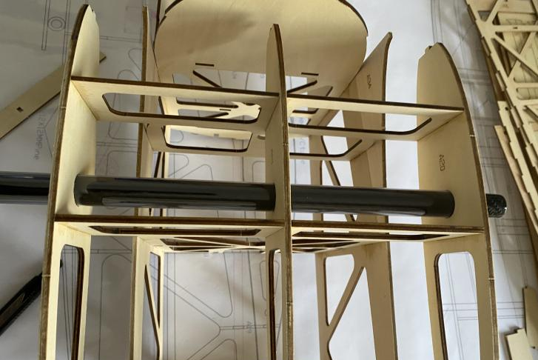
6: Install magnets on the bottom plate of the hatch cover and fix them with glue, ensuring that the polarities of the four magnets are consistent.
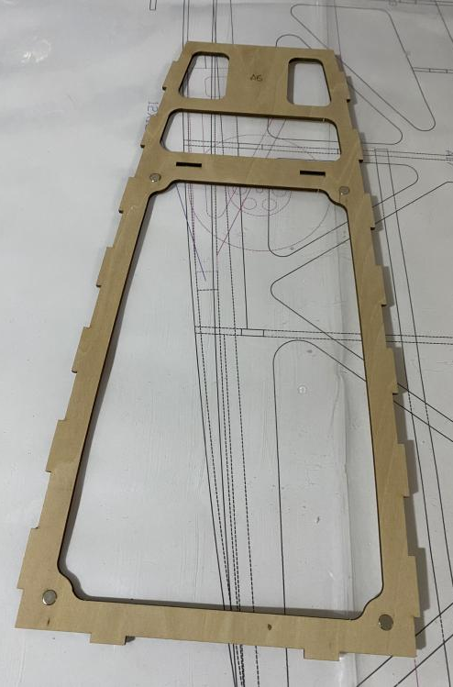
7: Glue the A6 bottom plate to the fuselage and glue 6mm balsa wood on the bottom for reinforcement.
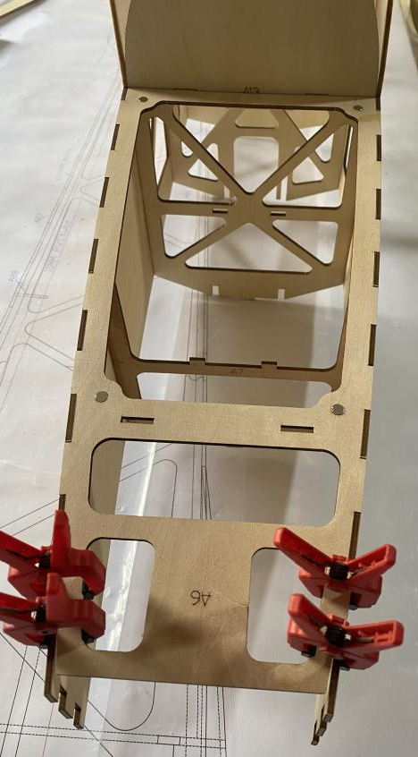

8-10: Assembly and glue the motor mount, and reinforce the bonding surface with balsa strips.
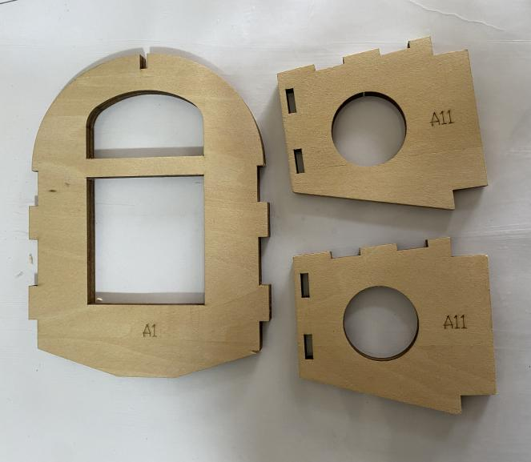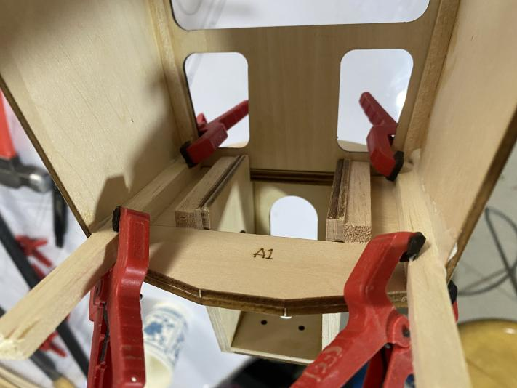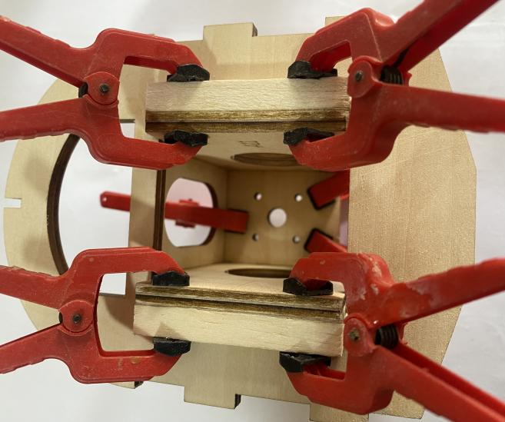
11-13: Install the landing gear support plate A22 on the bottom of the fuselage, and stick two 12mm pine wood strips at the notched position.
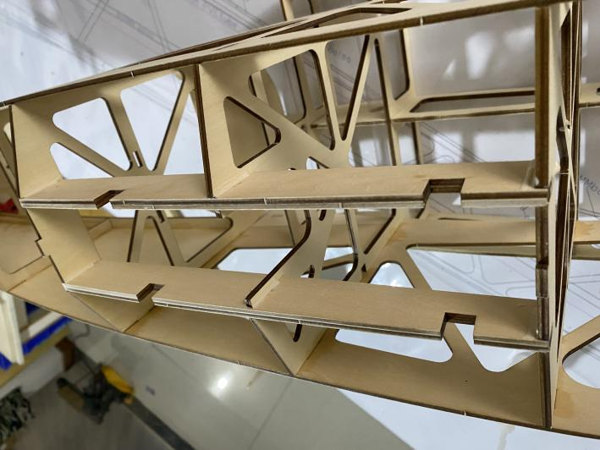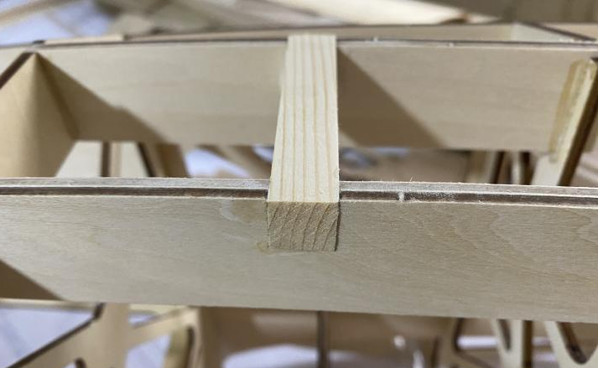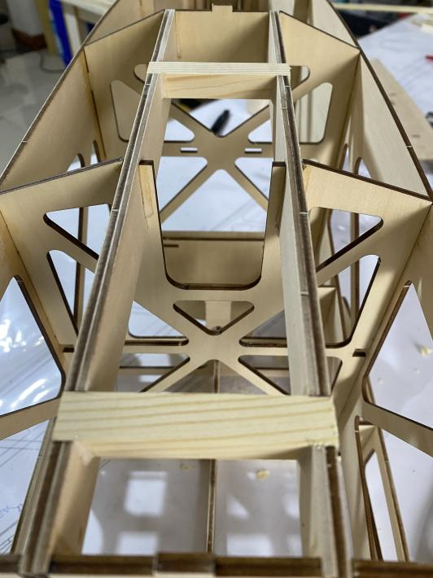

14-15: Glue the upper and lower cover plates at the rear of the fuselage, and then reinforce the periphery with 6X6mm balsa strips. Note: The fuselage should remain vertical and without any deformation or distortion.
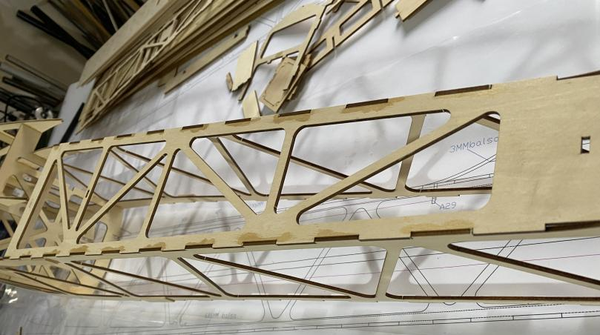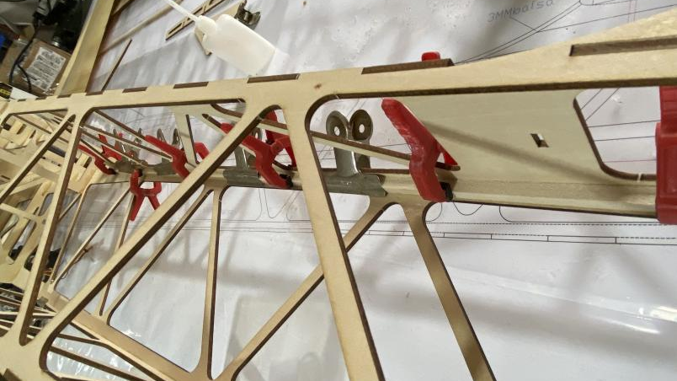
16: Glue 8x8mm balsa strips inside the fuselage on both sides for reinforcement.
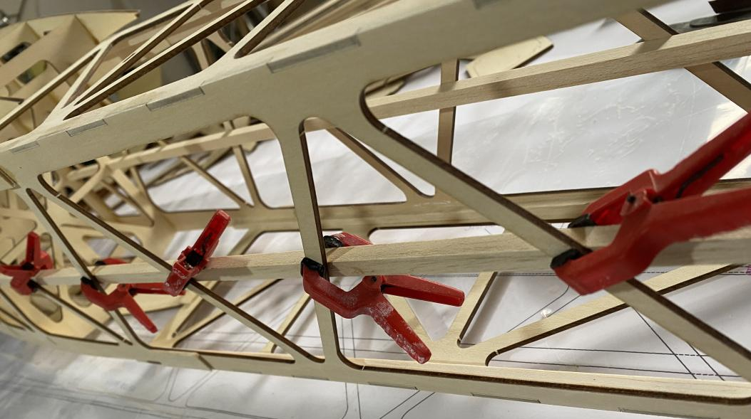

17-19: Glue the PVC pipe seat and insert the PVC pipe. Align and fix the middle connection position with adhesive tape.
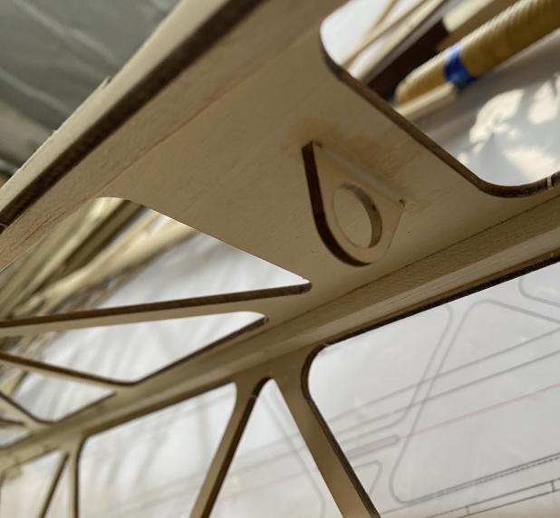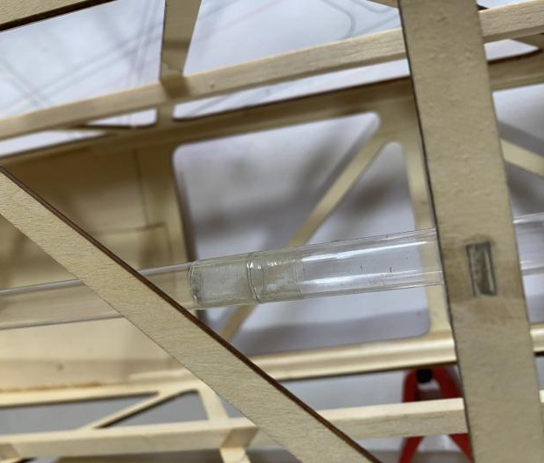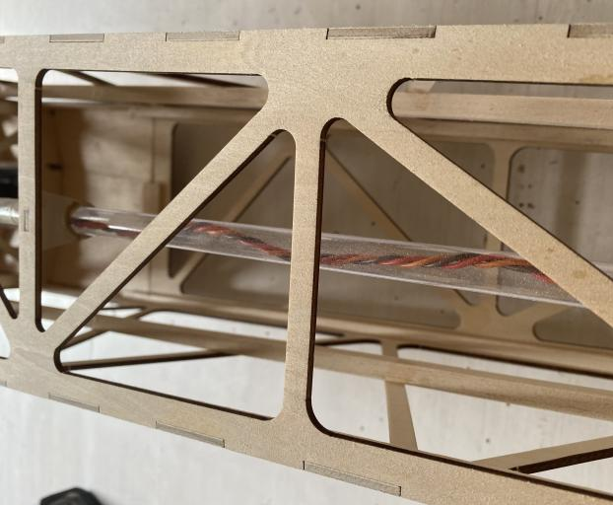
20-21: Glue the claw nuts and washers to the fuselage.
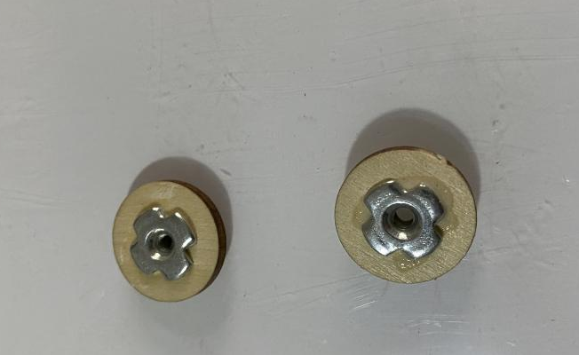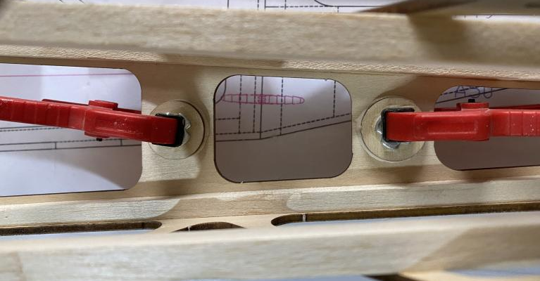
22: Glue balsa sheets and A58 reinforcement plates to the tail wing platform.
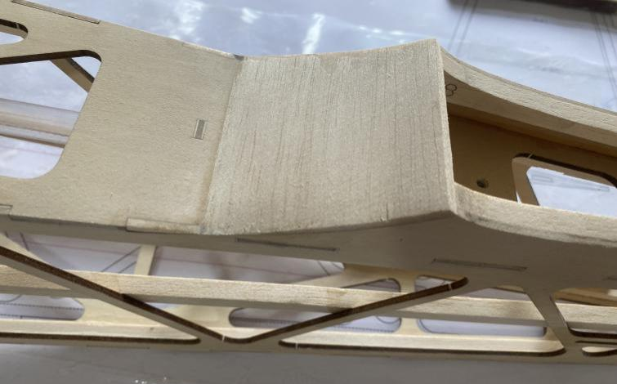
23: Glue the bottom cover of the fuselage.
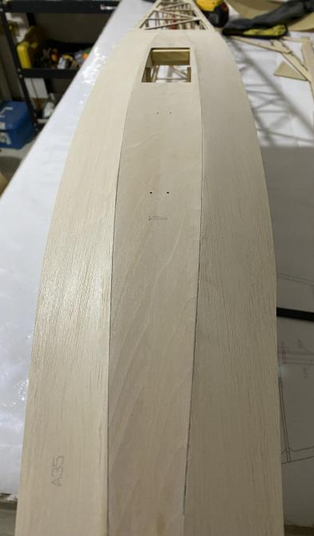
24-25:The rear edge of A26 needs to be polished a bit and then attached to the fuselage.
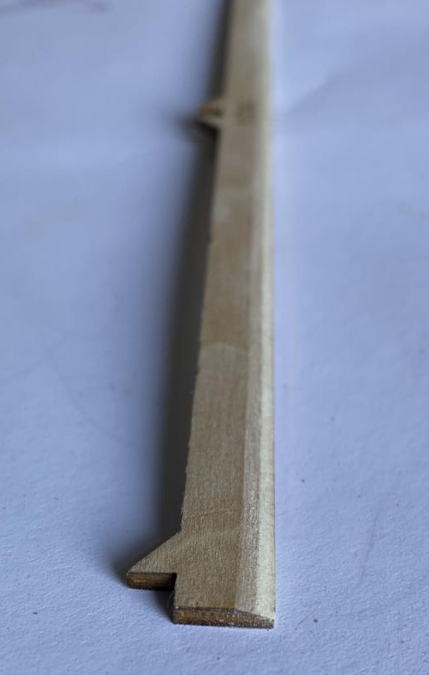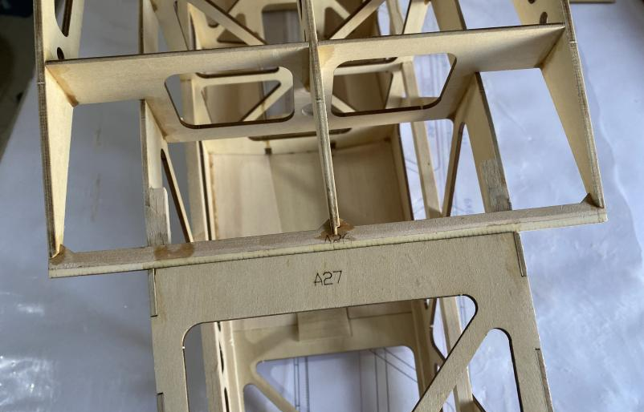
26-27: Glue the lower cover of the wing platform, and glue 6x8 pine wood strips at the marked positions for reinforcement.
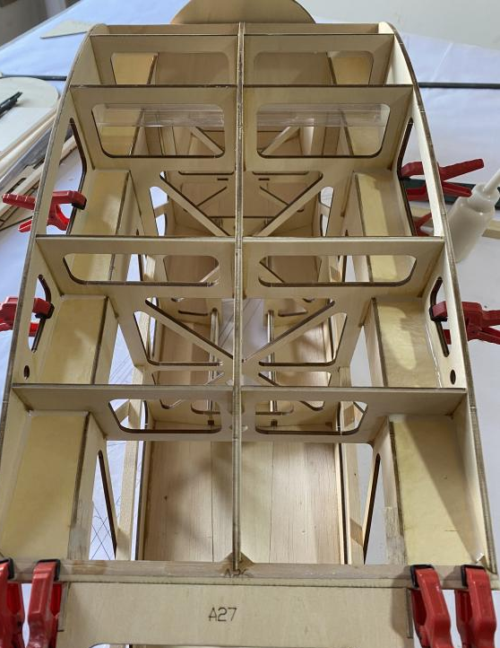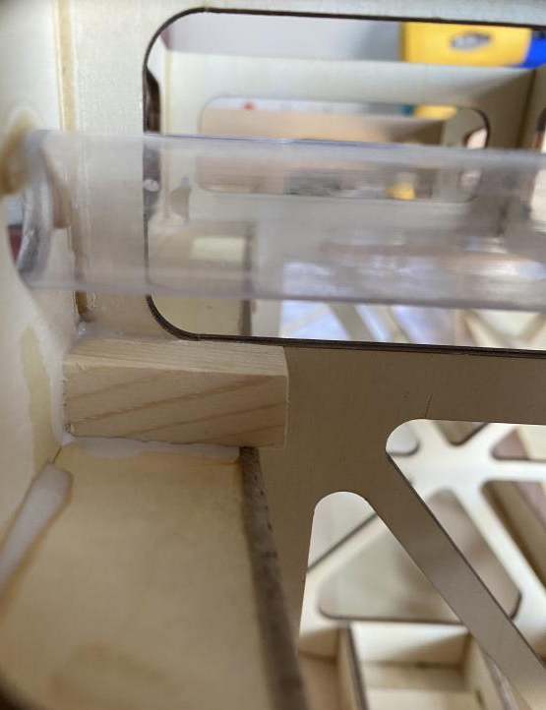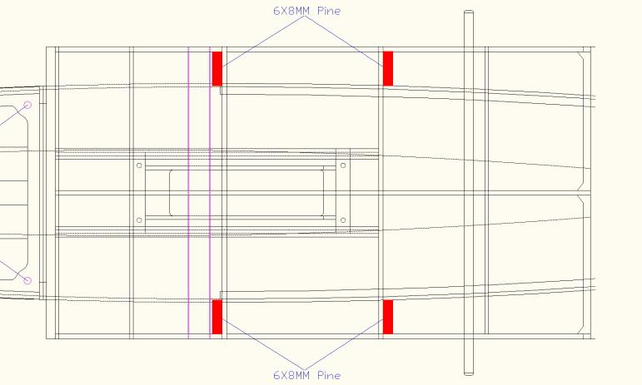
28-29: Glue the upper cover of the wing box.
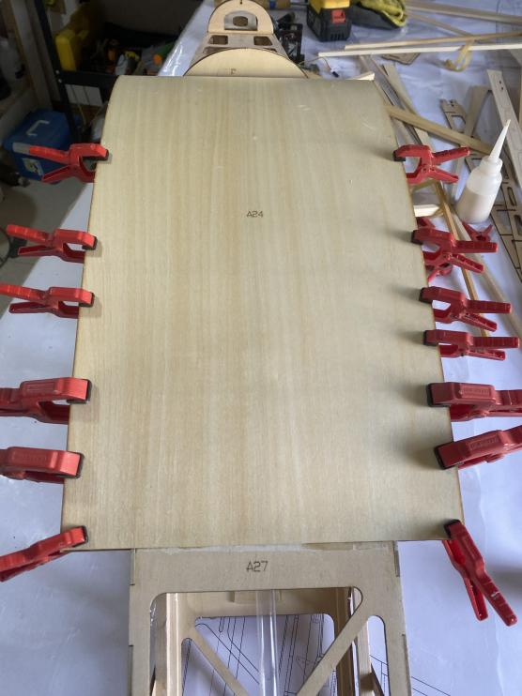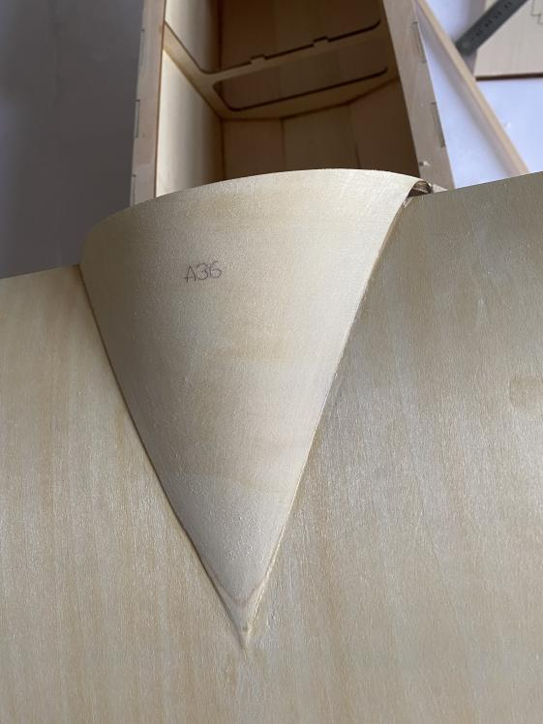

30: Glue 8mm balsa sheet to the leading edge,cut and polish it, referring to the B1 leading edge template.
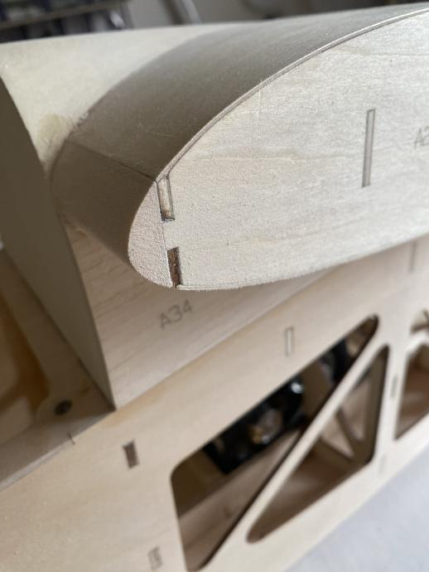
31-32: Glue 6x6mm balsa strips to both sides of the fuselage head. So that the cover will have better strength.
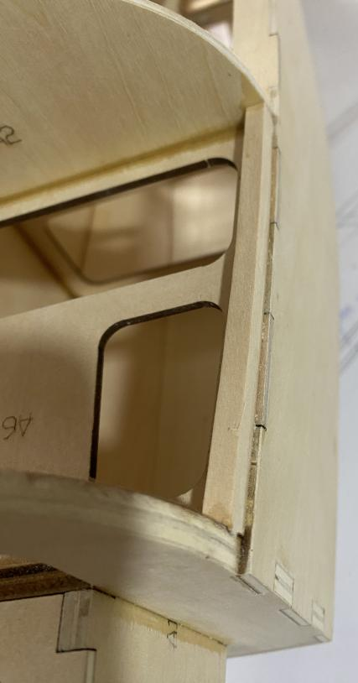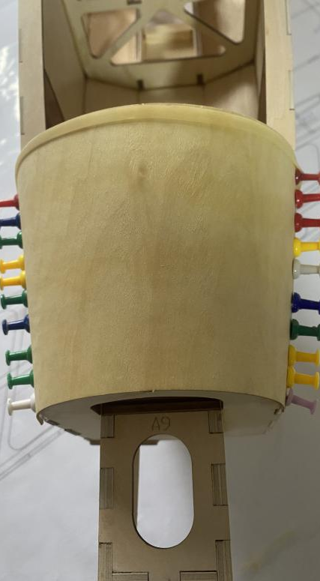
33-35: Assemble the cockpit bulkhead and cover it. Reinforce the middle with balsa stick.
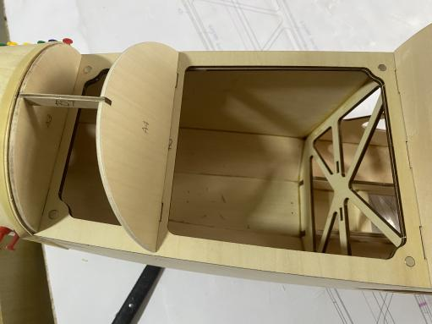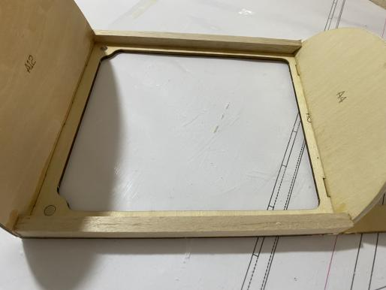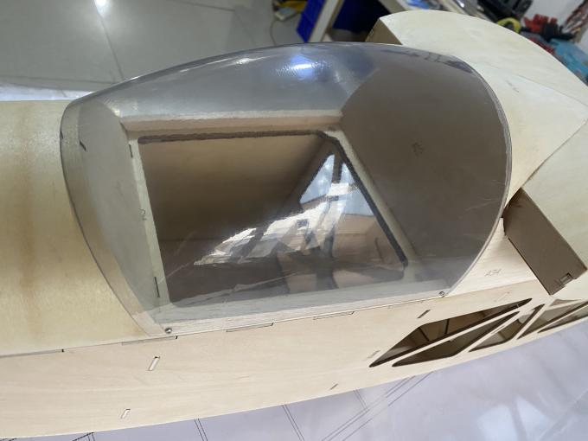
36-37: Glue the A38 to the fuselage with balsa block for reinforcement, and keep it at a 90-degree to the fuselage.
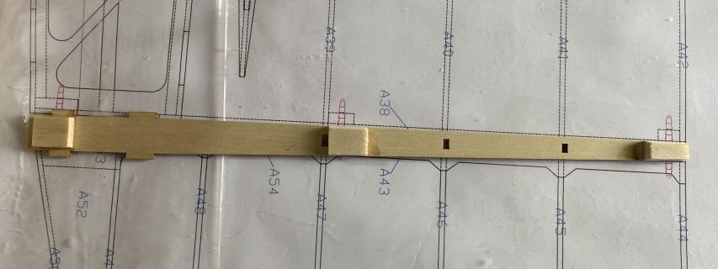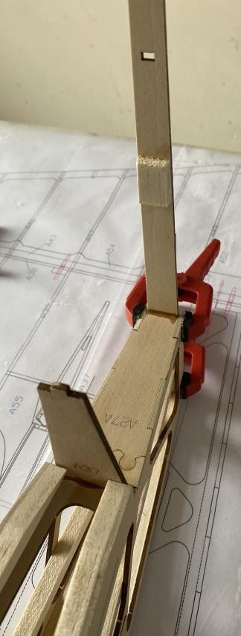

38-39: Glue the vertical tail wing ribs and leading edge, and cover them with 3mm balsa sheets.
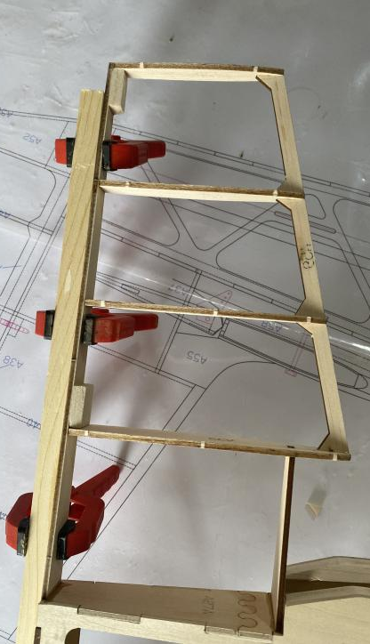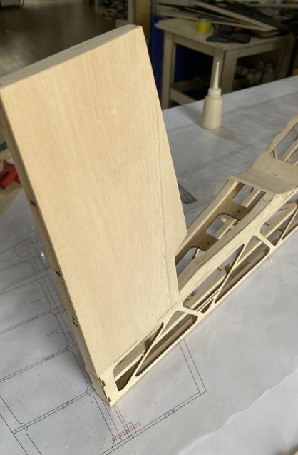
40-41: Stack and attach the A55 balsa blocks to the vertical tail, and glue balsa strips to the leading edge and polish them.
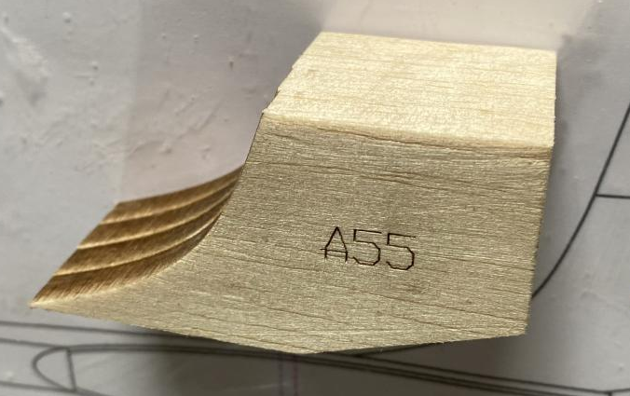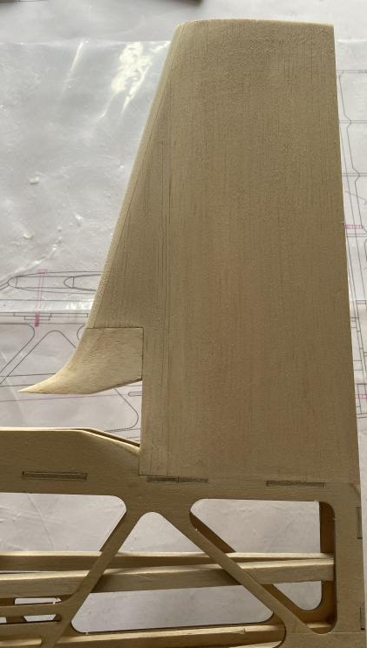
42-43: Insert the motor from the bottom and fix it with screws. Install ESC and adjust the motor's rotation direction.
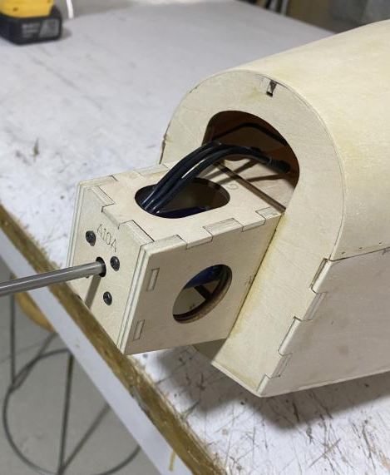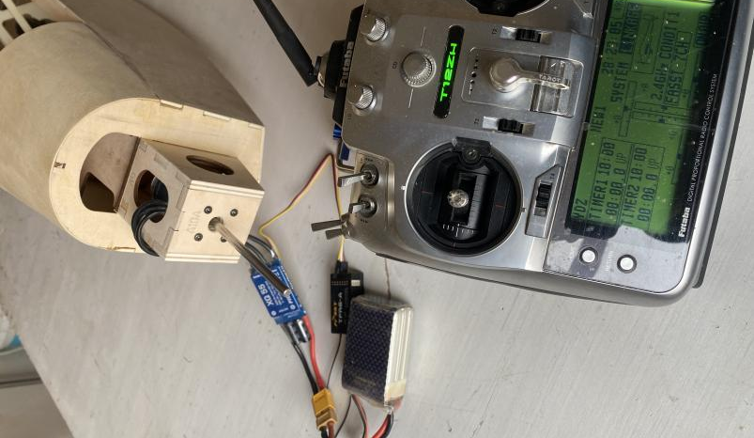
44-45: Glue the nose in the numbered sequence and polish it.
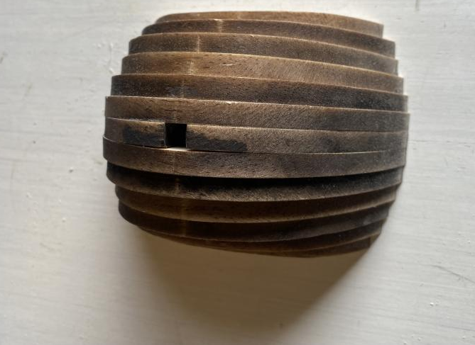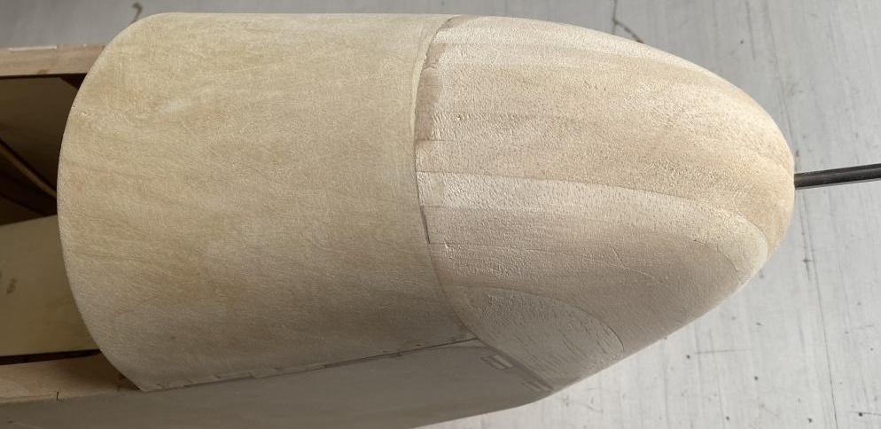
46-47: Install the electric landing gear system(optional) and fix it with self-tapping screws.
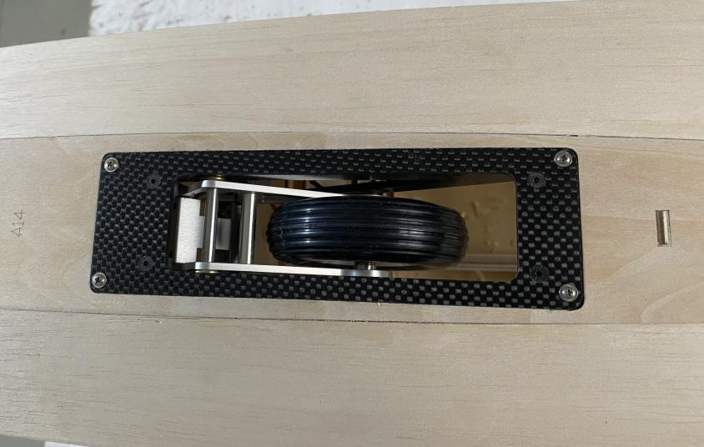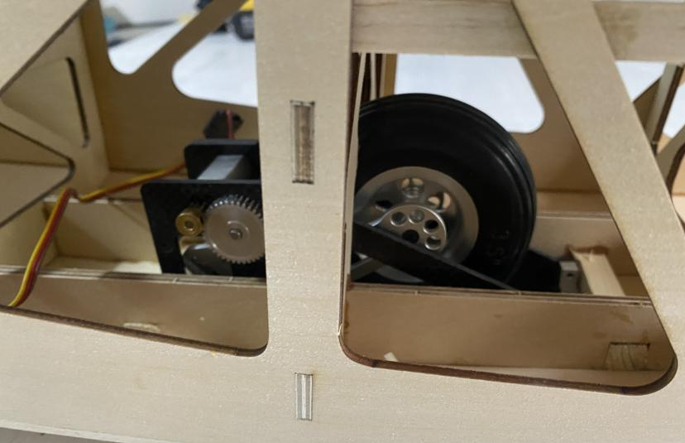
48: Fix the shock-absorbing rubber(landing skid) to the fuselage with nylon wires.
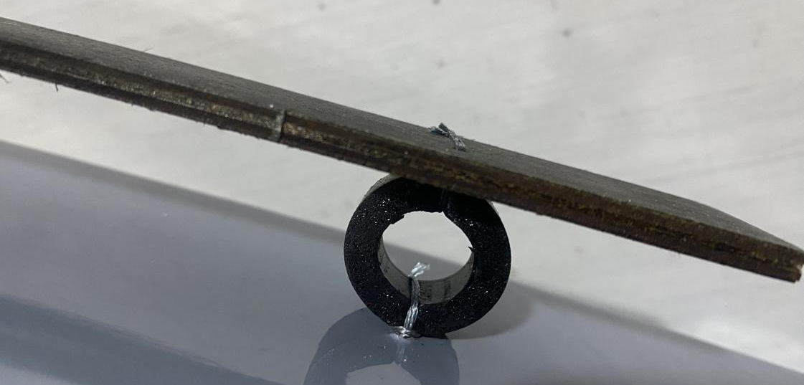

2 WINGS Assembly

1-2 Join and glue the baseboard and leading edge positioning plates of the wing.
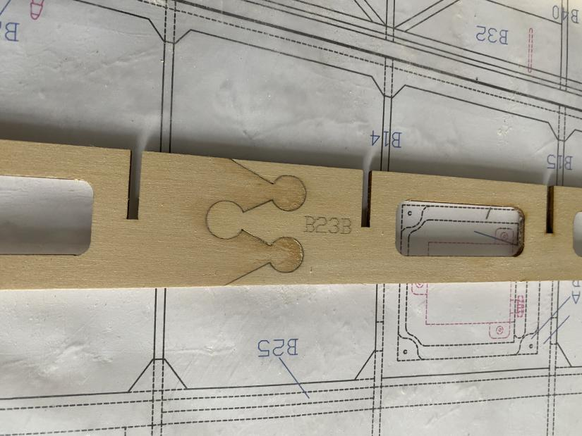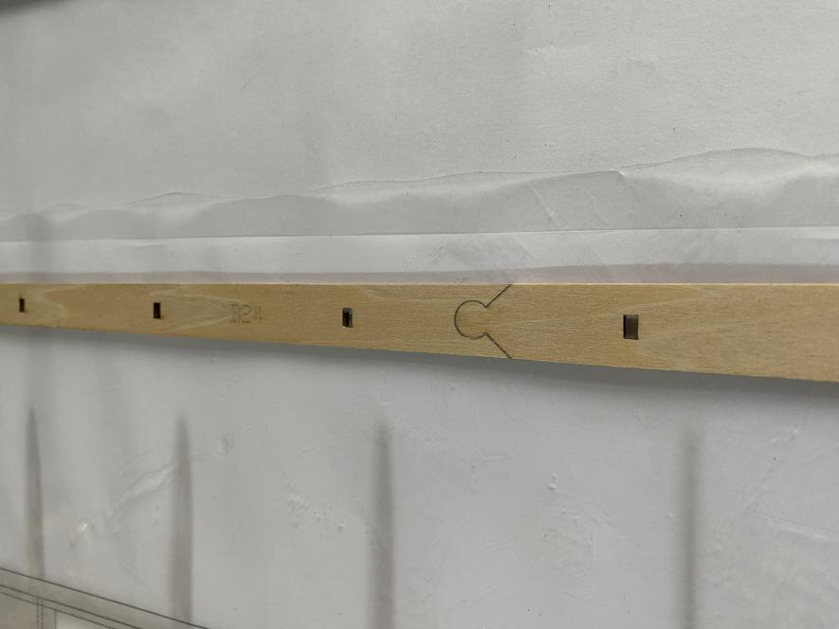
3-5 Assemble the wing ribs and the wing trailing edge according to the part numbers, then glue the leading edge B24, and install the main beam.
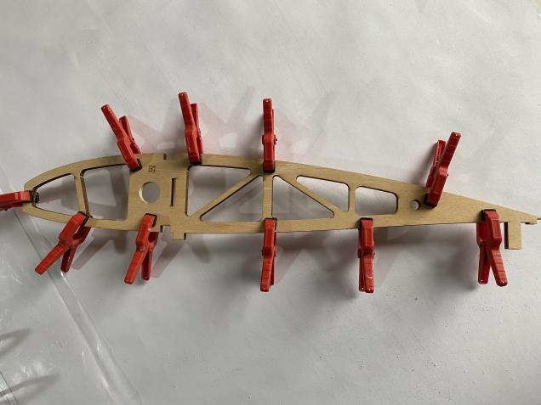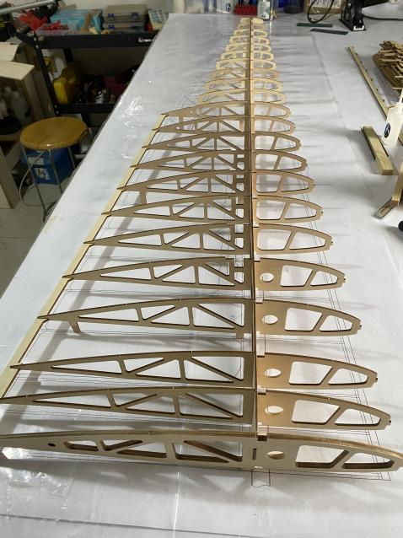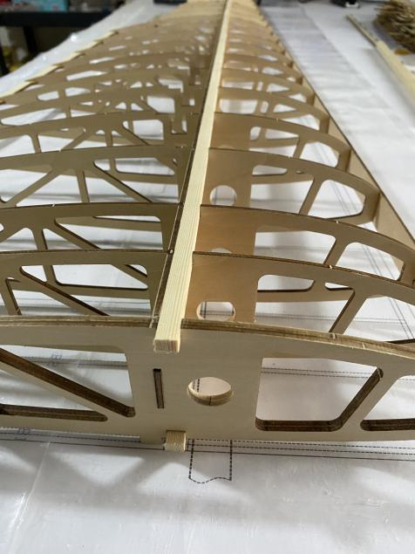
6-8 Insert PVC sleeves, position with carbon tubes, and use straight objects to correct the leading edge to avoid bending. The length of the pine strips needs to be joined, and the position is between the B13 and B14 wing ribs.
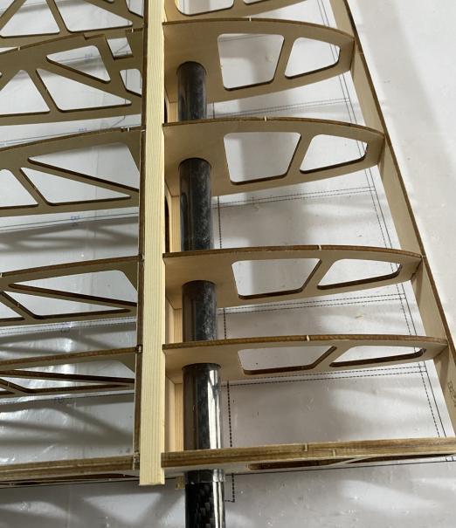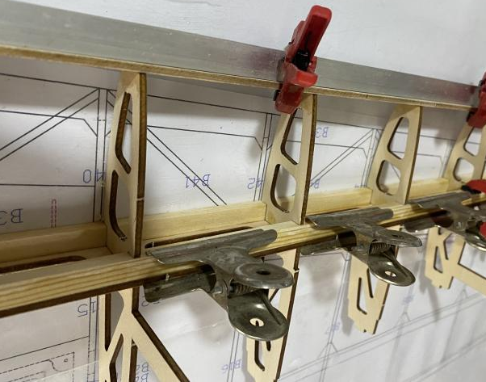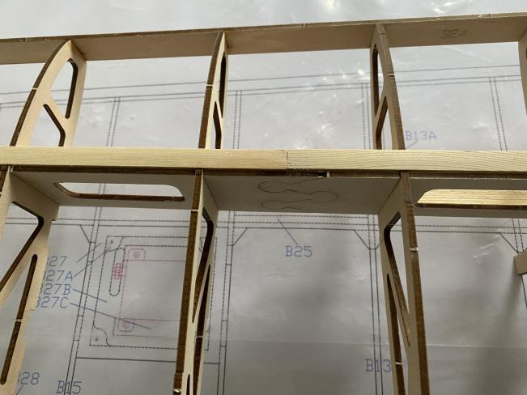
9-10 Glue the reinforcing plate B25 at the joint position, and glue the B13A balsa sheet at the leading edge.
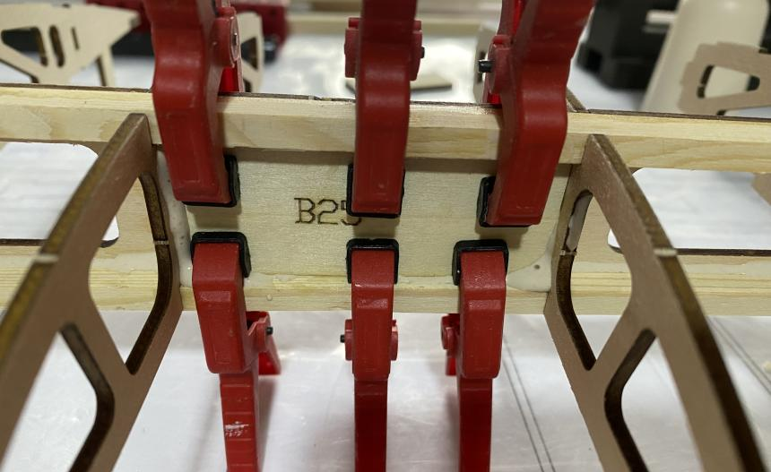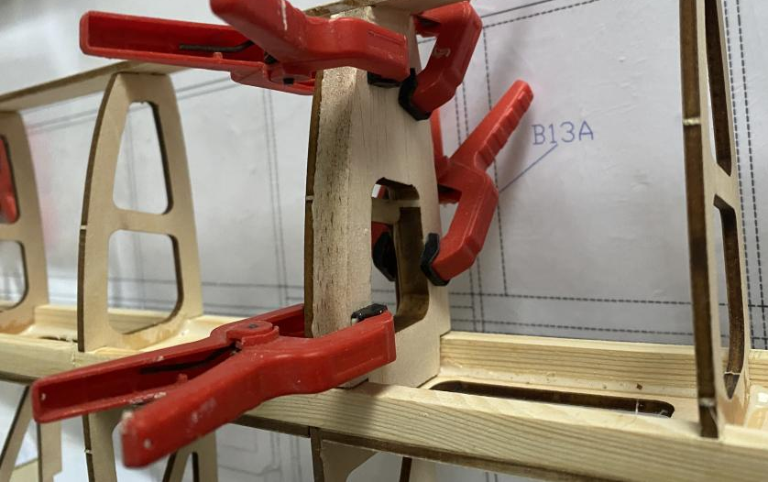
11-12 Glue the upper and lower cover of the wing.

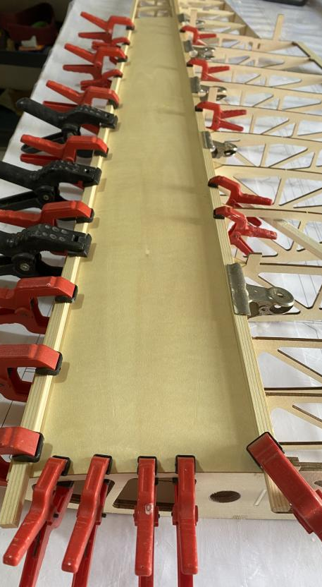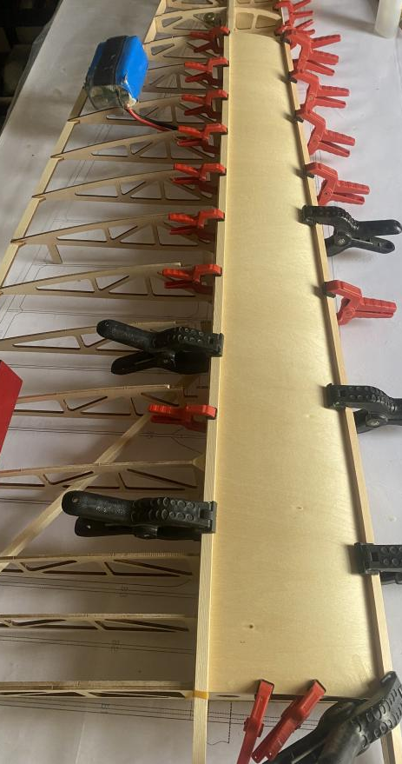
13-14 Glue the air brake fixing mount B26 and the cover B55.
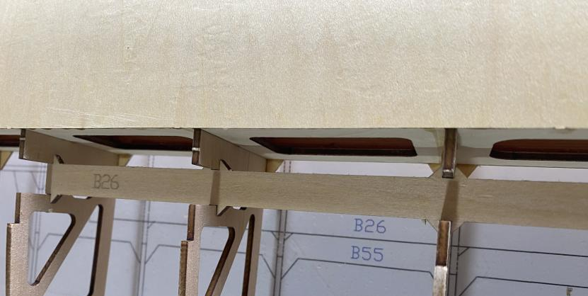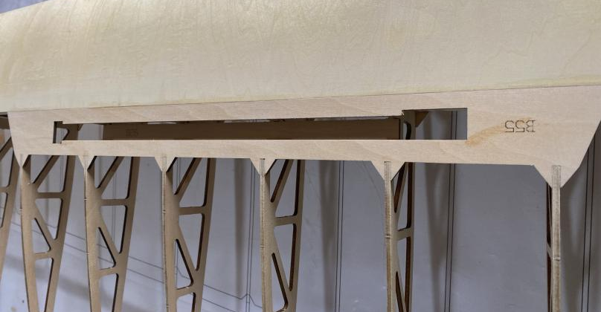
15 Glue 8MM balsa sheets at the leading edge of the wing.
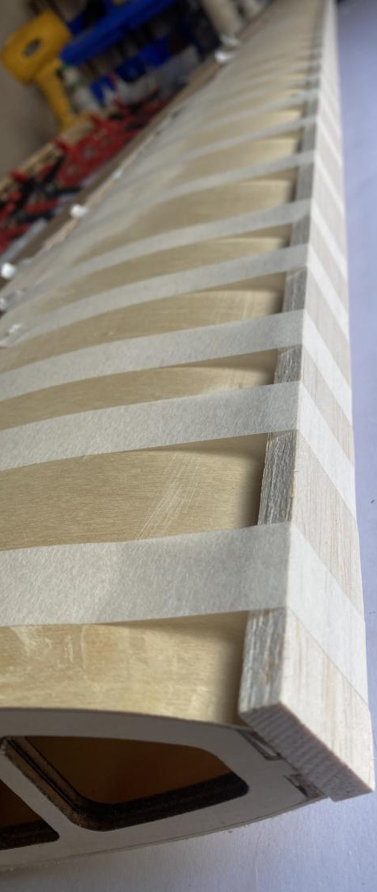
16 Glue the B29 trailing edge plywood sheet and the B56A cover of the wing.
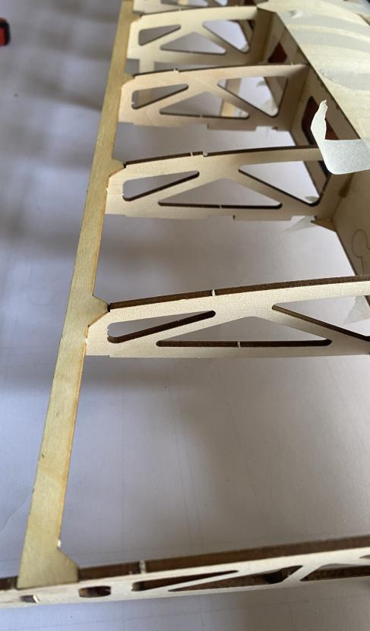
17-20 Glue 6X6MM balsa strips at the wing cover to provide a larger contact surface for it. After gluing the upper and lower cover, cut off the excess support plywood plates.
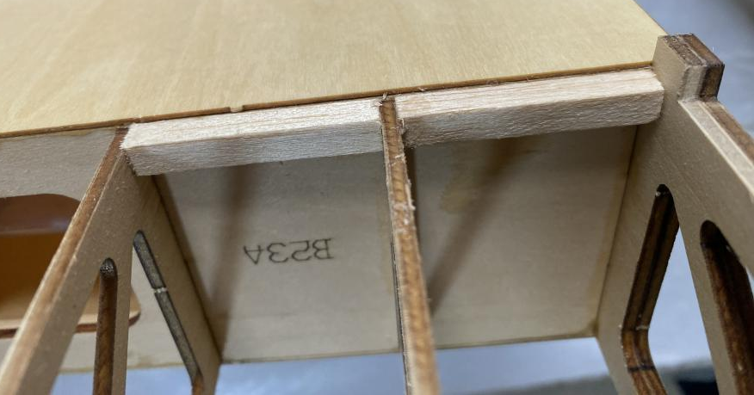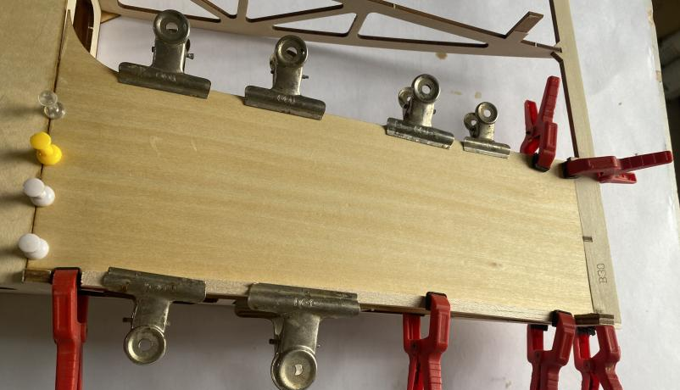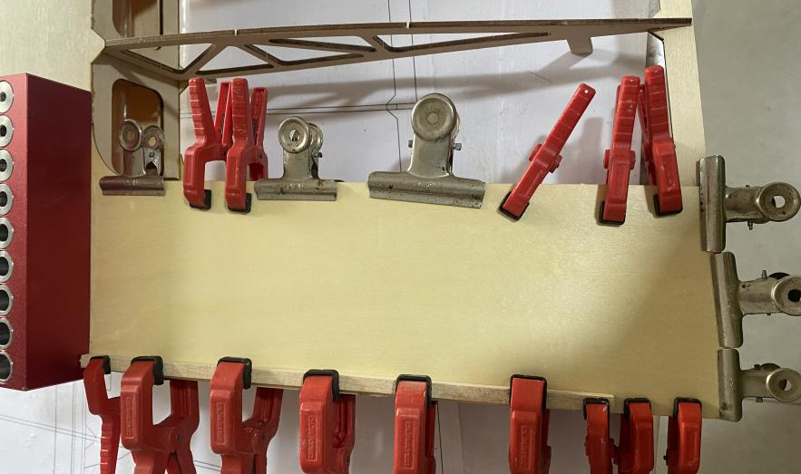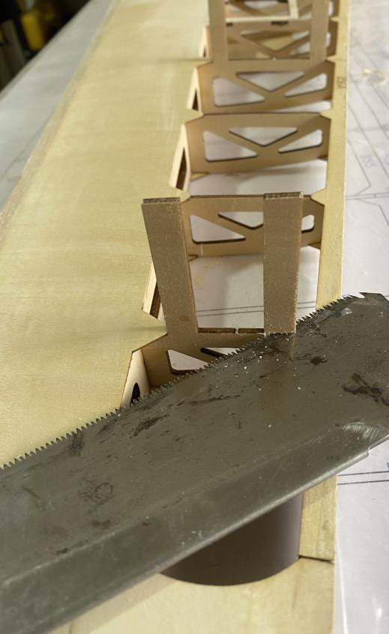
21-22 Glue the aileron control mount.
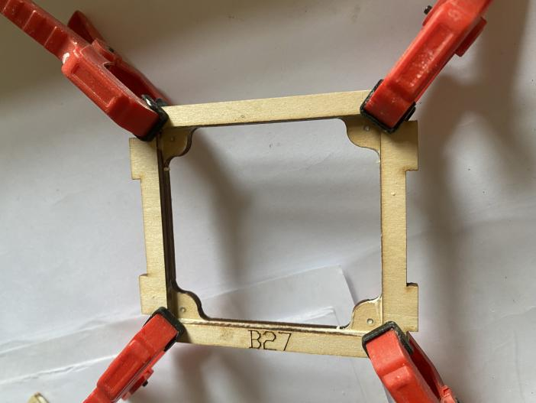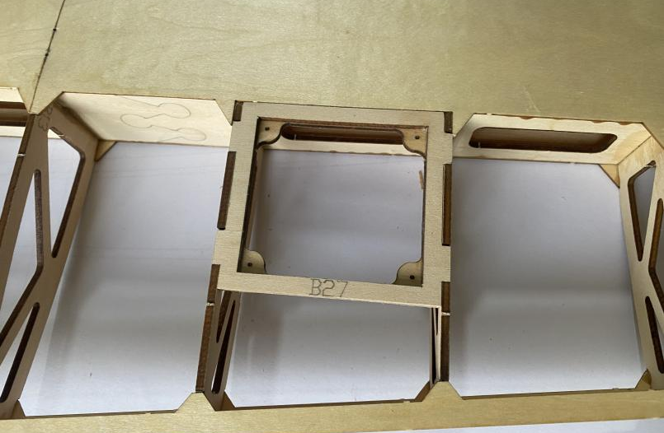
23-24 Glue the upper wing surface and the servo mount.
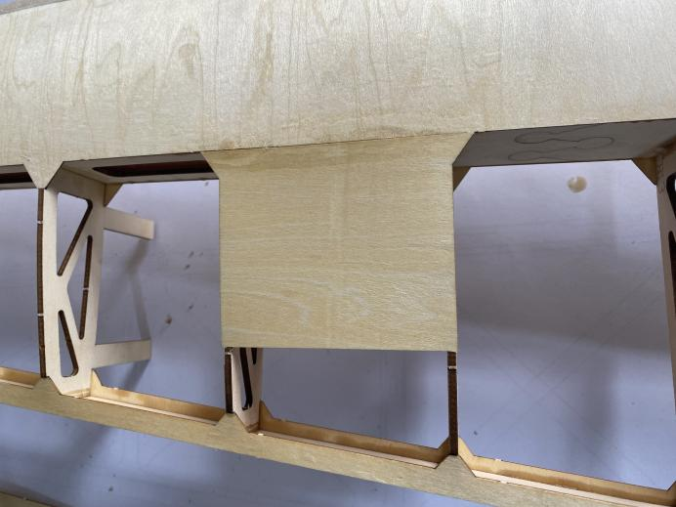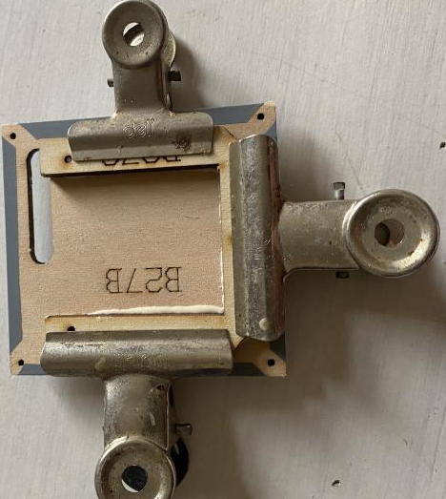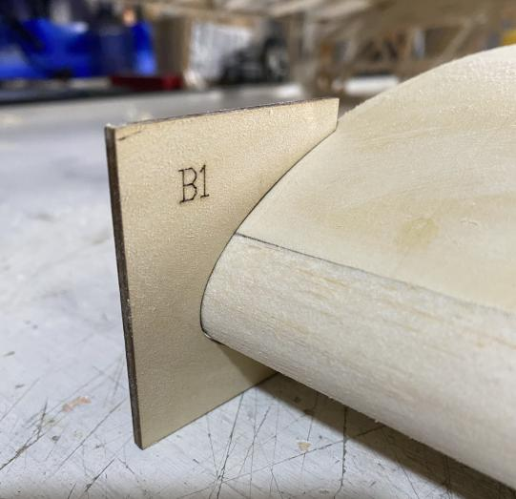
25-27 Sand the leading edge of the wing, and calibrate with the card plate B1,B11,B22....
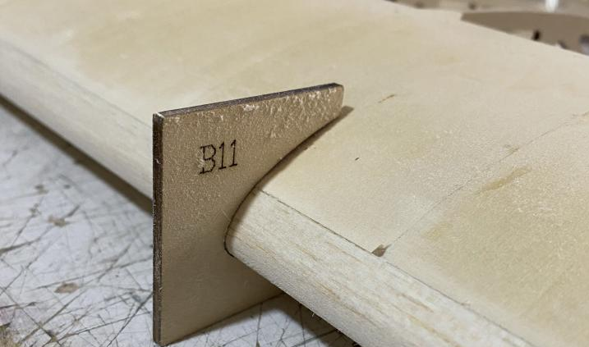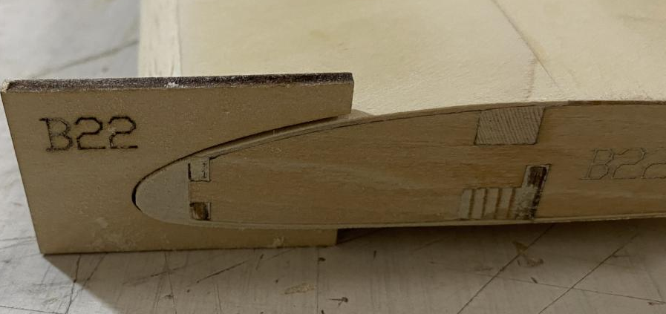

28-30 Assemble and glue the aileron ribs, and glue 8MM balsa sheet at the leading edge.
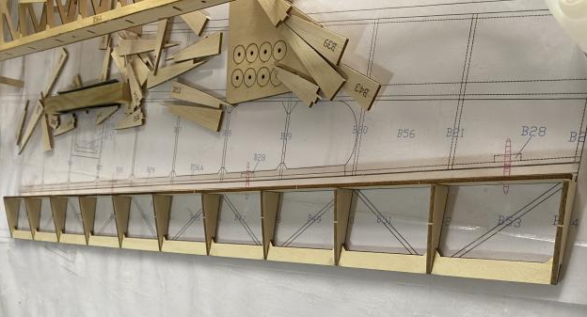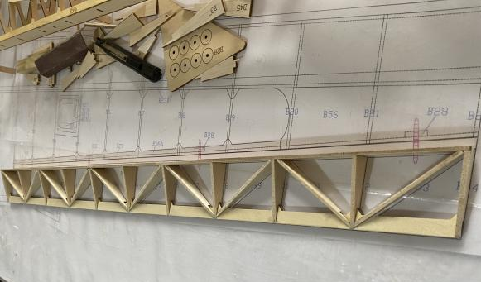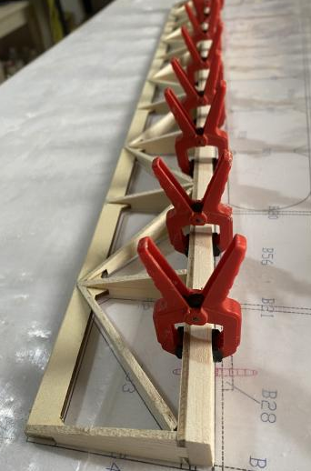
31-32 Glue the B32 aileron corner reinforcing plate, and polish the leading edge of the aileron into a V shape.
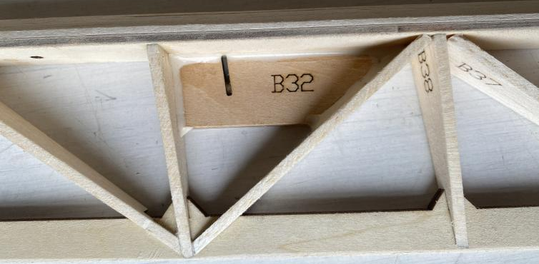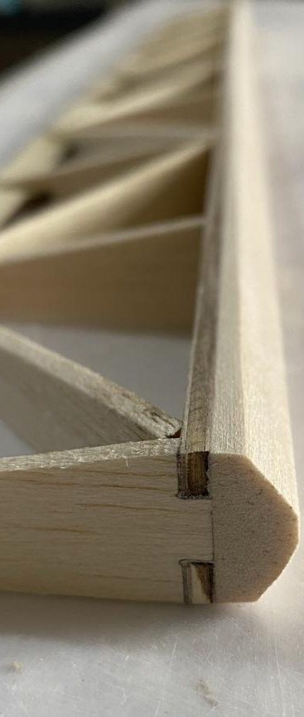
33 Install the air brake. Connect the receiver to lift the brake, and then fix it with self-tapping screws.

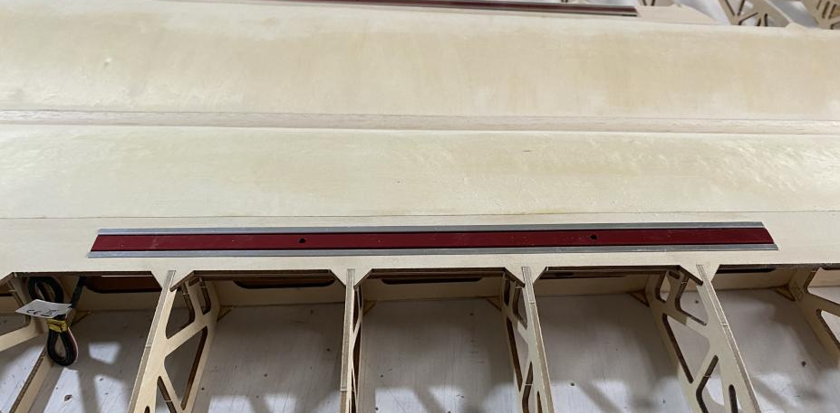
34 The wing and the fuselage are fixed with O-rings.(This step is carried out before the flights to prevent the wings from slipping off the carbon tubes due to vibrations or other factors.)
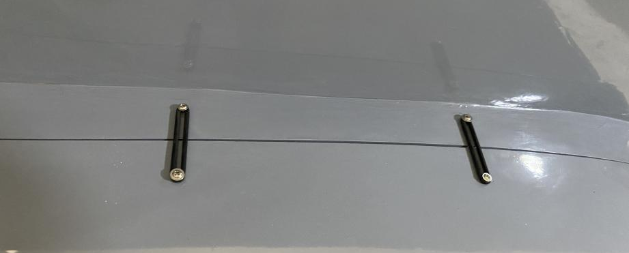
3 Tail Assembly
1-3 Assemble and glue the rudder.
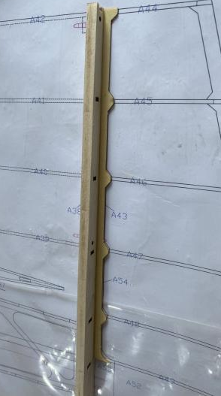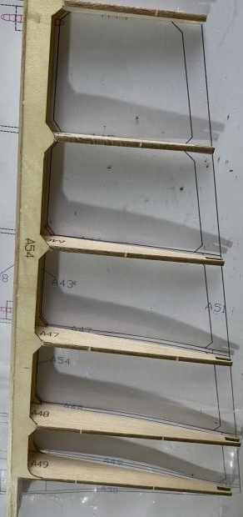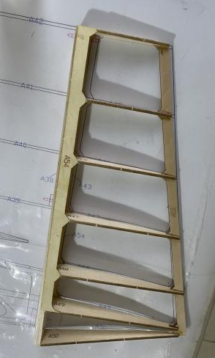
4-6 Glue the reinforcing blocks for the horns and then glue the side covers. Cut and sand the front part of the rudder into a V shape.
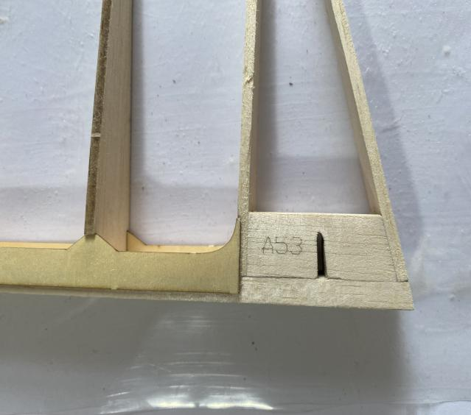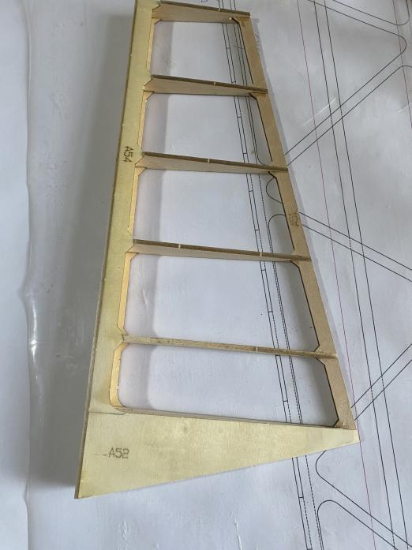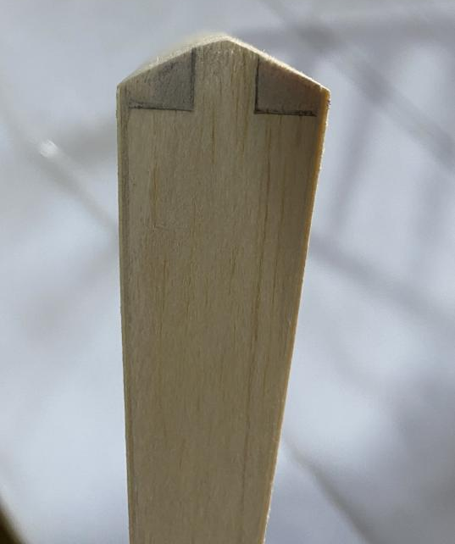
7-9 Glue the C9 horizontal tail wing reinforcing block, assemble and glue the servo mount, and the middle wing ribs need to be glued in layers.
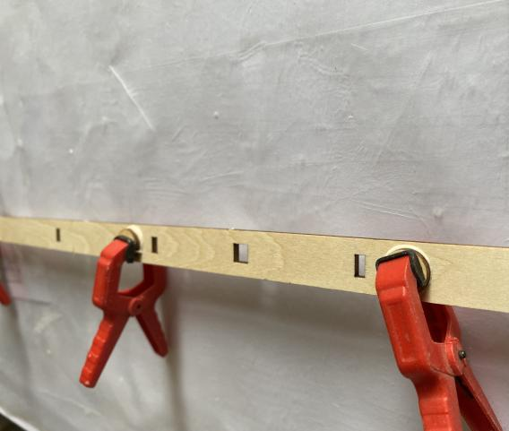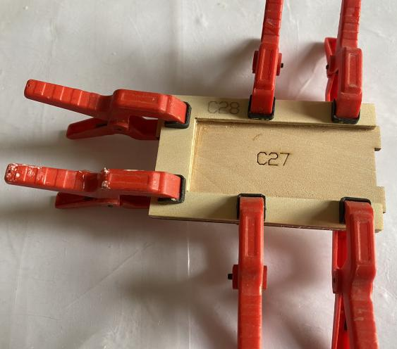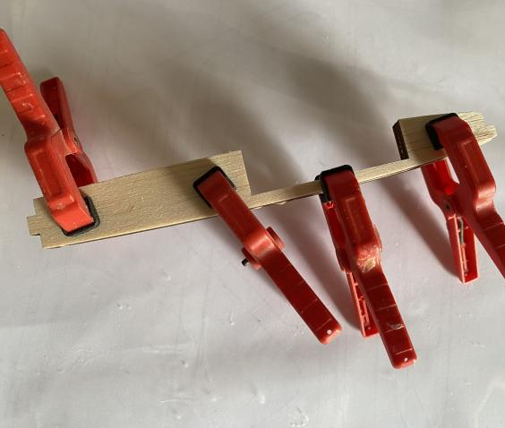
10-11 Assemble the wing ribs according to the drawing numbers, Glue the servo mount and the leading edge balsa sheet C8.
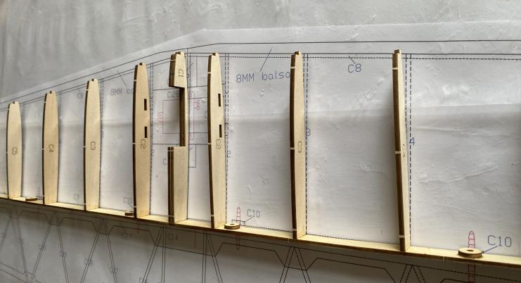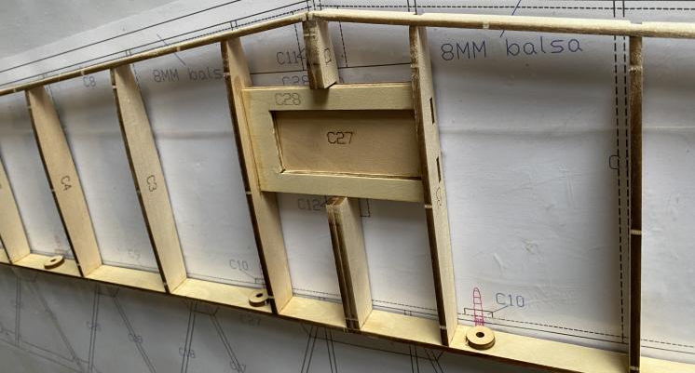
12 Assemble and glue the horizontal tail wing template.
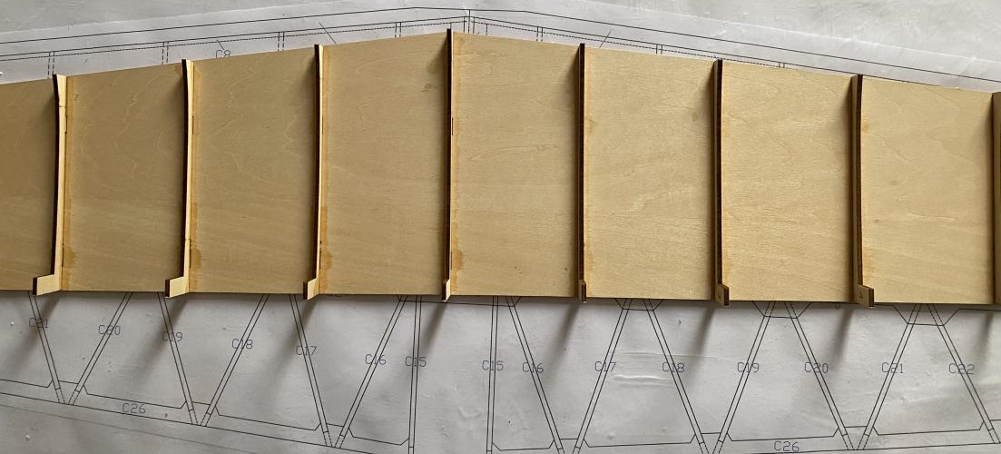
13 Glue the upper cover of the horizontal tail wing.
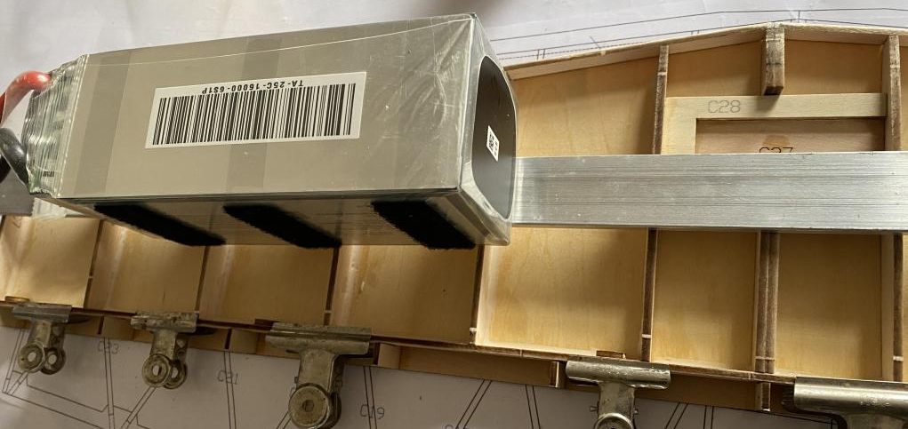
14-15 Adjust the servo and install it onto the mount. Fill balsa blocks C11 and C12 on both sides.
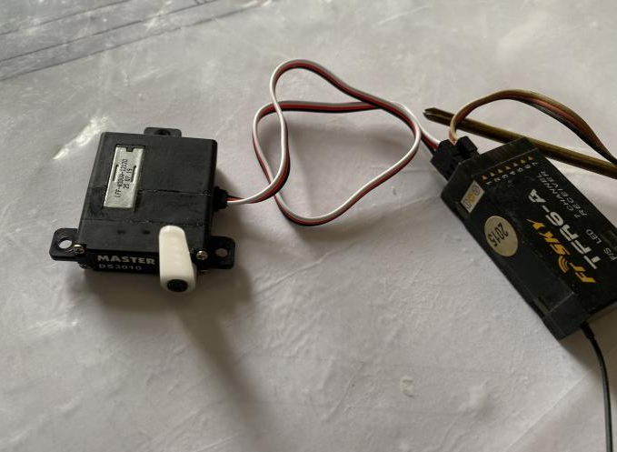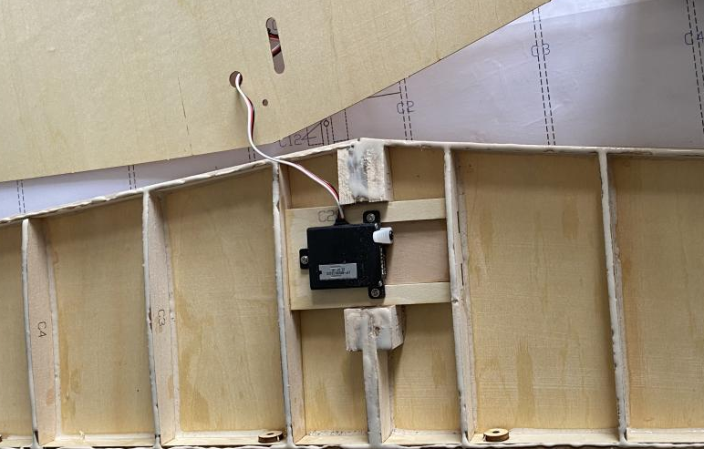
16-17 Glue the lower cover of the horizontal tail wing, and glue balsa on the leading edge then cut and sand it.
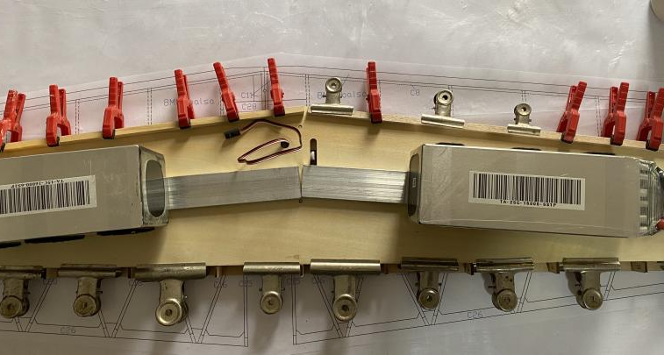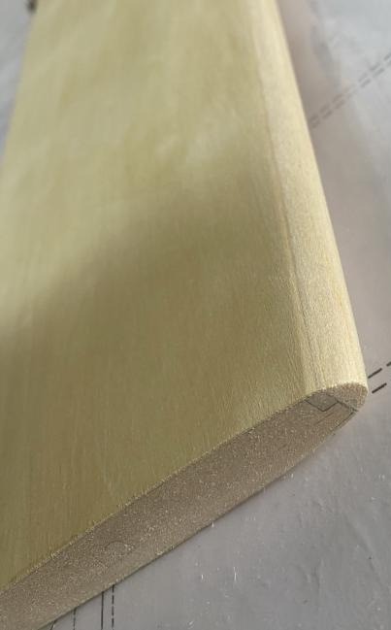
18-22 Assemble the elevator according to the drawing numbers, fill in with C14 balsa in the middle, then cut and sand the leading edge into being a V shape.
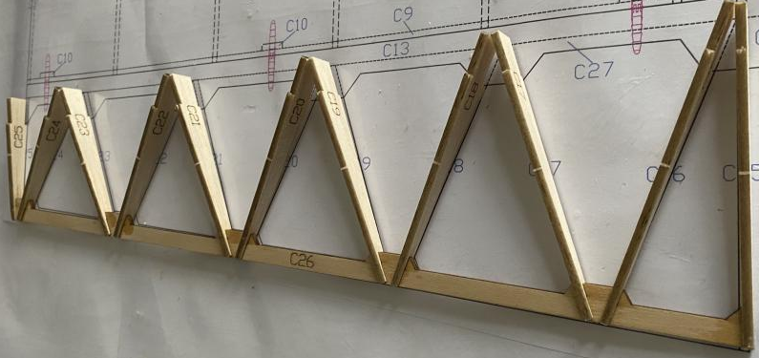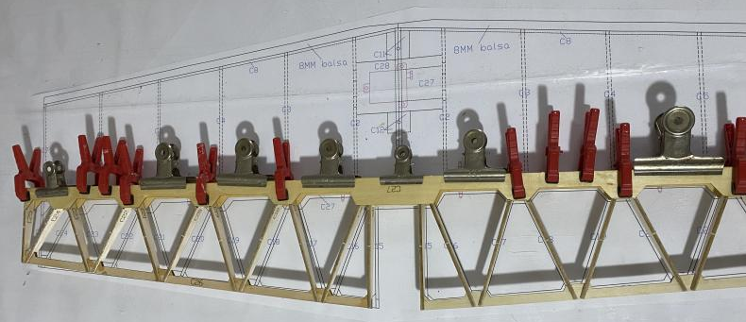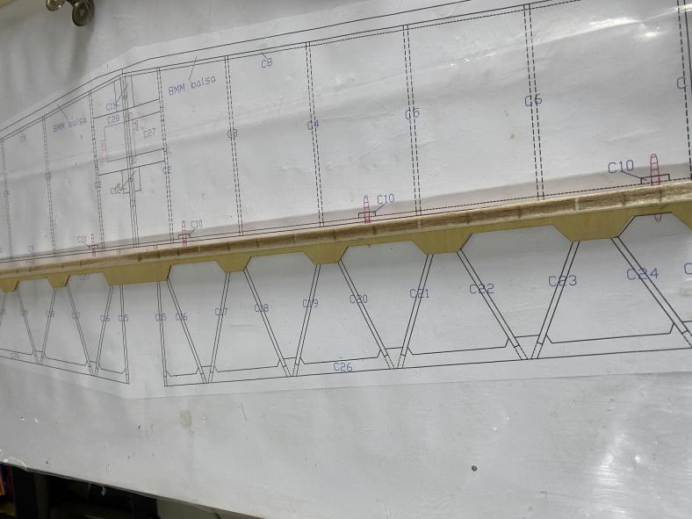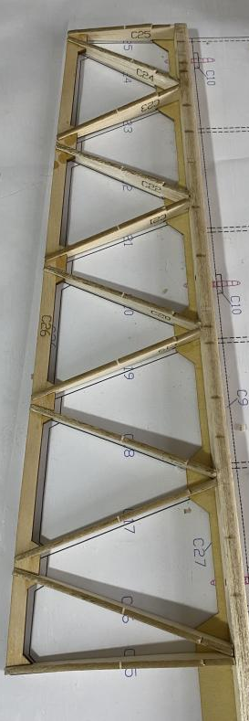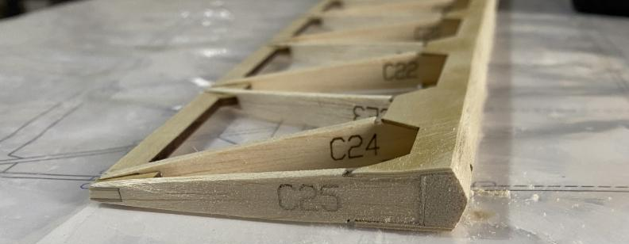
23-24 Fix the horizontal tail wing to the fuselage using screws.
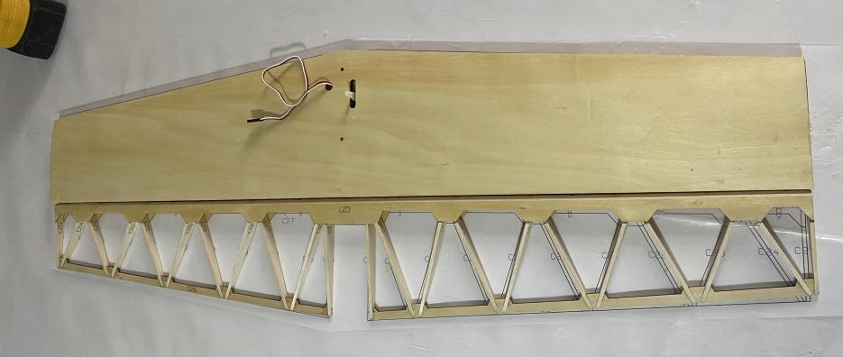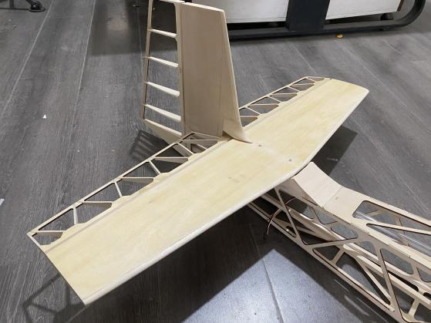
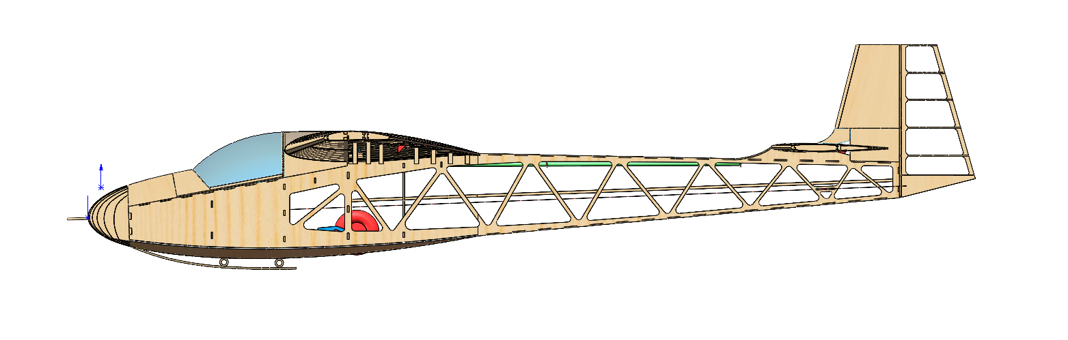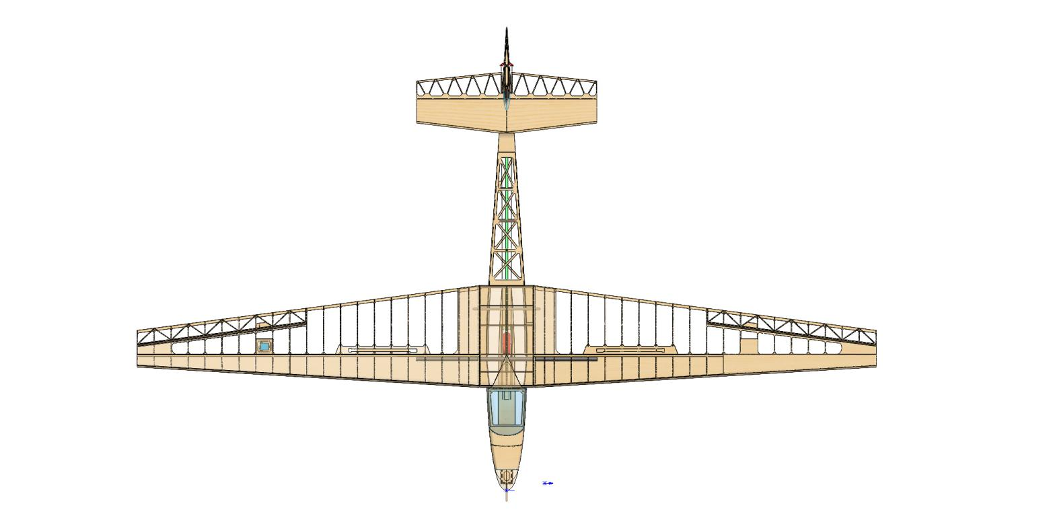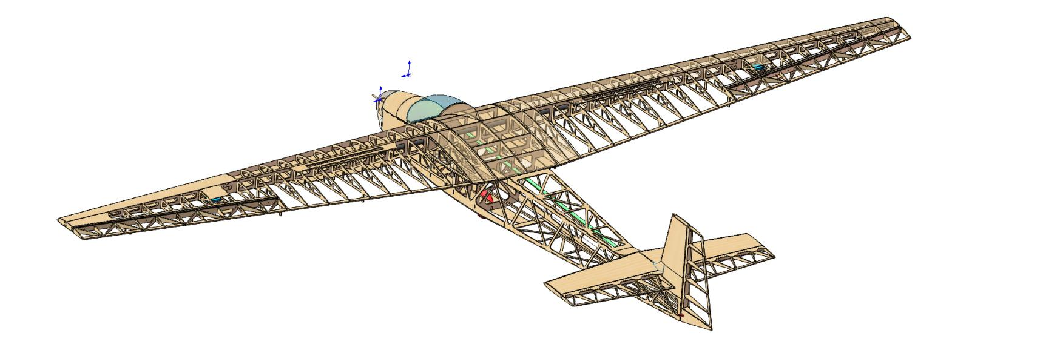

4 FINISHED
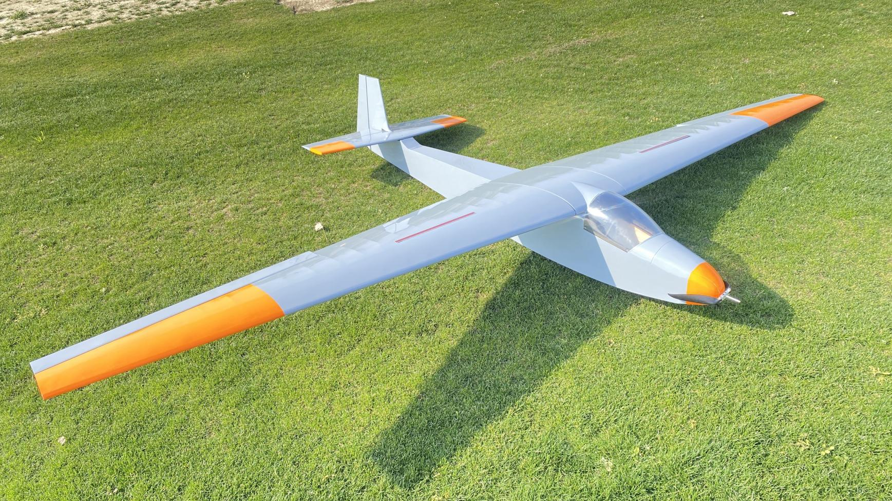

尾面

Address：No.30, 4th Rd. Linji Community Yingzhong Town Zhongxiang 431900 CN.
Sales: sales@valueplanes.com
Tech: tech@valueplanes.com
Tel:0086 18608628766 158 7294 1801

